SVS-2WAH 2 Wire Audio Phone User Manual

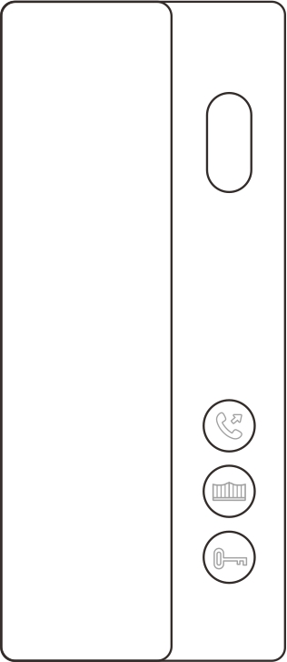

Version: V1.0

·Thank you for purchasing our products.
·Please read this User Manual carefully before using this product.
·Products are subject to change without prior notice.
1. Product Features and Main Function
◆ Digital 2 wire, nonpolar and easy wiring
◆ Make intercom to management center
◆ Make intercom to the indoor monitors with same address
◆ Ring volume and types are adjustable

- Names of Each Part

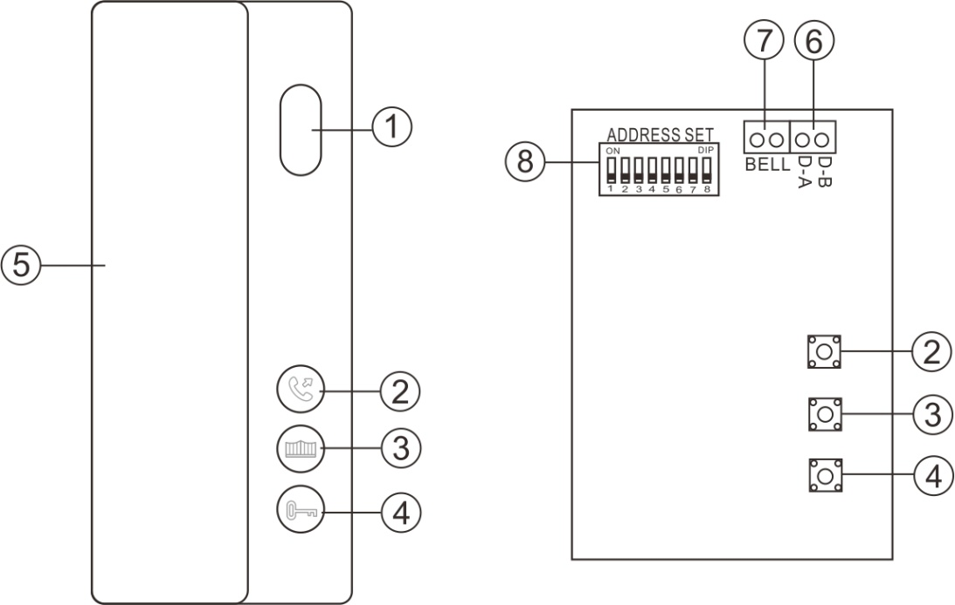

No. | Name | No. | Name
① | Speaker | ⑤ | Handset
② | Call button | ⑥ | 2 Wire BUS port
③ | Gate unlock button | ⑦ | Call button port
④ | Door unlock button | ⑧ | DIP switch for address setting

⑦ Diagram for call button connection
Call button

3. Address Setting
You need to set right address for each audio phone by the DIP switch. The address list of DIP switch is as below.
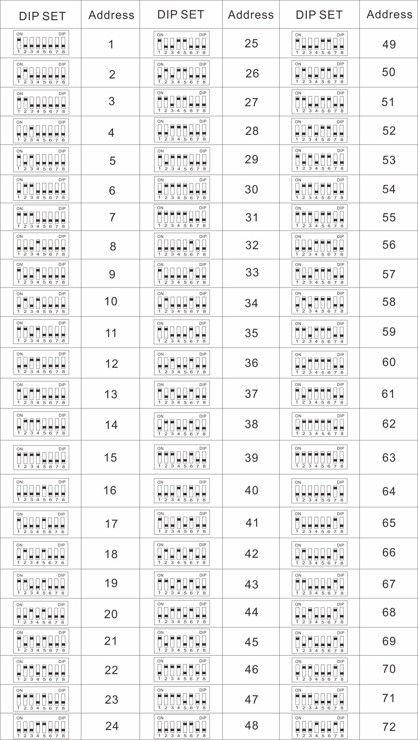

- Operation Guide
4.1 Call Answering
When someone presses call button on the door station, the audio phone rings, pick up the handset to answer the call, and you can have a maximum 60 seconds talk with the visitor. After finishing talk, put the handset back to hang up.
During talking, touch or to unlock the gate or door lock.

4.2 Intercom Function
(1) Call to Management Center
Pick up the handset, press to call management center.

- Make Internal Call to Monitors with Same Address
Pick up the handset, press and hold on , all monitors with same address will ring.
Remark:
When you make intercom from audio phone, if it does not call successfully, there will be 2 beeps. If it calls successfully, there will be ring tones.

4.3 Ring Volume Setting

There are 3 levels of ring volume can be set.
At standby state, press and hold on for 2 seconds to enter ring volume setting mode, then press to set ring volume. Three levels of ring volume cycle:

Press
Press
High-range
Low-range
Mid-range

Press
If no operation in 6 seconds, it will exist ring volume setting mode. Or you can pick up the handset to exit the ring volume setting mode.

4.4 Ring Tone Setting
There are 3 rings tones for setting.
At standby state, press and hold on for 2 seconds to enter ring tone setting mode, then press to set ring tones. Three kinds of ring tones cycle:
Press
Press
Ring tone 1
Ring tone 3
Ring tone 2

Press
If no operation in 6 seconds, it will exist ring tone setting mode. Or you can pick up the handset to exit the ring tone setting mode.

4.4. Bell for Call Button
Each time when someone presses the bell call button, there will be 2 beeps on the audio phone.

4.5. Management Center and Unlock Button State Setting
The management center address and unlock button state can be set in a monitor in the system.
Operation guide:
- Connect a monitor into the system.
- Create a txt file named ConfigAudioDoorphone.txt in the micro SD card, and insert it into the monitor.
Go the SETTING of indoor monitor Go to DEVICE CONFIGURATION Audio Doorphone device list Choose the audio phone you want to set.
Remark:
In case you forget the password of the audio phone, please set the all DIP switch to be ON, reboot it, then you can go into the AUDIO PHONE DEVICE LIST directly without a password(touch # button directly at password input interface). When all DIP switch is set ON, the audio phone will ring all the time. Please change the DIP switch after resetting the password.

- Wiring Diagram
5.1 Wiring Diagram for Villa System
(1) Use DC24V, 1A Adapter as System Power Supply
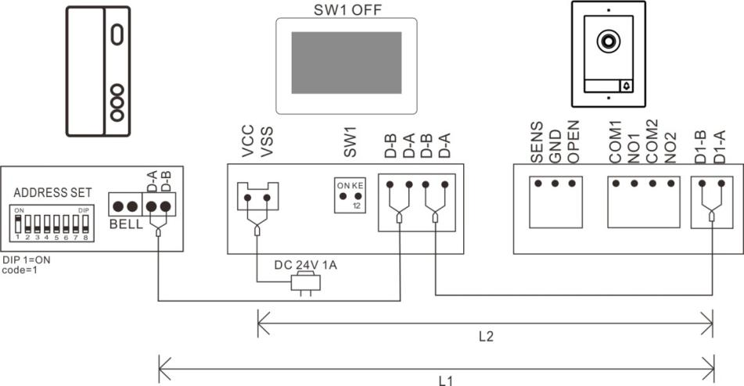

- Use DC24V, 1A DIN Rail Power as System Power Supply
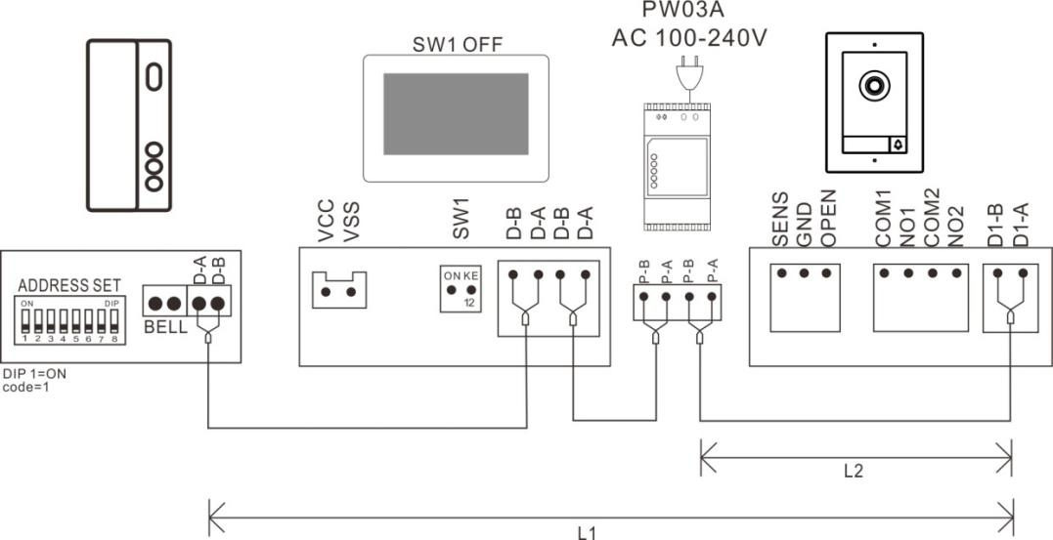

5.1 Wiring Diagram for Apartment System

- Audio Phone Connects to NV20 Directly
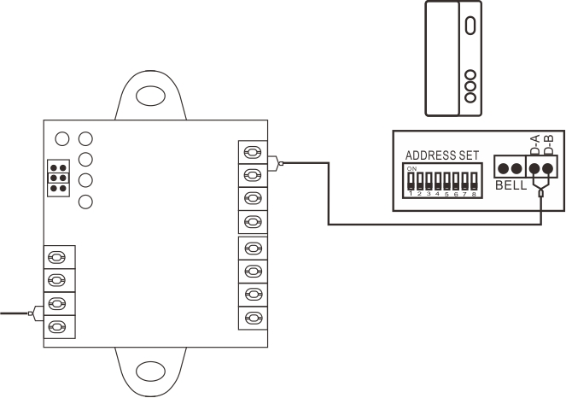

- Audio Phone Connects to Monitor
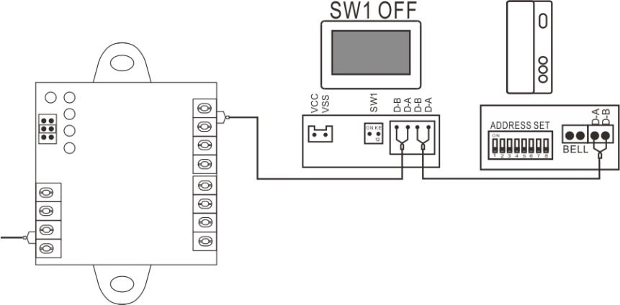

- Installation
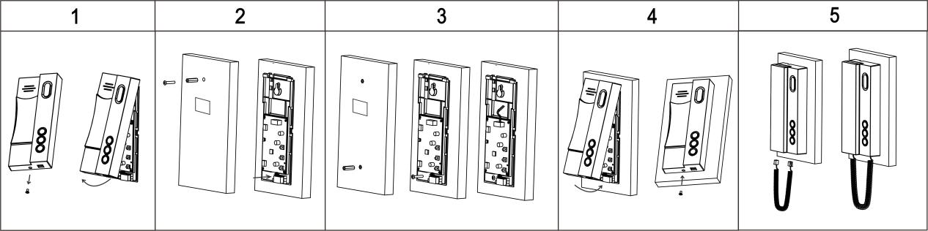

- Remove the screw on the bottom of the audio phone, and remove the front panel from the audio phone.
- Drill 1 hole on the wall, insert 1 expansion column into it, then hang the audio phone onto the screw, and mark the position for the second screw, then remove the audio phone.
- Drill 1 hole at the marked place, and insert 1 expansion column into it. Hang the audio phone on the first screw, and fix it with the second screw at the bottom. Then connect the wires according to the wiring diagram.
- Clip the front panel onto the audio phone, and fix it with a screw at the bottom.
- Insert the connection wire into the audio phone main body and handset.

- Specification
No | Item | Content
1 | Communication | Digital 2 wire
2 | Audio | Digital signal(bidirectional)
3 | Audio distortion | Less than 3%
4 | Frequency response | 400-3.5K
5 | Wire distance | Less than 100 meters (RVV2*0.5mm²)
6 | Biggest system | 72 flats
7 | Buttons | Mechanical buttons
8 | Internal call | Support
9 | Working voltage | DC24V, 70mA (Max)
10 | Power consumption | 1.5W(Max), 0.5W(Standby)
11 | Working temperature | -10℃- +40℃
12 | Storage temperature | -30℃- +60℃
13 | Dimension | 180*77*34mm

SVS – Secure Video Systems
The Drive
Erith
DA*1ED

WWW.s-v-s.co.uk
info@s-v-s.co.uk
08001216097

Products are subject to change without prior notice. Svs Secure video systems is a trading name of Intercom repair LTD
Registered company number: 07648814 Vat No 140598900

