SVS-2WTMHC & SVS-2WTMC
2-Wire Touch Screen Indoor Monitor
User Manual

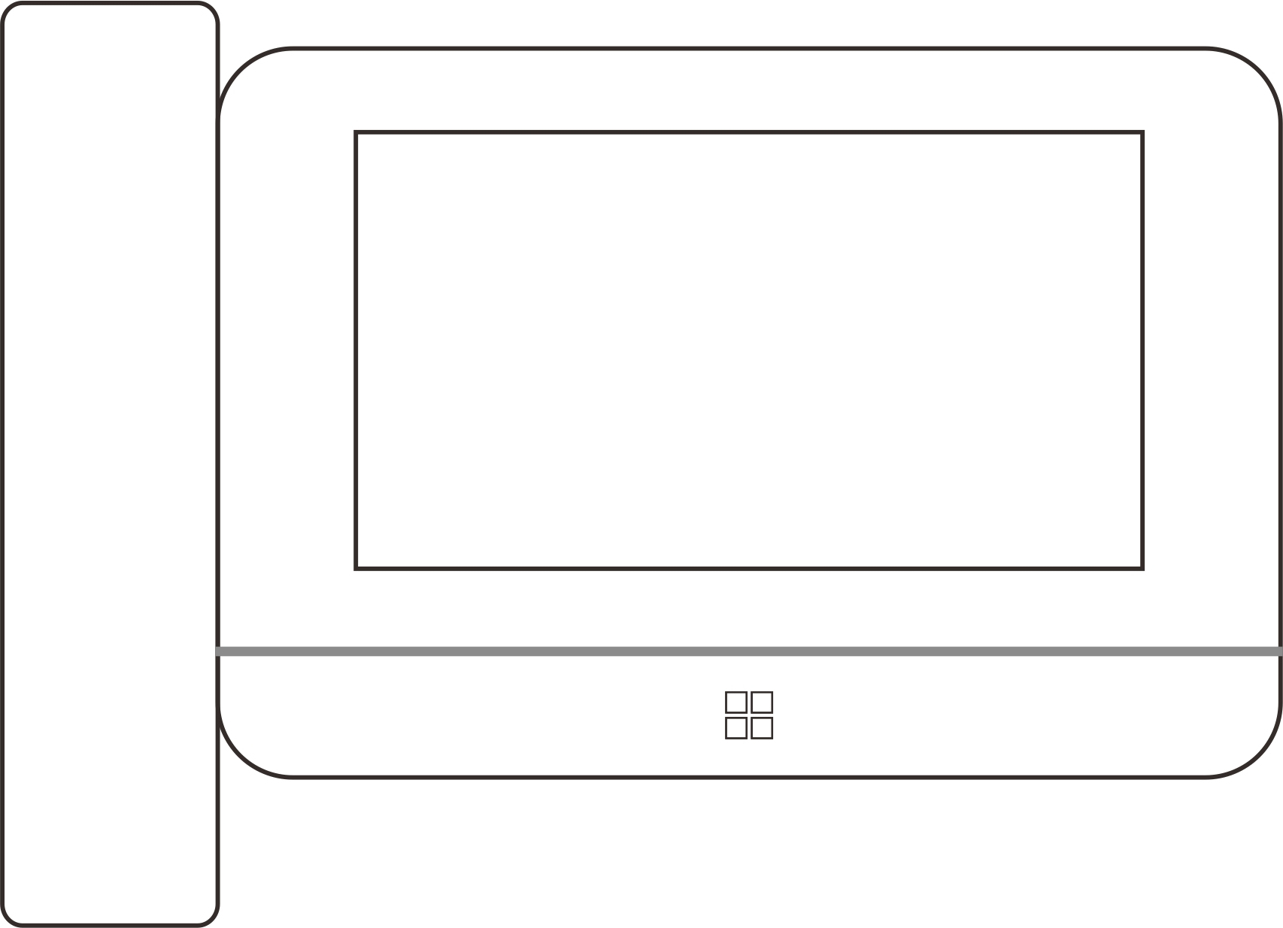
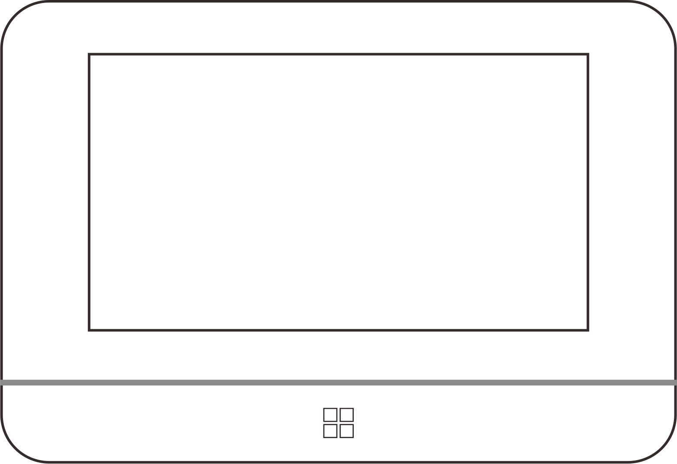

Hands Free Monitor SVS-2WTMC
Monitor with Handset SVS-2WTMHC

Version: V1.0

Thank you for purchasing our products.
Please read this User Manual carefully before using this product.
The company is not responsible for any safety accidents caused by abnormal operation of the product.

Index
1. Warnings and cautions 1
2. Name and function of each part 3
3. Feature and main function 4
4. Packing list 5
5. Wiring Diagram 5
5.1 Power Supply from Adapter 5
5.2 Power Supply from BUS 6
6. Installation 7
6.1 Installation Guide 7
6.2 Wire Specification & Distance 8
7. Operation Guide 9
7.1 Basic Operation Gesture for Touch Screen Monitor Incoming call answer 9
7.2 Call Answering 9
7.3 System Main Menu 10
7.4 Intercom Function 10
7.5 Add a Door Station to Monitoring Devices List 11
7.6 Add CCTV to Monitoring Devices List 11
7.7 EPTZ: Zoom In Function 12
7.8 Do Not Disturb Function 12
7.9 Photo Taking and Video Recording 12
8.0 Photo/Video Playback and Delete 12
8.1 Audio Record/Playback/Delete 13
8.2 Storage Information Checking 14
8.3 Alarm Clock Function . 14
8.4 DVR Function 14
8.5 Backup Internal Memory 14
8.6 Set User’s Own Ringtone 14
8.7 Access control management 15
9. System Settings 16
9.1 System Time Setting 16
9.2 Password Setting . 16
9.3 Room Address Setting . 17
9.4 Device Name Setting . 17
9.5 Reset Some Parameter in System . 17
10. Door Station Setting 17
10.1 Device Name(Door Station Name) . 17
10.2 Device NO. . 18
10.3 Button Address (Set Calling Target) . 18
10.4 Private Device . 18
10.5 Monitor . 18
10.6 Set the Doorbell Unlock Parameters . 18
10.7 Elevator Control State . 19
10.8 Set Doorbell Security Parameters . 19
10.9 Set the Doorbell Speaker Volume . 19
11.0 Adjust the Viewing Angle . 19
11.1 Set the Doorbell Configuration Password . 19
11.2 Setup Mode . 19
12. System setting 20
13. Audio record /Video/DVR function parameters 23
14. Specification 24

Warnings and cautions
Make sure to follow the instructions to prevent any danger or property losses
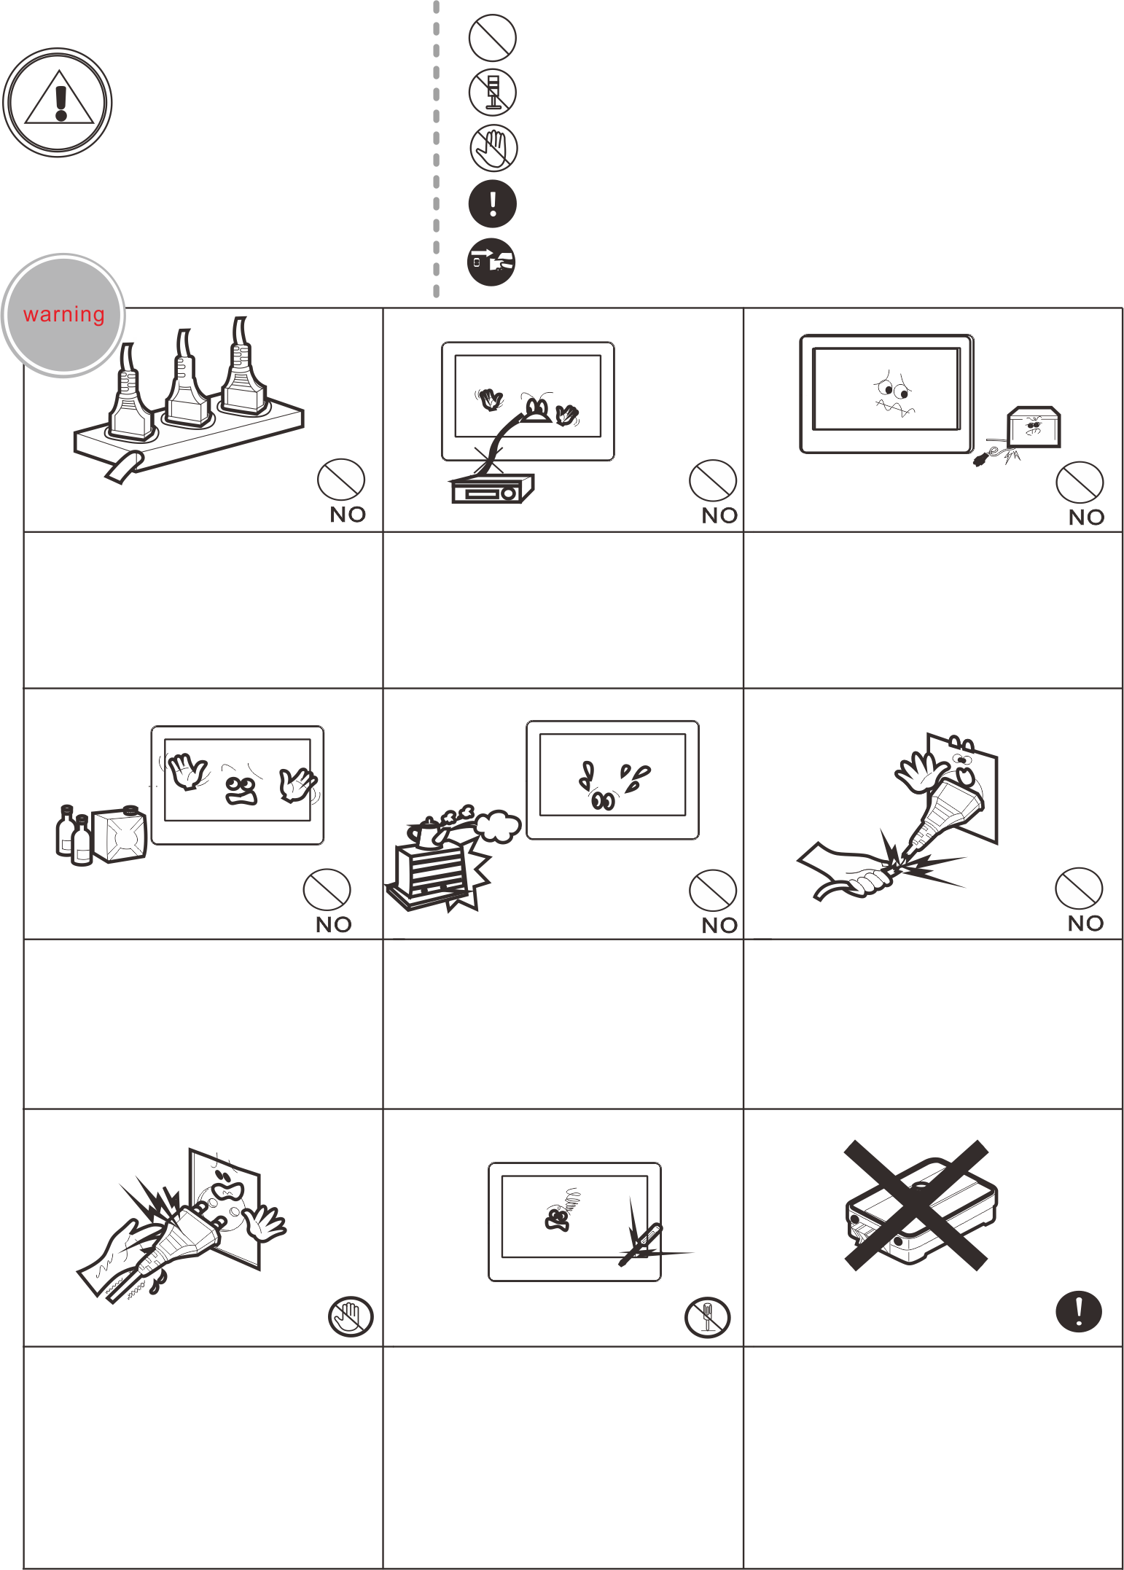
Warning
Death or serious
injury is expected. здоровью
It indicates prohibition.
It indicates disassembly.
It indicates prohibition of contact.
It indicates dos and don’ts.
It indicates that the plug should be pulled out from
the socket.
Do not put the plug in the
socket simultaneously.
It may generate abnormal
heat or cause a fire.
Do not connect to other
products while in use.
It may cause breakdown.
Do not forcibly bend the cord or put a heavy object on the product.
It may cause a fire. .
Do not use water or a detergent to clean the product surface.
Do not install the product in a humid place.
It may cause an electric
shock or a fire.
Do not forcibly pull out the cord from the socket. If the cord is damaged, it may cause a fire or an electric shock.
Do not put the plug in the
socket with a wet hand.
It may cause an electric
shock.
Do not disassemble, repair
or modify the product.
It may cause a fire, an electric shock or an injury due to malfunction of the product.
Do not use the electric lock which is over the lock specification in the door station user manual.

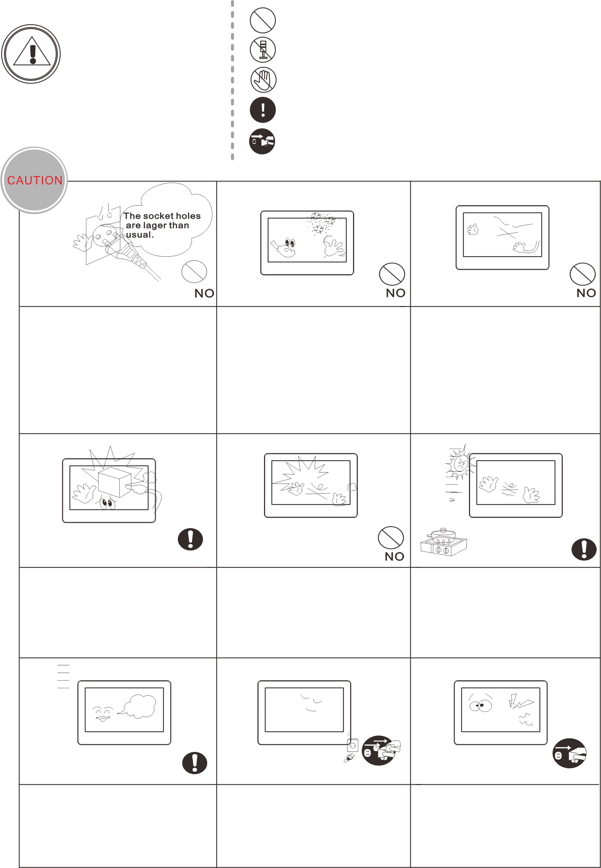
Warning
Death or serious
injury is expected. здоровью
It indicates prohibition.
It indicates disassembly.
It indicates prohibition of contact.
It indicates dos and don’ts.
It indicates that the plug should be pulled out from
the socket.
If the socket holes are larger than normal, do not put the plug.
It may cause an electric shock or a fire.
Make sure that dust or
foreign substances are not gathered on the product.
Make sure to prevent foreign substances from entering the product.
It may cause a breakdown.
Do not put a heavy object on the product.
It may cause a breakdown.
Do not disassemble the
product.
Avoid direct rays of the sun
or heating devices at a time
of installation.
Install the product in a flat and stable place.
Otherwise, it may not function properly.
Pull the plug if the product is
not used for a long time.
If the product generates
strange sound, make sure to
pull the plug immediately
and contact service center.

Name and Function of Each Part
2.1 Front View

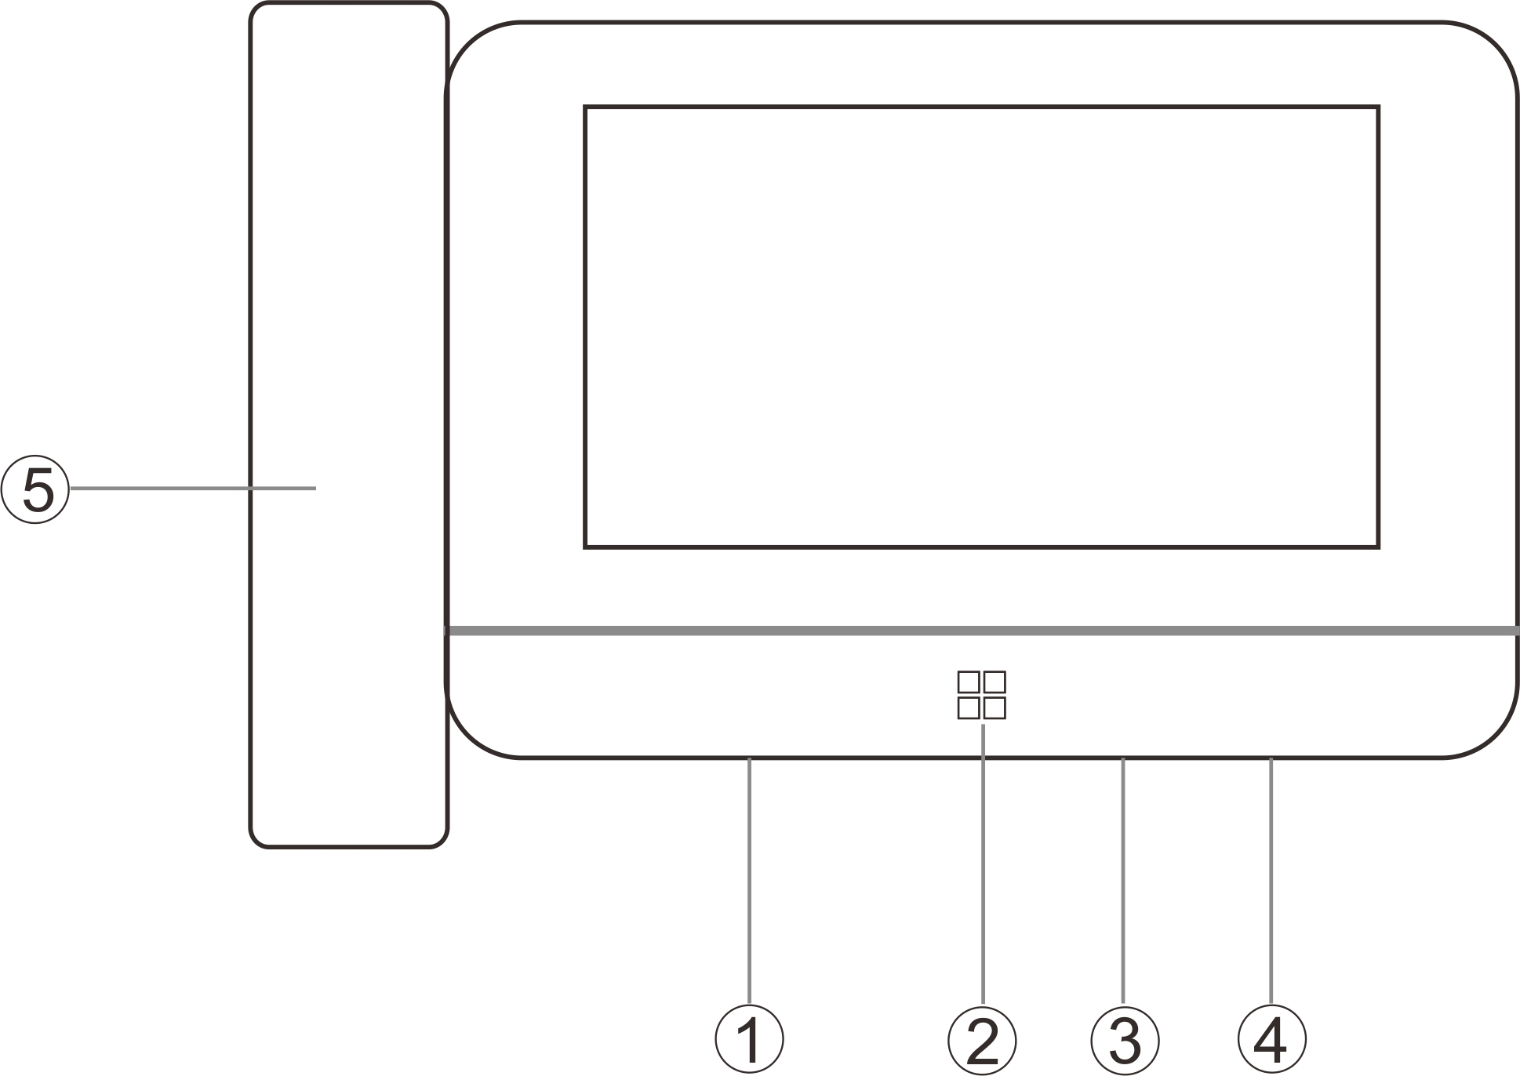
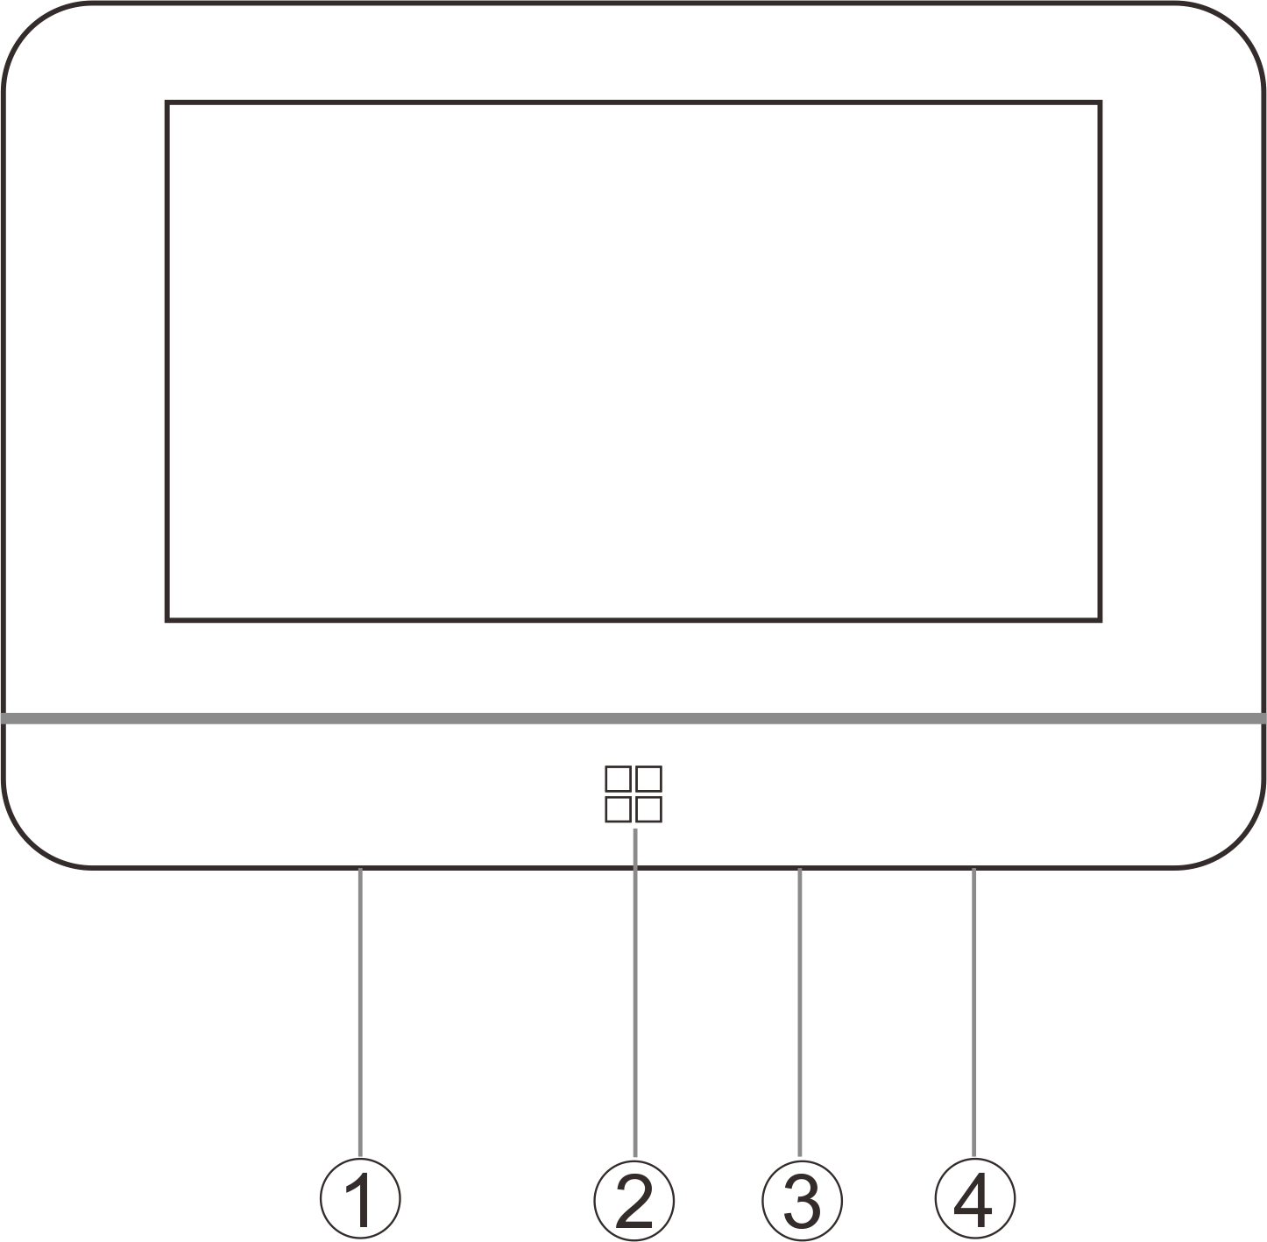
NO. | Name | Description
1 | Microphone
2 | Home Key | Enter system main menu
3 | TF Card Slot
4 | Power switch | Power on/off the monitor
5 | Handset

2.2 Terminal Description

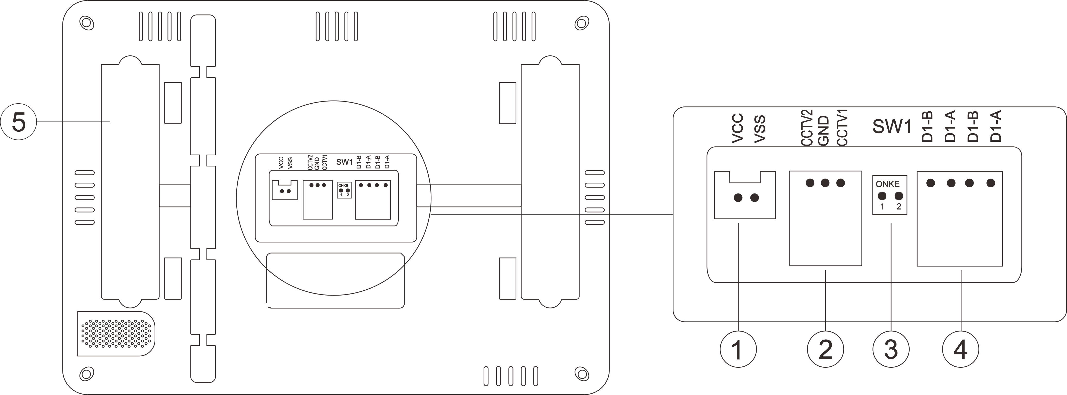

- Power Port(DC 15-24V 1A Max)
- CCTV Port(1 GND for both CCTV channels, this function needs to add extra CCTV module inside the monitor)
- SW1 DIP Switch
- 2-Wire BUS Connection Port
- Replaceable plastic cover(The distributors/installers can add a camera module by replacing this plastic cover.

Remark:
It’s OK to supply power from 2 wire BUS or an external adapter, but the system can not work if both power connected at the same time.

Feature and Main Function
◆ Hands-free video intercom
◆ Digital signal transmission
◆ Friendly user interface with full touch screen
◆ Easy installation as same as normal/traditional 2 wire analog system
◆ 256 photos and 36 videos taking with built-in memory
◆ H. 264 coding and decoding technology provides high quality photo and video
◆ DVR with face detection, motion detection & dynamic frame rate recording
◆ EPTZ: Lossless video quality with Zoom in and Move
◆ Intercom between the monitors
◆ Monitor and door station names can be edited by user
◆ Support 2 CCTV cameras(optional)

Packing List

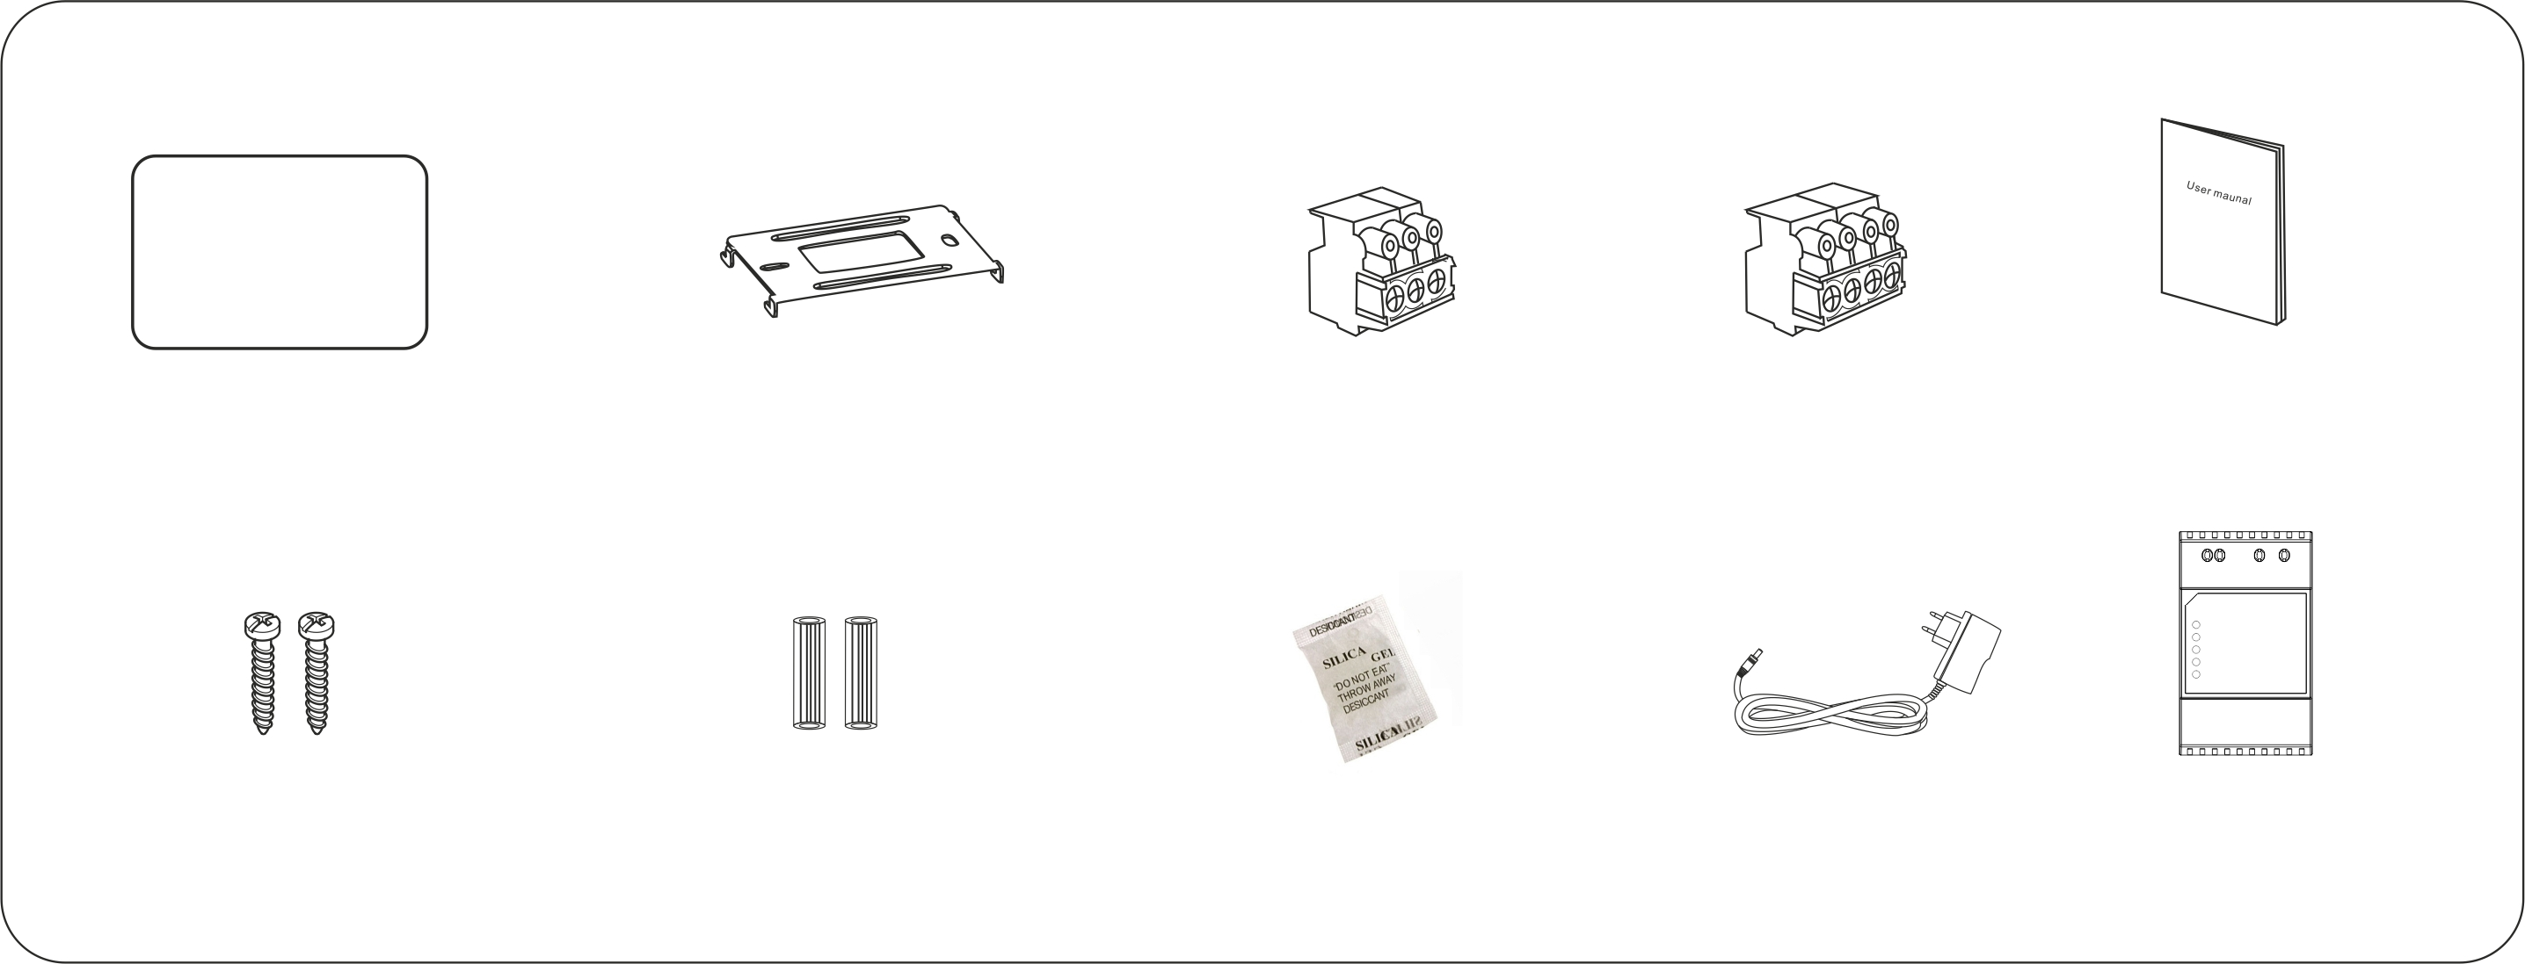
Monitor
User manual
Wall bracket
4P Terminal block

Din Rail Power
(Optional)
Adapter
(Optional)
3P Terminal block
(Optional)
Desiccant
2pcs M3*20mm
screws
2pcs Expansion
columns

5. Wiring Diagram
5.1 Power Supply from Adapter

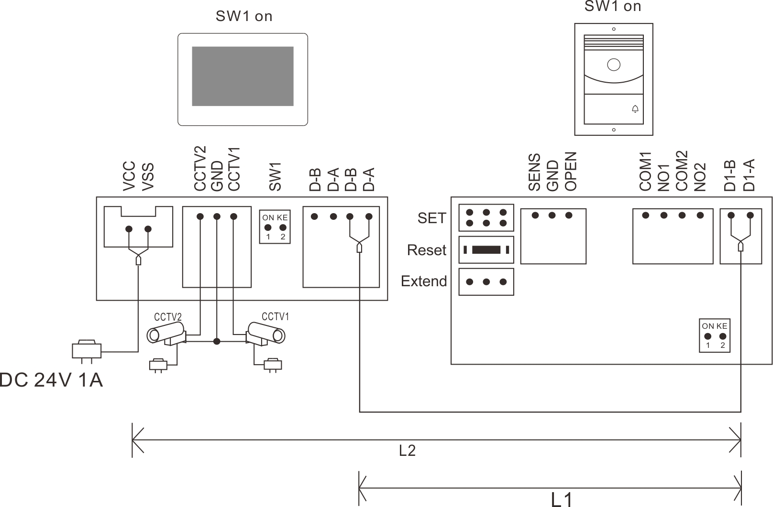

5.2 Power Supply from BUS
5.21 Wiring of One Monitor Connection

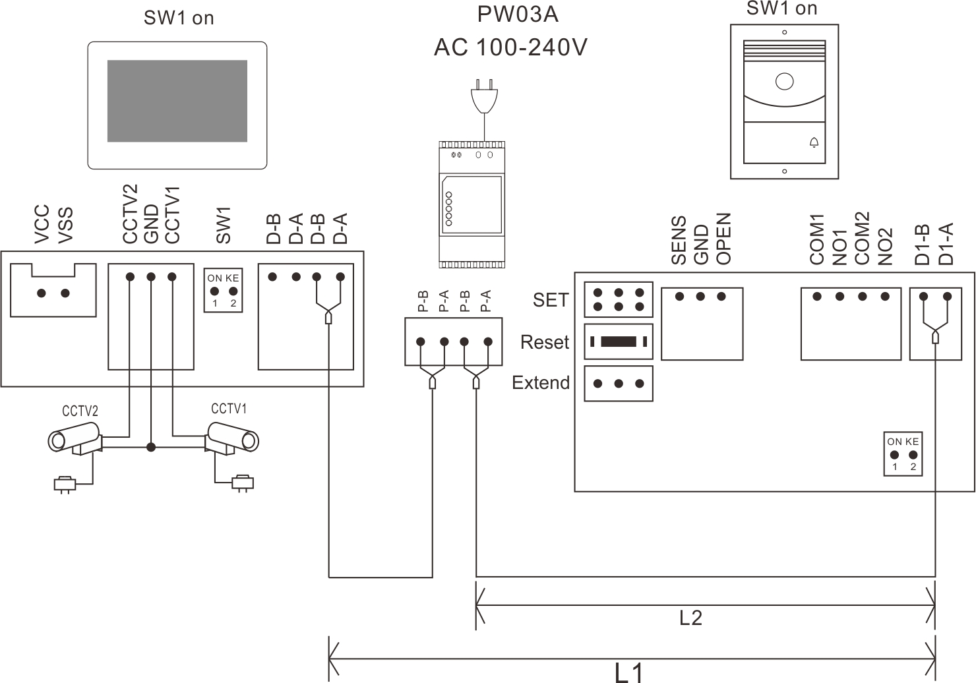

5.22 Wiring of Two Monitors Connection

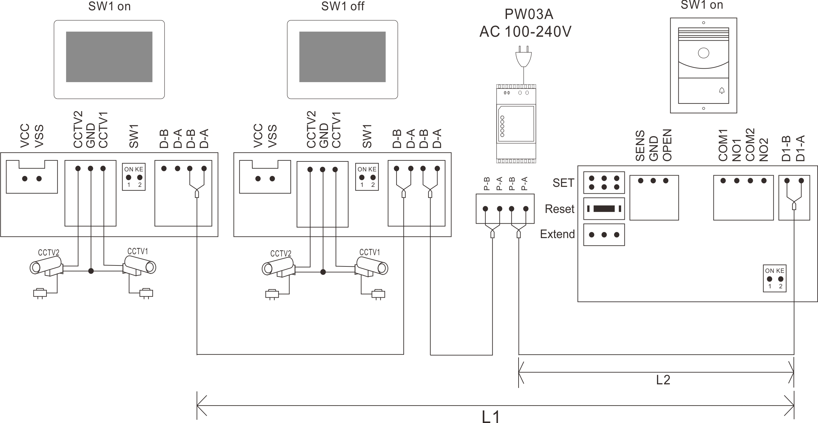

Remark:
- You need to make right terminal match setting for 2-wire BUS.
Setting Guide: The last monitor on 2-wire BUS should set SW1 to be ON as below picture 1. The other monitors should set SW1 to be OFF as below picture 2.
Picture ①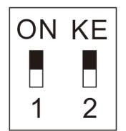 Picture ②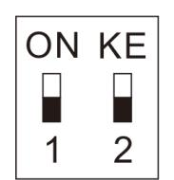
SW1 ON SW1 OFF

Remark: SW1 DIP Switch is ON by default.
- For the wire and distance limit, please refer to installation.
- The AHD cameras can only be connected for the version with a camera module.
- The monitor can only watch the CCTV which is connected to itself.
- If you want to connect more monitors or door stations, please refer to wiring diagram in the user manual of door station.

6. Installation

6.1 Installation Guide
(1) Select a right position for installing indoor monitor. The recommend installation height is 1.5-1.6 meters.
(2) Drill 2 holes according to the wall bracket structure, and insert 2 expansion columns into the holes.
(3) Fix the wall bracket with 2 screws.
(4) Connect the wires according to the system wiring diagram.
(5) Fix the monitor onto the wall bracket.
(6) Power on the monitor to check if the system works properly.

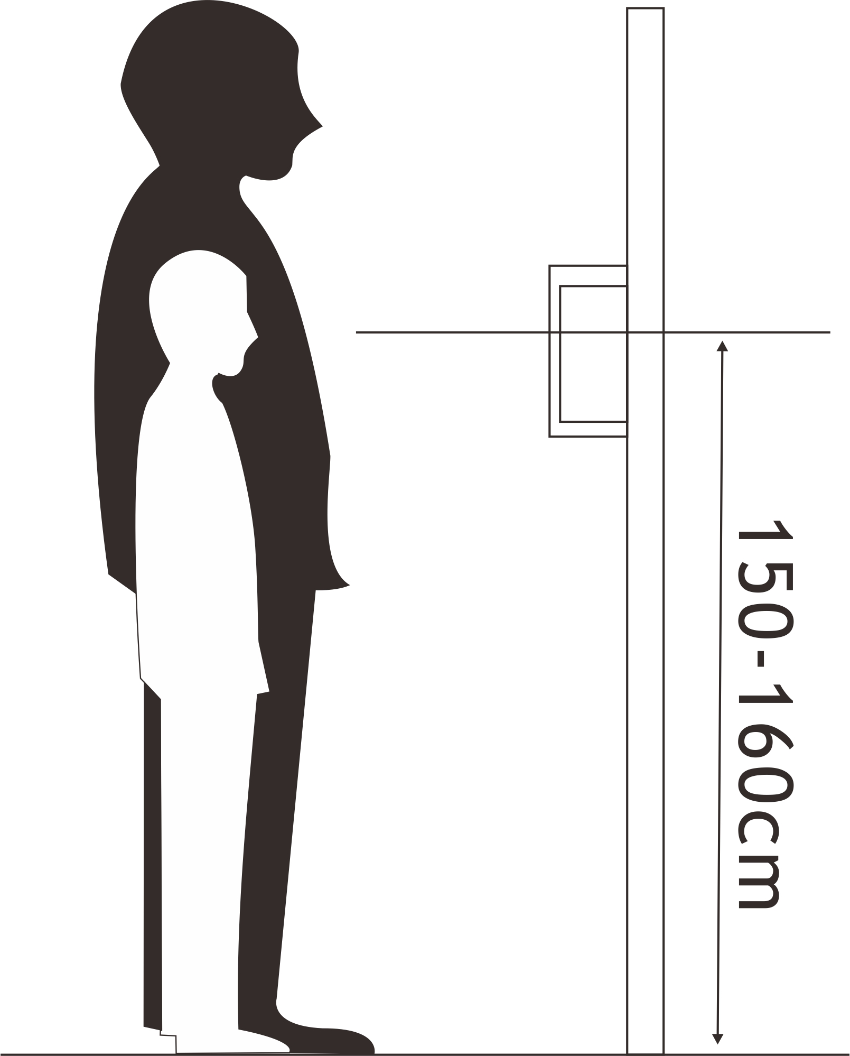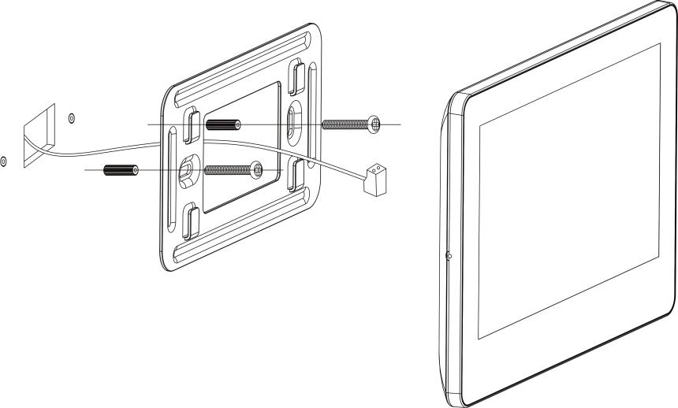

6.2 Wire Specification & Distance
The longest distance of the wiring is limited by using different cables.
No. | Cable Type | DC24V 1A Adapter |  |  | PW03A
No. | Cable Type | Intercom distance L1(m)  (MAX) | Inner power unlock distance L2 (m)  (MAX) | External power unlock distance  (m)  (MAX) | Intercom distance L1(m)  (MAX) | Inner power unlock distance L2 (m)  (MAX) | External power unlock distance  (m)  (MAX)
1 | Parallel pair cable (BVVB) 2*0.5mm²   | 125 | 125 | 10 | 125 | 125 | 10
2 | Parallel pair cable (BVVB) 2*0.75mm² | 125 | 125 | 10 | 125 | 125 | 10
3 | Twisted cable (ZC-RVS)2*0.5mm²   | 150 | 150 | 10 | 150 | 150 | 10
4 | Twisted cable (ZC-RVS) 2*0.75mm² | 150 | 150 | 10 | 150 | 150 | 10
5 | Single pair cable (Standard CAT-5)   | 150 | 100 | 10 | 150 | 100 | 10
6 | Double pair cable (Standard CAT-5)   | 200 | 150 | 10 | 200 | 150 | 10
7 | Telephone line (HBV) 2*0.2mm²   | 50 | 50 | 10 | 50 | 50 | 10
8 | Parallel pair cable 2*0.3 mm²   | 100 | 100 | 10 | 100 | 100 | 10

Remark:
- Inner power unlock distance L2 means the distance from the 1st door station to the system power supply.
- If using system power to supply power to the door lock, the maximum wiring distance must not exceed L2.
- If using additional power supply for the door lock, the maximum wiring distance is L1.
- External power unlock distance means the distance from door lock to additional lock power supply.

7. Operation Guide
7.1 Basic Operation Gesture for Touch Screen Monitor

(1) Touch: Choose/Confirm
(2) Slide Left: Return to last menu/Turn off screen
(3) Slide Up: Go to next page
(4) Slide Down: Go to last page

7.2 Call Answering
After ringing, the visitor’s image and the icon  will be showing on the screen. The below icons will be showing on the screen too.

Icon |  | 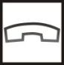 |  |  |  | 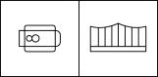 | 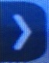&
Function | Answer | Hang up | Volume | Photo capture | Video recording | Unlock door or gate | Show or hide the icons on screen

Touch  to answer the call, and you can have a maximum 60 seconds talk with the visitor. After finishing talk, touch  to hang up.

During talk
Touch to adjust the volume.
Touch , the icon will change to , and microphone in monitor will be mute.
Touch  to take a picture.
Touch  to start or end the video recording.
Touch 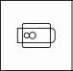 to unlock the door, touch 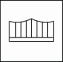 to unlock the gate.

7.3 System Main Menu
Touch home key 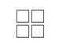 at any time can enter system main menu as below.
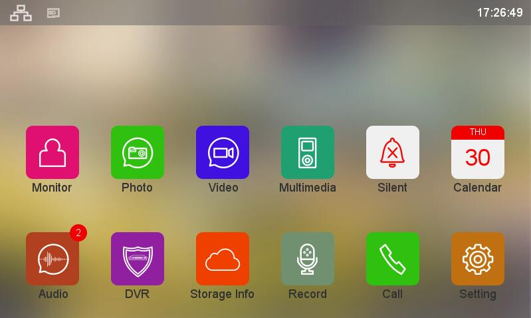

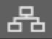 This icon means the communication is good.
 This icon means no communication. Before the 1st time communication, or if there is problem in communication, this remark will be showing on the screen. Once there’s communication in the system, the remark “?” will disappear.
 This icon means a micro SD card is detected in good condition.
 This icon means no micro SD card is detected.
 This icon means the inserted micro SD card needs to be formatted.

7.4 Intercom Function
If you install more than one monitor in one family, touch CALL button on Main Menu to enter Dial Menu, you can do below operations:

(1) Make Internal Call to Anther Monitor
Touch DIAL icon  on Dial Menu to enter a DIAL interface, input the target room address, then touch to make a call.
Remark:
If you install a multi buttons door station, the monitor can call to the monitor in another flat too.

(2) Make Broadcast to Other Monitors
Touch BROADCAST icon  on Dial Menu to enter BROADCAST interface. All monitors with same ROOM ADDRESS will be showing on the screen. You can select any room or ALL ROOMS to make broadcasting.

Remark: When make broadcasting, the listeners can't talk to the broadcaster.

(3) Call History
Touch RECENT icon  on Dial Menu to enter call history interface. Touch any call history can recall it.

(4) Call Favorites
Touch and hold on any call history, then icon 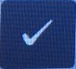 will be showing on the screen, touch it to add the monitor to Favorites. Touch FAVORITES icon  on Dial Menu to enter FAVORITES interface. Touch any room number or room name on FAVORITES interface can make a call.

7.5 Add a Door Station to Monitoring Devices List
Touch MONITOR icon 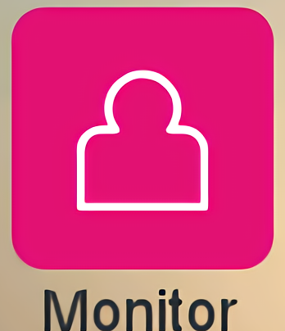 on Main Menu to enter "MONITORING" interface. Touch ADD DEVICE icon 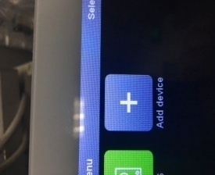, all door stations in the system will be showing on the screen, touch the target door station can add it to MONITORING DEVICES LIST, and the door station icon and name will be showing on "MONITORING" interface, touch it can monitor the door station.
Touch and hold on a door station icon on "MONITORING" interface, icon 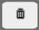 will be showing on the screen, touch it can delete the door station from MONITORING DEVICES LIST.

7.6 Add CCTV to Monitoring Devices List
Touch HOME KEY to enter MAIN MENU, touch SETTING icon  to enter SETTINGS interface, touch DEVICE CONFIGURATION, then input password to enter DEVICE CONFIGURATION interface. Touch CCTV CONFIGURATION to enter CCTV CONFIGURATION interface, touch icon 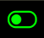 to enable the needed CCTV. After enable the CCTV state, it will be added automatically to the MONITORING DEVICES LIST.

Remark:
The setting CCTV CONFIGURATION will only be showing in the system setting for the monitor which is with camera module inside.

If you want to change the name for CCTV, touch CHANNEL 1 NAME enter CCTV name edit interface. After editing the name, touch RETURN to exit it.

7.7 EPTZ: Zoom In Function
At talking or monitoring state, touch the place you want to zoom in, the image at the touch place will zoom in with same resolution. Touch any place on screen again, the image returns to the normal.

7.8 Do Not Disturb Function
You could enable DO NOT DISTURB function if you don’t want to be disturbed by ringing.

Method 1:
Touch SILENT icon on Main Menu, the DO NOT DISTURB function will be enabled, and the icon will change to .

Method 2:
Touch SETTING icon on Main Menu to enter SETTINGS interface, then touch item SILENT to enable it. At the same time, the SILENT icon on Main Menu will change to automatically.

7.9 Photo Taking and Video Recording
Both auto-recording & manual recording are available.

- Manual recording
At talking or monitoring state, touch to take a picture. Touch , the icon turns red and starts recording, touch again to end recording, and the icon turns back to white color.

- Auto-recording
Touch SETTING icon on Main Menu to enter SETTINGS interface, then touch ACTION FOR RINGING. There are 4 options for choosing:
DO NOTHING
TAKE A PHOTO
RECORD A VIDEO
TAKE PHOTO AND RECORD A VIDEO

8.0 Photo/Video Playback and Delete
Touch PHOTO icon  on Main Menu to enter IMAGE interface, touch any image file can view it. Touch icon or can view the previous or next picture.

Touch VIDEO icon  on Main Menu to enter VIDEO interface, touch any video file to watch it. Touch Icon or can watch the previous or next video.

Touch and hold on any photo or video file, a DELETE icon will be showing on the screen, touch it to delete the photo/video file.

8.1 Audio Record/Playback/Delete
8.11 Audio Record
Touch RECORD icon on Main Menu to enter RECRD interface, touch red icon 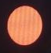 to start recording, the red round icon will be changed to green square icon 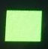, and a timer will be showing on the screen. Touch to end recording.

8.12 Audio Playback
All the audio files are listed on the right side, and there would be a MESSAGE icon behind the unchecked files. Touch the target file to play it.

Also users can check the recorded audio files from the main menu:

If there are unchecked audio messages, there would be a number on the right top corner of the AUDIO icon 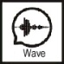 , touch AUDIO icon to enter WAVE interface, Touch the target file to play it.

8.13 Audio File Delete
Touch AUDIO icon on Main Menu, Touch EXTERNAL MEMORY or INTERNAL MEMORY, then touch and hold on an audio file, a DELETE icon will be showing on the screen, touch to delete it.

Remark:
If you want to delete all the audio/picture/video files, touch SETTING icon on Main Menu to enter SETTINGS interface, touch DELETE, then you can choose to delete all the audio/picture/video files in external memory or internal memory.

8.2 Storage Information Checking
Touch STORAGE INFO icon 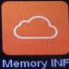 on Main Menu to enter STORAGE INFOMATION interface, and you can see the detail storage information for external memory or internal memory.

8.3 Alarm Clock Function
Touch SETTING icon on Main Menu to enter SETTINGS interface, then touch ALARM CLOCK. Alarm clock volume and 6 groups alarm clock can be set according to the users' needs. When the alarm clock is triggered, touch the red alarm clock icon to stop it. If nobody stops the alarm clock, it will alarm again in 1 minute, after that it will be stopped automatically.

8.4 DVR Function
Touch SETTING icon on Main Menu to enter SETTINGS interface, then touch DVR SETTING to enter DVR SETTINGS interface. 3 Time Frame of working time can be set. Choose one TIME FRAME, enable it, set BEGING TIME, END TIME & RECORD SOURCE NAME. The DVR will work automatically when it reaches the BEGINNG TIME.

Remark:
- DVR only records video, no audio.
- It requests at least 2G SD card to support DVR function. 16GB and 32GB SD card are recommended.
- It records with a normal speed (about 25 to 30f/s) when there’s a moving object detected. And it records with a lower speed when there’s no moving object detected (about 3f/s).
- If set the BEGINNING TIME and END TIME same, the DVR function will work all the time.

8.5 Backup Internal Memory
If you want to backup all the recorded files from the internal flash to SD card, touch SETTING icon on Main Menu to enter SETTINGS interface, touch BACKUP INTERNAL MEMORY, then touch to

confirm the backup.

8.6 Set User’s Own Ringtone
Users can not only choose the preset ring tones in the monitor, but also can set their own mp3 files as ring tone.
Operation as below:
Create a folder named eRingTone into a micro SD card, then copy mp3 files into the folder. Insert the micro SD card into monitor. Touch SETTING icon on Main Menu to enter SETTINGS interface, touch RINGTONE TYPE, then touch DOOR TRIGGER RINGTONE TYPE. Find the target mp3 file, touch it to confirm the ringtone.
8.7 Access Control Management
At standby state, read a registered card at the door station, the door will be open after a beep.
If want to open the gate lock, press and hold on the call button on the door station, the button light will be on, read a registered card within 3 seconds, the gate lock will be open.
If read a unregistered card at the door station, there will be 2 beeps to remind you that it’s invalid card.

Touch SETTING icon on Main Menu to enter SETTINGS interface, then touch DEVICE CONFIGURATION, then touch DOOEBELL LIST. Touch the Door Station you want to change the settings, touch MODIFY, input password and # to enter MODIFY interface. Touch ACCESS CONTROL MANAGEMENT to do the below settings:

8.71 Access State
It’s on by default. If users do not want to use card access control function, please disable this item.

8.72 Register Access Card(125KHz ID card)
Touch it, the screen will display below message: Please show your card to the door panel...
At such state, the user can register new cards at the door station. When the user shows a new ID card to the card reading area on the door panel, the card will be registered after a beep. Same operation to add more access cards. After registered all the cards, please exit REGISTER ACCESS CARD interface.
Remark: The registered card information is save in the door station, so you can mange it at any indoor monitor which connects to the door station. If it’s a private door station, it can only be managed by its call target monitors.

8.73 Check/Manage Registered Card Information
All the registered access card information could be found in VALID REGISTERED CARD LIST. Touch any registered card to enter a sub menu, then you can edit the card information.
MAIN INDEX can be a room no. or any easily remember no. for one family.
SUB INDEX can be a series no. for registered card of one family.
If you want to pause one access card, touch MOVE TO INVID REGISTERED CARD LIST.
If you want to delete one access card, touch DELETE ACCESS CARD.
If you want to delete all registered card information, touch DELETE ALL REGISTERED CARD INFORMATION.

8.74 Backup Registered Card Information
Insert a micro SD card into the indoor monitor. Then go to ACCESS CONTROL MANAGEMENT, touch BACKUP REGISTERED CARD INFORMATION, a sub menu will appear, touch CONFIRM to start backup. When backup finished, it will go back to ACCESS CONTROL MANAGEMENT interface.

8.75 Restore Registered Card Information
Insert the micro SD card, which has registered card backup information, into the indoor monitor. Then go to ACCESS CONTROL MANAGEMENT, touch RESTORE REGISTERED CARD INDORMATION. Choose ACCESS DATE folder, a sub menu will appear, touch  to restore registered card information.

- System Settings
9.1 System Time Setting
Touch SETTING icon on Main Menu to enter SETTINGS interface, then touch SYSTEM TIME. The time format is: Year: Month: Date :Hour: Minute: Second. After setting, touch SETTINGS on the left top corner, then touch CONFIRM to save the setting.

9.2 Password Setting
9.21 The Password for System Setting and Submenu Setting
Touch SETTING icon on Main Menu to enter SETTINGS interface, then touch PASSWORD PROTECTION to choose protection mode.
There are 3 protection modes:
- No Protection: No need to input password for all settings.
- Partial Protection: Need to input password for entering some submenu setting. But no need to input password to enter SETTINGS interface.
- All Protection: Need to input password to enter SETTINGS interface and submenu setting.

Remark:
- You can set a 4 digits password after choosing protection mode (the default password is 0000).

- When input password, touch # to confirm, touch * to clear the input.

9.22 Doorbell List Password Protection
If enable any password protection mode in 9.21, you need to input password to enter MODIFY interface for doorbell list. The default password is 0, and it can be set differently as System Setting password.
Operation Guide:
Touch SETTING icon on Main Menu to enter SETTINGS interface, then touch DEVICE CONFIGURATION, input password to enter DEVICE CONFIGURATION interface. Touch DOORBELL LIST, choose a door station, then touch MODIFY, input default password 0 and touch # to enter MODIFY interface. Go to PASSWORD SETTING, you can set a new password with 1 to 8 digits.

Remark:
When input password for DOORBELL LIST, only needs to input from the first number which is not 0.

9.23 Password Reset
(1) System Password Reset
If you forget the system password, please follow below process to reset.
Restart the monitor, touch HOME KEY to enter Main Menu, then touch SETTING icon to enter SETTINGS interface. It does not need password to enter SETTINGS interface for the 1ST TIME when restart the monitor. Then touch PASSWORD PROTECTION to check and change the password if you need.

(2) Doorbell List Password Reset
If you forget the Doorbell List password for one door station, press and hold on the reset button of the door station, then reboot the door station. The password resets successfully after two beeps.

9.3 Room Address Setting
Touch SETTING icon on Main Menu to enter SETTINGS interface, then touch DEVICE CONFIGURATION. Touch ROOM ADDRESS to set it as you want.

Remark:
- The full ROOM ADDRESS is 8 digits, but when you make an internal call, you only need to input from the 1st number which is not 0.
- For the monitors which installed in one family, the ROOM ADDRESS must be set the same. When the door station calls, all the monitors will ring at the same time in this family, and you can answer from any of them.

9.4 Device Name Setting
9.41 Monitor Name setting
You can set a name for each monitor. You only need to choose the names when you make an internal call.
Touch SETTING icon on Main Menu to enter SETTINGS interface, then touch DEVICE CONFIGURATION. Touch DEVICE NAME to change the monitor name.

9.42 Door Station Name setting
Touch SETTING icon on Main Menu to enter SETTINGS interface, then touch DEVICE CONFIGURATION, then touch DOOEBELL LIST. Touch the Door Station you want to change the name, touch MODIFY, input password and # to enter MODIFY interface. Touch DEVICE NAME to set a name for the door station.

9.5 Reset Some Parameter in System
Touch SETTING icon on Main Menu to enter SETTINGS interface, then touch RESET. You can reset TALK PARAMETER, ALARM CLOCK PARAMETER, UNREAD TAGS.

- Door Station Setting
Touch SETTING icon on Main Menu to enter SETTINGS interface, then touch DEVICE CONFIGURATION, then touch DOOEBELL LIST. Touch the Door Station you want to change the settings, touch MODIFY, input password and # to enter MODIFY interface. Then you can set all parameters for the door station.
  - Device Name(Door Station Name)
Please Refer to 9.42.
  - Device NO.
The full DEVICE NO. for door station is 8 digits, you can set as you want. But if there are more than 1 door station in the system, it’s not allowed to set 2 door station with same device no.

  - Button Address(Set Calling Target)
You need to set calling target for each button of the door station. Touch BUTTON ADDRESS 1, set a ROOM ADDRESS you want to call. After setting, you can call to the monitors with this room address by press this button.
Same operation for setting the other BUTTON ADDRESSES.
Remark:
If the BUTTON ADDRESS does not set as same as the ROOM ADDRESS of the target monitor, the monitor can monitor the door station, but the door station can not call to the monitor.

  - Private Device
If enable this function, this door station can be set as a private device for one family. The private door station can only be monitored by this family, and it can only call to this family.

10.5 Monitor
If enable this function, the door station can be monitored by indoor monitors. If disable this function, the door station can not be monitored by indoor monitors.

10.6 Set the Doorbell Unlock Parameters
10.61 Monitor Unlock
If enable this function, you can unlock the door or gate at monitoring state by touching UNLOCK icon. If disable this function, you can only unlock the door or gate at talking state by touching UNLOCK icon.

10.62 Door Lock State
If you connect a door lock to the system, you need to enable this function, and set UNLOCK TIME for it. Also you need to set UNLOCK SIGNAL TYPE(NORMAL OPEN or NORMAL CLOSE) according to door lock type.

10.63 Gate Lock State
If you connect a gate lock to the system, you need to enable this function, and set UNLOCK TIME for it, also you need to set UNLOCK SIGNAL TYPE(NORMAL OPEN or NORMAL CLOSE) according to gate lock type.

10.64 Exit Button Control Type
Set exit button control target, it can be gate or door according to the actual installation. Press the exit button can open the door/gate.

10.65 Associated Unlocking Device
The associated unlocking device information will only display after the unlock devices are connected into the system.

10.7 Elevator control state
It can disable/enable elevator control function.
10.8 Set Doorbell Security Parameters
10.81 Tamper State
The tamper in the door station will be active after enable this function, and it will alarm when someone tries to disassemble the door station. Also you need to set TARGET ROOM NUMBER FOR HANDLING ALARMS.

10.82 Check Door State
If enable this function, the system will check the door state after longest door open time. Set MAGNETIC CONTACT NODE TYPE to NORMAL OPEN or NORMAL CLOSE according to actual needs. Set LONGEST DOOR OPEN TIME. Once the door is open, the door station will detect the door state after it reaches longest door open time. If the door is not closed after the longest door open time, the door station will alarm with beeps sound.

10.9 Set the Doorbell Speaker Volume
You can set 10% to 100% volume according to actual needs.

11.0 Adjust the Viewing Angle
You can adjust the viewing angle for the door station. Touch ADJUST THE VIEWING ANGLE to start monitoring. Touch the place you want to focus on the screen. Then touch hang up icon to exit the monitoring. Finally, touch the return icon on the top left corner or slide left on the screen, touch CONFIRM to finish the setting. After that, the screen will be only showing the focused place when be called by the door station.

11.1 Set the Doorbell Configuration Password
The password can be maximum 8 digits. You only need to input from the first digit which is not 0.

11.2 Setup Mode
It’s on by default. At this state, the ROOM ADDRESS and FLOOR POSITION of the monitors in the network can be set freely. If disable it for all the door stations in the network, the addresses of the monitors in the network can not be changed.
So if you do not want users to change the monitors address by mistake, please disable this function for all door stations after installation.

12. System setting

No. | Setting item | Item | Introductions
1 | Sounds settings | Silent | Off by default. If enable it, the monitor will not ring when be called.
1 | Sounds settings | Ringtone type | Repeat ringtone：If disable it, the monitor rings only once when be called.
1 | Sounds settings | Ringtone type | Door trigger ringtone type: Set the ringtone for the door station call. 8 tones are optional.
1 | Sounds settings | Ringtone type | Intercom ringtone type: Set the ringtone for internal call. 8 tones are optional.
1 | Sounds settings | Ring time | Duration time of ringing: 10S~60S is optional.
1 | Sounds settings | Ring volume | Ring volume for doorbell call
1 | Sounds settings | Ring volume | Ring volume for internal call
2 | Display date and time information during standby | Displays the date and time during standby | Off by default. You need to enable this function if you want it.
3 | Action for ringing | Do nothing | No any automatic action when called by door station.
3 | Action for ringing | Take a photo | Take a picture automatically when be called by door station.
3 | Action for ringing | Record a video | Record a video automatically when be called by door station.
3 | Action for ringing | Take a photo and record a video | Take a picture and record a video automatically when be called by door station.
4 | Brightness | Low/Normal/High | Set the brightness for the screen.
5 | Alarm Clock | The alarm clock settings | Alarm Clock volume: 10% to 100% is optional.
5 | Alarm Clock | The alarm clock settings | Alarm Clock 1, 2, 3, 4, 5, 6.  Each alarm clock can be set separately.
5 | Alarm Clock | The alarm clock settings | State: On/Off alarm function
5 | Alarm Clock | The alarm clock settings | Alarm clock type: week/month/year/Once
5 | Alarm Clock | The alarm clock settings | Date&Time: Set the alarm time. Format is: Year/Month/Day/Hour/Minute
5 | Alarm Clock | The alarm clock settings | Alarm Clock ringtone type: 8 tones are optional.
5 | Alarm Clock | The alarm clock settings | Repeat for week (Valid when set alarm as every week type):  Set which days the alarm clock works.
6 | DVR setting | Screen savers time | Never/1/2/5/10/30 Minutes are optional.
6 | DVR setting | Time section 1/2/3 | DVR function：On/Off DVR function
6 | DVR setting | Time section 1/2/3 | Begin time
6 | DVR setting | Time section 1/2/3 | End time
6 | DVR setting | Time section 1/2/3 | Record source name: Choose the record device.
7 | Password Protection | Protection Mode | No protection: No password is required to enter the Settings menu and its sub menu.
7 | Password Protection | Protection Mode | Partial protection: Need to input password when you enter a password-protected submenu in the Settings menu.
7 | Password Protection | Protection Mode | All protection: Need to input password when enter both the Settings menu and password-protected sub menus.
7 | Password Protection | Allow reset to factory parameters from the network | If enable it, its parameters can be reset from other device in the same 2 wire BUS network.
8 | System time | Format:Year:Month:Date:  Minute:Second
9 | Device configuration | Device name | For editing the monitor name.
9 | Device configuration | Room address | Set room address(The address of the same apartment/family must be set to the same).
9 | Device configuration | Call management center | You can set the Management Center Address when enable it.
9 | Device configuration | Management center Address | Any indoor monitor can be set as a management center.
9 | Device configuration | The last digit appears as a letter | The last digit of the room address will show as a letter if enable it.
9 | Device configuration | Floor position
9 | Device configuration | CCTV configuration | Chanel 1 State:  Chanel 1 name:
9 | Device configuration | CCTV configuration | Chanel 2 State:  Chanel 2 name:
9 | Device configuration | Monitoring devices list | Display a list of monitoring devices.
9 | Device configuration | Private doorbell list | Display a list of private door station list.
9 | Device configuration | Add monitoring device in the monitoring interface
9 | Device configuration | Delete monitoring device in the monitoring interface
9 | Device configuration | Doorbell list | View only
9 | Device configuration | Doorbell list | Modify: for setting door station, it needs to enter the correct password to enter modify interface.
9 | Device configuration | Doorbell list | Cancel
9 | Device configuration | Doorbell list | Button index: For setting call target address of each button on the door station.
9 | Device configuration | Doorbell list | Private device: It can only call to this family or be monitored by this family if enable it.
9 | Device configuration | Doorbell list | Trigger: It only displays after enable PRIVATE DEVICE. The private door station can only make a call to this family after enable this function.
9 | Device configuration | Doorbell list | Monitor: If enable this function, the door station can be monitored by indoor monitors. If disable this function, the door station can not the monitored by indoor monitors.
9 | Device configuration | Doorbell list | Monitor unlock: If enable this function, user can unlock the door or gate by touch UNLOCK icon at monitoring state.
9 | Device configuration | Doorbell list | Unlock Time: 0.8 seconds to 30 seconds is optional.
9 | Device configuration | Doorbell list | Door Lock State: You can set door lock unlock time and unlock signal type.
9 | Device configuration | Doorbell list | Gate Lock State: You can set gate lock unlock time and unlock signal type.
9 | Device configuration | Doorbell list | Exit button control type: For choosing exit button control target: Door or Gate lock.
9 | Device configuration | Doorbell list | Access control management: it can enable/disable access control function, register cards, delete cards and set registered cards valid state.
9 | Device configuration | Doorbell list | Associated unlocking device
9 | Device configuration | Doorbell list | Tamper state: The tamper in the door station will be active after enable this function, and it will alarm when someone tries to disassemble the door station.
9 | Device configuration | Doorbell list | Check door state: If enable this function, the system will check the door state after longest door open time.
9 | Device configuration | Doorbell list | Volume: For setting the door station speaker volume.
9 | Device configuration | Doorbell list | Adjust the viewing angle: for setting the viewing angle for door station calling.
9 | Device configuration | Doorbell list | Password Setting: Set the password to enter the Doorbell list.
9 | Device configuration | Doorbell list | Setup mode: On by default. If disable this item for all the door stations, the Room Address and Floor Position of the monitors in the network will turn red, and can not be changed.
9 | Device configuration | Doorbell list | Allow reset to factory parameters from the network: Off by default. If enable it, engineering people can reset factory parameters for the door station from the network.
9 | Device configuration | Doorbell list | About the network state: It’s for the engineering people to check the network state.
9 | Device configuration | Doorbell list | About this device: check product number and program version.
9 | Device configuration | Unlock device list | The list will only display after the unlock devices are connected into the system.
10 | Language | Default English
11 | Backup Internal Memory | Backup file in internal flash.
12 | Delete | Erase audio files in internal memory
12 | Delete | Erase photos files in internal memory
12 | Delete | Erase videos in internal memory
12 | Delete | Erase all content internal memory
12 | Delete | Erase audio files in external memory
12 | Delete | Erase photos in external memory
12 | Delete | Erase videos in external memory
13 | Reset | Reset talk parameter
13 | Reset | Reset alarm clock parameter
13 | Reset | Reset unread tags in internal memory
13 | Reset | Erase unread tags in external memory
13 | Reset | Erase all content in external memory
13 | Reset | Erase all unread tags
14 | About the network state | Program Version | This item is only for the engineering people to check the network state of the system.
15 | About this device | Program Version
15 | About this device | Upgrade Program

Remark: At Calendar, standby clock or DVR interface, the device will be in screen saver state if no operation in 4 hours.

Audio record /Video/DVR function parameters

Item/Time | Record | Video | DVR | Monitoring | Talking Time | Other interface
Without TF card | About 30 seconds | About 8 seconds | NO | 5 Minutes  (The longest time) | 1 Minute  (The longest time) | 10 Minutes  (The longest time)
With TF card | About 120 seconds | About 15 seconds | The time of every DVR file is about 300 seconds when it detects the moving object. (maximum time per file) and about 48 minutes when it doesn't detect the moving object. | 5 Minutes  (The longest time) | 1 Minute  (The longest time) | 10 Minutes  (The longest time)

14. Specification
NO. | Items | Content
1 | LCD | 7 inch digital (800*480)
2 | Intercom type | Hands free
3 | Communication | Digital two wire
4 | Audio distortion | Less than 3%
5 | Frequency response | 400-3.5K
6 | Wire distance | Less than 200 meters (Refer to 6.2 for details)
7 | Audio | Digital signal(bidirectional)
8 | Video | Digital signal(Input)
9 | Button | Touch button (1 button)
10 | Internal call | Support
11 | Extension monitors | Support
12 | Power Supply | DC15-30V
13 | Power Consumption | 4W (MAX),1.5W (Standby)
14 | Working temperature | -10℃～+40℃
15 | Storage temperature | -30℃～+60℃
16 | Dimension | 208*143*22.5mm(Hands free)  250*143*22.5mm(With Handset)

SVS – Secure Video Systems
The Drive
Erith
DA*1ED

WWW.s-v-s.co.uk
info@s-v-s.co.uk
08001216097

Products are subject to change without prior notice. Svs Secure video systems is a trading name of Intercom repair LTD
Registered company number: 07648814 Vat No 140598900

