SVS-PW03D User Manual

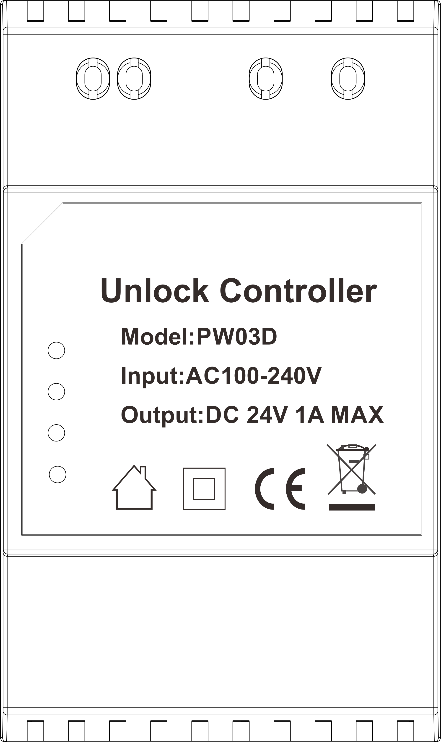

·Thank you for purchasing our products.
·Please read this User Manual carefully before using this product.
·Products are subject to change without prior notice.

Index
1 Warning and Precaution 1
2 Product Features 1
3 The Function and Name of Each Part 1
3.1 Front&Side View 1
3.2 Terminal Description Lock Port 2
3.3 SET Jumper Instruction 2
3.4 Bottom View 2
4 Packing List 3
5 Wiring Diagram 3
6 Installation 8
6.1 Surface Mounted 8
6.2 DIN Rail Mounted 8
6.3 Uninstall the power with DIN Rail Mounted way 8
7 Specifications 9

Version: V1.0
1. Warning and Precaution
● Always allow good ventilation clearances around the unit in use to prevent it from
overheating.

● Do not mount it near other heat sources.

● Check that the power cord(s), plug(s), and sockets are in good condition before installation.

● Do not connect cables with power on. Ensure proper wiring first then check to ensure no short- circuit, then power on

● Do not handle any metallic connector before the power has been disconnected, or it may cause electric shock.

● Don't repair it by yourself whenever an error occurs. Contact the supplier for any inquiry.

- Features
● Support 2 Channel unlock output, One Channel DC 12V output for electronic lock,
another Channel for Dry contact output.
● Easy installation-Support Surface mounted and Din Rial mounted.

3. The Function and Name of Each Part
3.1 Front & Side View
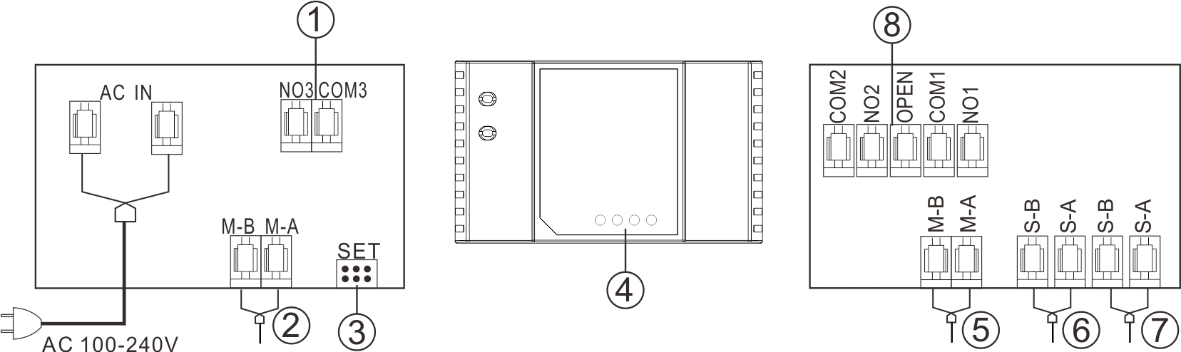
No | Functions | No | Description
 | Preserved port no function | ⑤ | Master Bus
 | Master Bus | ⑥ | Slave Bus
 | Jumper | ⑦ | Slave Bus
 | LED Indicator | ⑧ | Lock Port
Remarks：When you use electronic Lock, the distance from PW03D to lock should be like below:
0.5 mm² Cable: Maximum Distance 20 Meters
1.0 mm² Cable: Maximum Distance 50 Meters

3.2 Terminal Description Lock Port ⑧
COM1 | Exit Button
OPEN | Exit Button
COM1 | Port for electronic door lock  When Connect with electronic lock, the polarity of COM1 and NO1 will be defined as below:  COM1 is Positive, NO1 is Negative
NO1
COM2 | Port for Gate Opener
NO2 | Port for Gate Opener

3.3 SET Jumper Instruction

SET | Function
 | There will be power supply for Port
 | Terminal match setting.
 | No match setting and no supply power to Port

No | Description | No | Description
 | Plastic sliding support |  | Plastic bottom hook for DIN Rail installation
 | Screw hole |  | Password reset button
 | Plastic upper hook for DIN Rail installation |  | Plastic bottom hook for DIN Rail installation

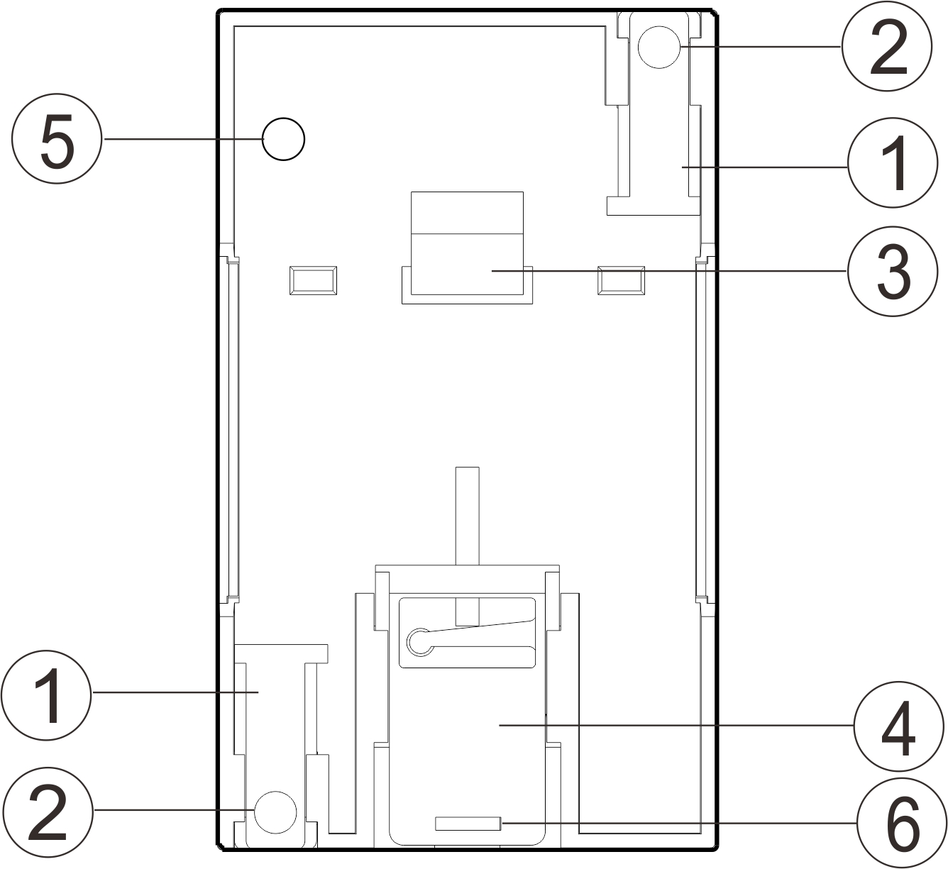
3.4 Bottom View

4 Packing List
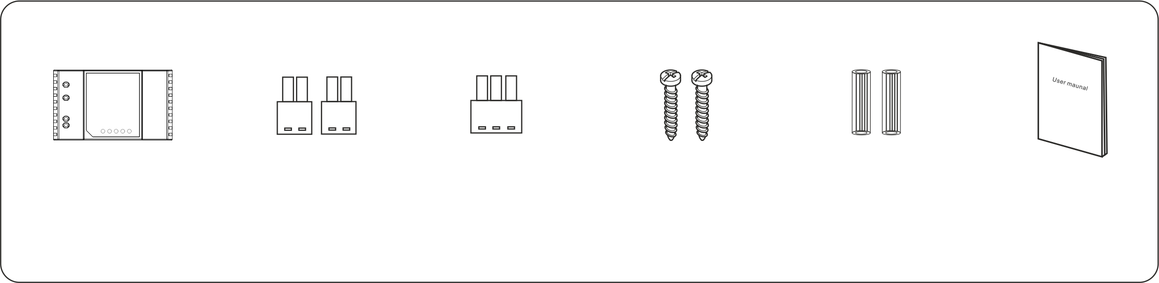
PW03D

User Manual
2*4*20
Screws
5*2P Connector
1*3P
Connector（）
Expansion columns

5 Wiring Diagram
5.11 One monitor with one outdoor panel

Exit Button
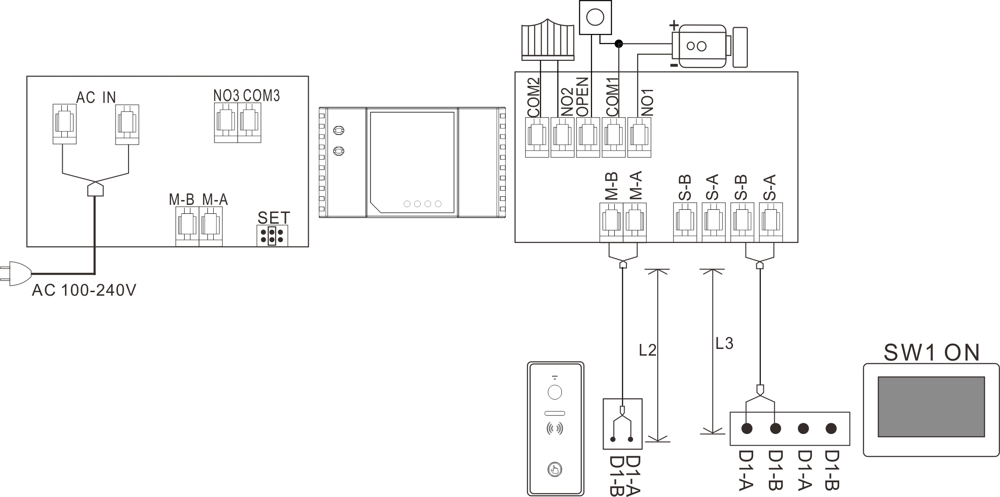
Gate Lock
Door Lock

5.12 Four monitors with one outdoor panel

Exit Button
Gate Lock
Door Lock

5.12 Four monitors with one outdoor panel
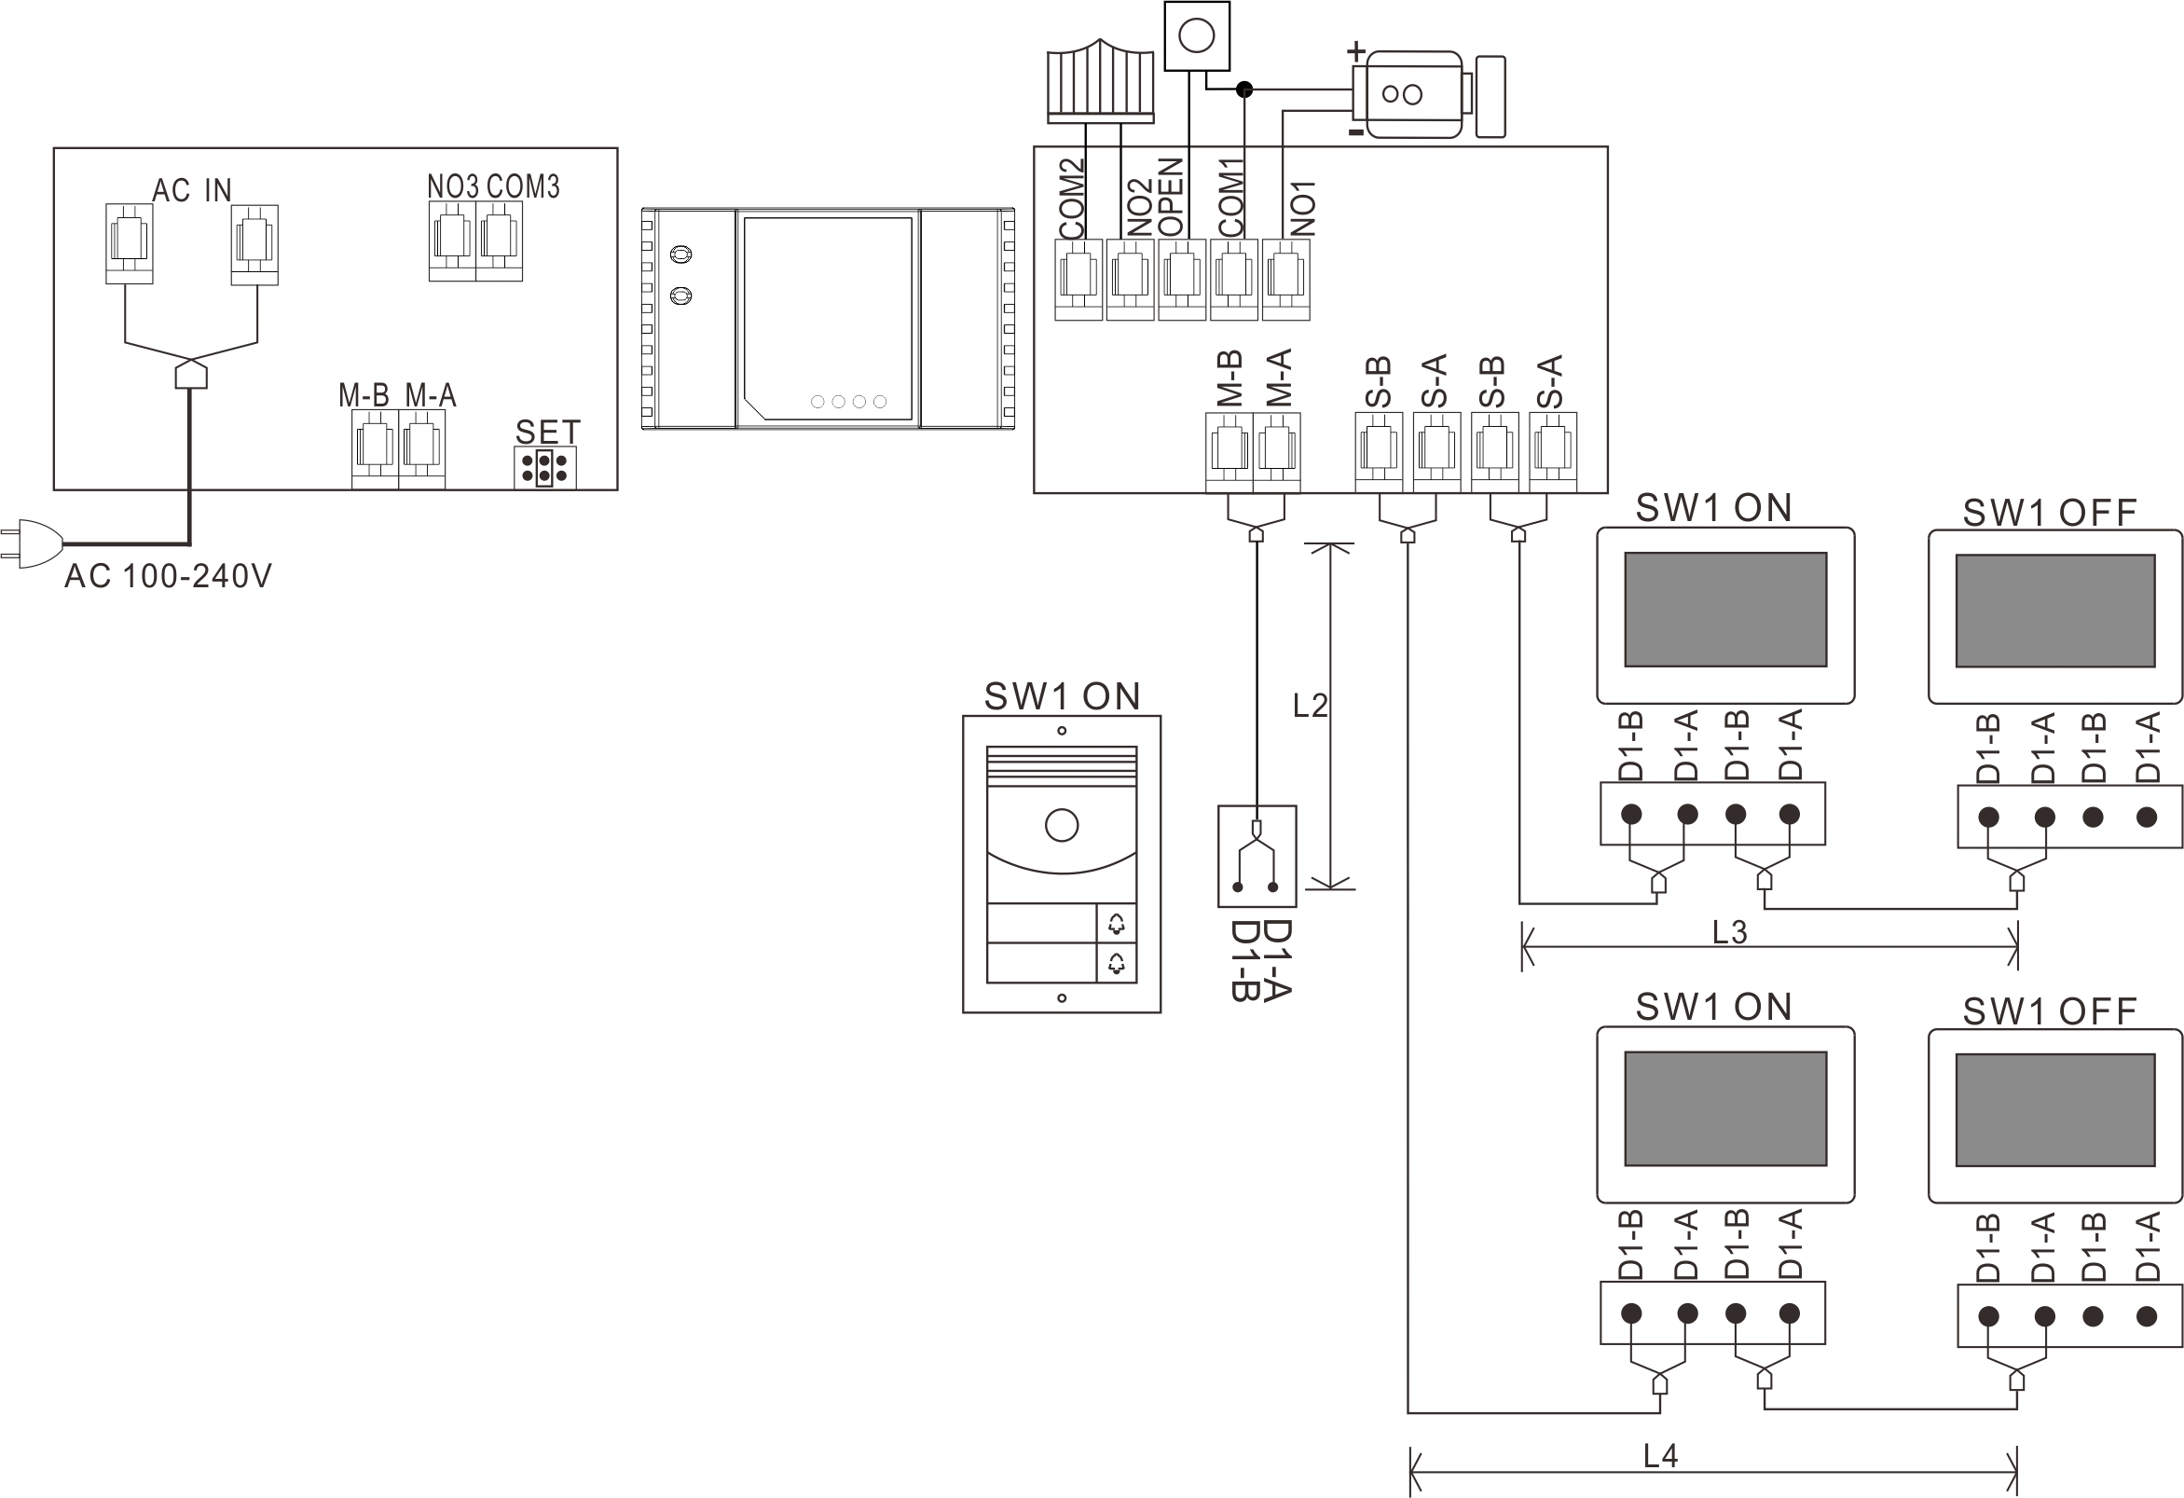

5.13 Three monitors with two outdoor panels
Exit Button
Gate Lock
Door Lock
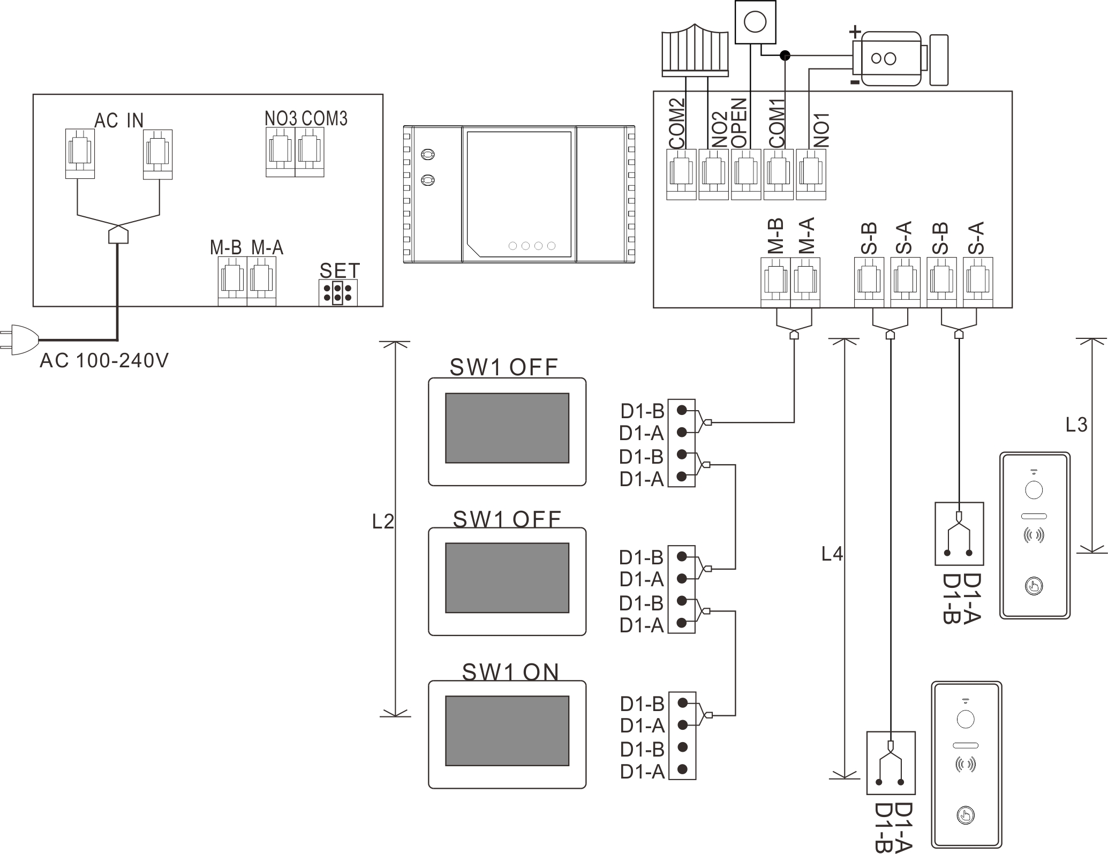

Remarks：(1) Please keep same jumper setting with above wiring diagram.
(2) The Slave BUS of and will be automatically matched with master BUS.
(3) Wiring Distance： L2≤100M，L3+L4≤100M。

(4) One PW03D could support 6 devices including indoor monitor and outdoor panel with AC Input.
(5) 0.5 mm² or above Cable is recommended

5.3 Operation Guide

（1）Binding PW03D to outdoor panel
Please follow below steps:
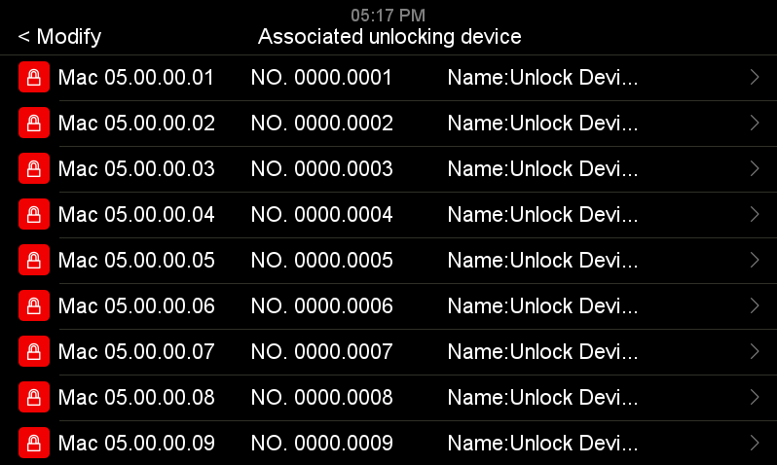
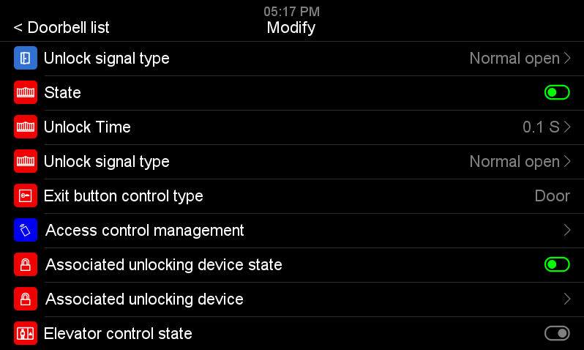
Turn on monitor → Setting → Device Configuration → Doorbell list → select the doorbell and enter → Associated unlocking device state → see all the PW03D in the system → select the PW03D which you want to bind the outdoor panel → input password to activate the bonding (default password 0000 0000)
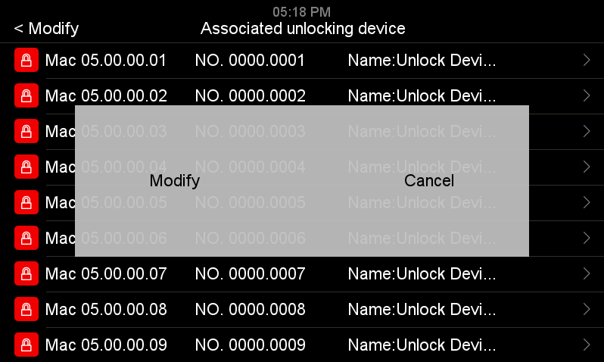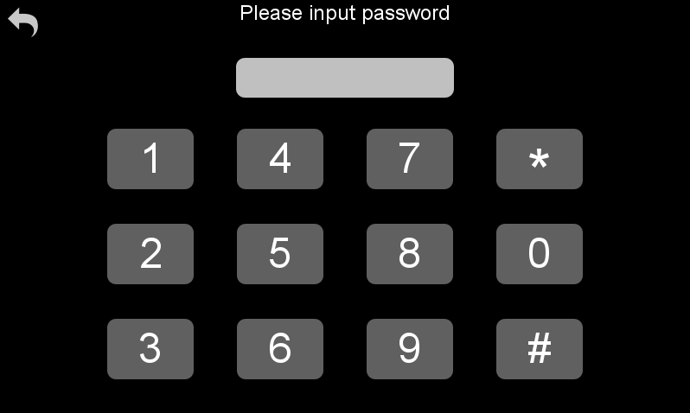

Remarks: After bonding PW03D to outdoor panel, the unlock parameters of outdoor panel will be synchronized to PW03D automatically.

（2）Modify Parameters of PW03D
Follow below route to modify the parameters of PW03D
Turn on the monitor → Setting → Device configuration →unlocking device list → select the PW03D device → input password to enter setting menu. (Default password 0000 0000).
In setting menu, The Device name/NO/password could be modified.

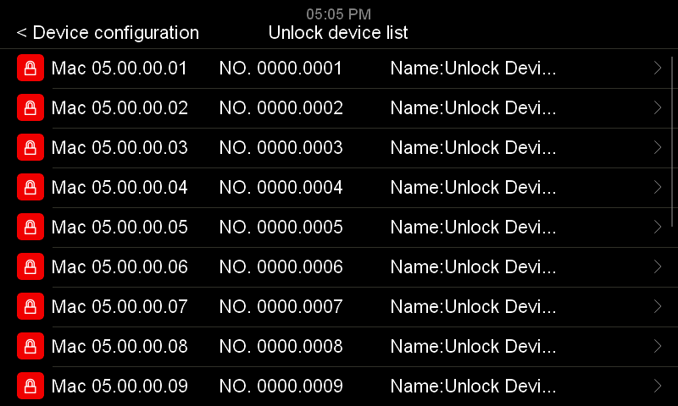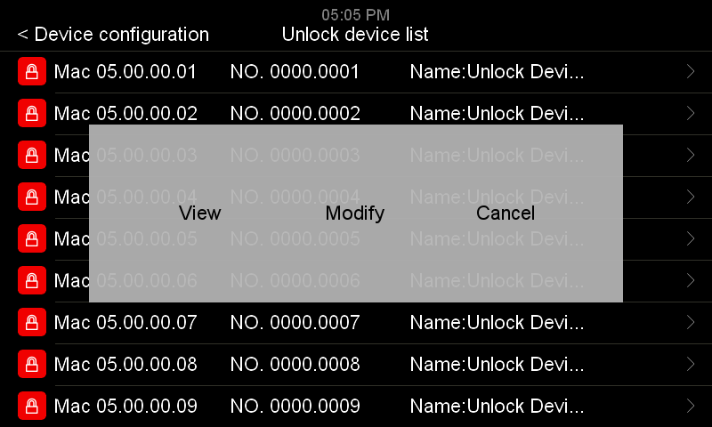
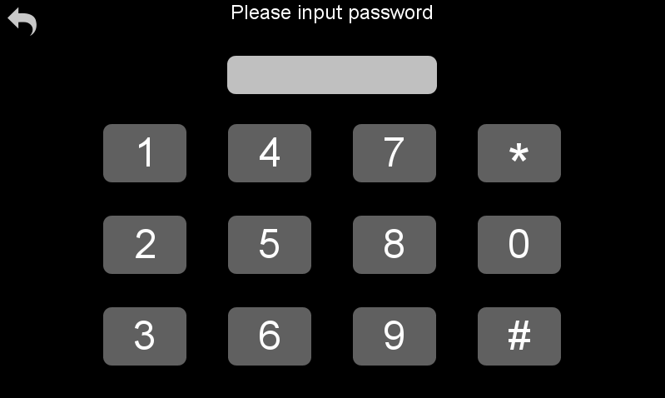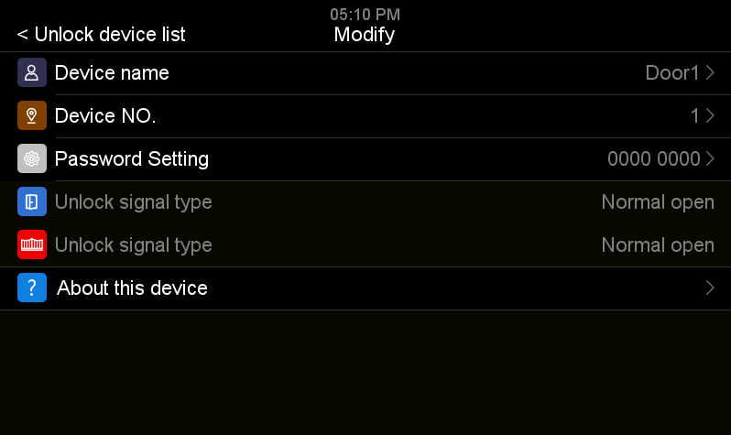
Remarks: Power on the PW03D and short press password reset button on the PW03D to recover the password to default value.

6 Installation
6.1 Surface mounted
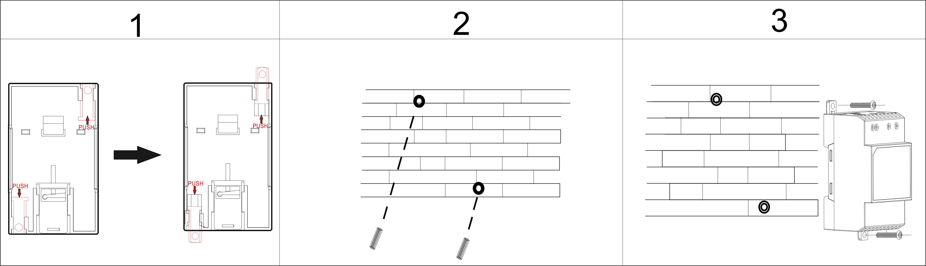
- Pull out the 2 plastic holders.
- Drill 2 holes on the wall according to the screw holes position, and put expansion columns into them.
- Fix the PW03D with 2 screws.

6.2 DIN Rail Mounted
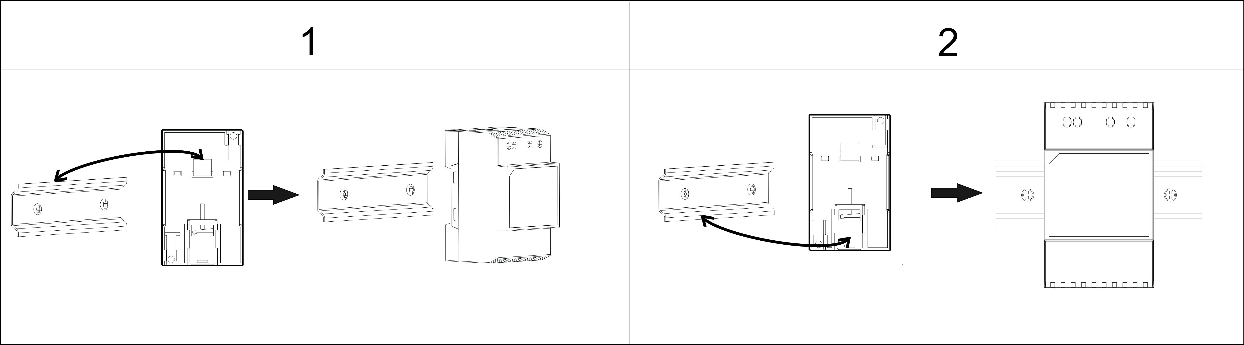
(1) Clip the plastic upper hook onto the upper side of the DIN rail.
(2) Press on the PW03D to fix it onto the rail tightly.

6.3 Remove from DIN rail
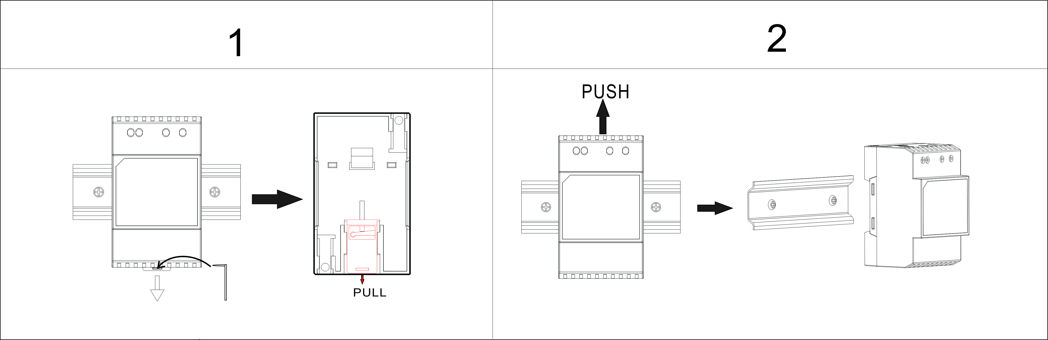
- Insert a hook into the pull hole, and pull the plastic bottom hook out.
- Push PW03B up and take it away from DIN rail.

7. Specifications
No. | Item | Content
1 | AC input | Input：AC100V-240V 50/60Hz Output：DC24V 1.0A Max
2 | DC input | DC18-30V， 4A Max（Non-polarized）
3 | Master BUS port quantity | 2（Input or Output 4A Max）
4 | Slave BUS port quantity | 2（Output 0.5A Max）
5 | Unlock power output | DC12V 0.5A Max
6 | Unlock output quantity | 1 Dry Contact（Current of Relay 0.5A/3A Max）
7 | Communication mode | 2 wire BUS
8 | Working temperature | -25℃ to +45℃
9 | Storage temperature | -30℃ to +60℃
10 | Dimension | 90*53.5*58mm（L*W*H）

SVS – Secure Video Systems
The Drive
Erith
DA*1ED

WWW.s-v-s.co.uk
info@s-v-s.co.uk
08001216097

Products are subject to change without prior notice. Svs Secure video systems is a trading name of Intercom repair LTD
Registered company number: 07648814 Vat No 140598900

