SVS-DDAP Apartment Door Station
User Manual

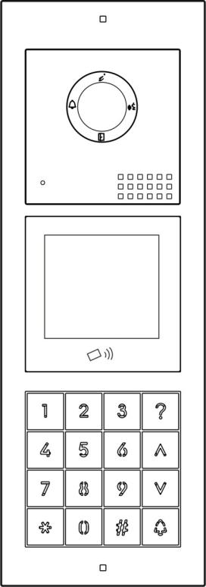
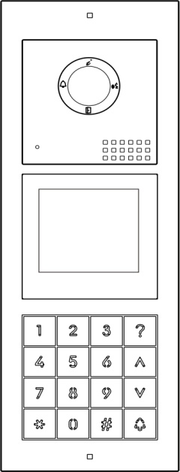

V1.0

·Thank you for purchasing our products.
·Please read this User Manual carefully before using this product.
·Products are subject to change without prior notice.

Index
1
1
1
3
4
4
4
4
6
7
7
8
8
9

10
12
13
14
15
15
15
15
16
16
17
18
18
18
- Product Features and Main Function .......................... ............................................................................
- Name and the Function of Each Part ....................................................................................................
  - Names of Each Part ...........................................................................................................................
  - Terminal Description .........................................................................................................................
3. Packing List ........................................................................................................................................
4. Wiring Diagram ..........................................................................................................................................
4.1 Electrical Lock Wiring Diagram ...............................................................................................................
4.11 Door Lock Powered by the Door Station ........................................................................................
4.12 Door Lock Powered by an External Power .....................................................................................
4.2 Wiring Diagram for BUS & Exit Button ...........................................................................................
4.3 Wiring Diagram for Wiegand Unlock & Door Status Checking ...........................................................
4.4 System Wiring Diagram...................................................... ...........................................................
4.41 System Wiring Diagram without Distributor NV20 ............................................................................
4.42 System Wiring Diagram with Distributor NV20 (Maximum support 24 monitors) .............................
4.43 System Wiring Diagram with Distributor NV20 & BUS Extender PW03B (Maximum 72
monitors) ..............................................................................................................................................
4.44 System Wiring Diagram with Villa Door Station for Each Flat (Maximum 36 monitors) ..................
4.45 System Wiring Diagram with Slave Monitor in Each Flat (Maximum 72 monitors) .........................
4.5 Cable & Distance..................................................... ......................................................................
5. Installation Guide .......................................................................................................................................
5.1 Cautions ..............................................................................................................................................
5.2 Module Connection Instruction .......................................................................................................
5.3 Surface Mounted .................................................................................................................................
5.4 Flush Mounted ...................................................................................................................................
6. Door Station Setting .................................................................................................................................
6.1 Device Name(Door Station Name) ....................................................................................................
6.2 Device NO. .................................................................................................................................
6.3 Private Device ............................................................................................................................
6.4 Monitor ........................................................................................................................................
6.5 Set the Doorbell Unlock Parameters ............................................................................................
18
1920
20
2121
212121
21
22
22
22
23
24

6.6 RFID Access Control Management...........................................................................................
6.7 Elevator Control State .................................................................................................................
6.8 Set Doorbell Security Parameters ...............................................................................................
6.9 Set the Doorbell Speaker Volume ...............................................................................................
7.0 Adjust the Viewing Angle .............................................................................................................
7.1 Set the Doorbell Configuration Password ...................................................................................
7.2 Setup Mode ................................................................................................................................
8. Operation Instruction...............................................................................................................................
8.1 Password unlock .......................................................................................................................
8.2 Unlock Password Change ...........................................................................................................
8.3 Call Management Center ..........................................................................................................
8.4 Household List ..........................................................................................................................
9. System Menu......................................................................................................................................
10. Specification .......................................................................................................................................
V1.0
1. Product Features and Main Function
● Module design, easy to customize
● Digital 2 wire technology
● Easy wiring with non-polarized 2 wire
● Support RFID with ID card module (optional)
● Support keypad unlocking with ID card module (optional)
● 1080P COMS camera
● Night vision with automatic luminance compensation
● Support 2 locks
● Surface mounted and flush mounted are optional
● IP54 & IK07
● Support connecting an exit button
● Support door status checking
● Tamper alarm

2. Name and the Function of Each Part
2.1 Names of Each Part
Flush mounted
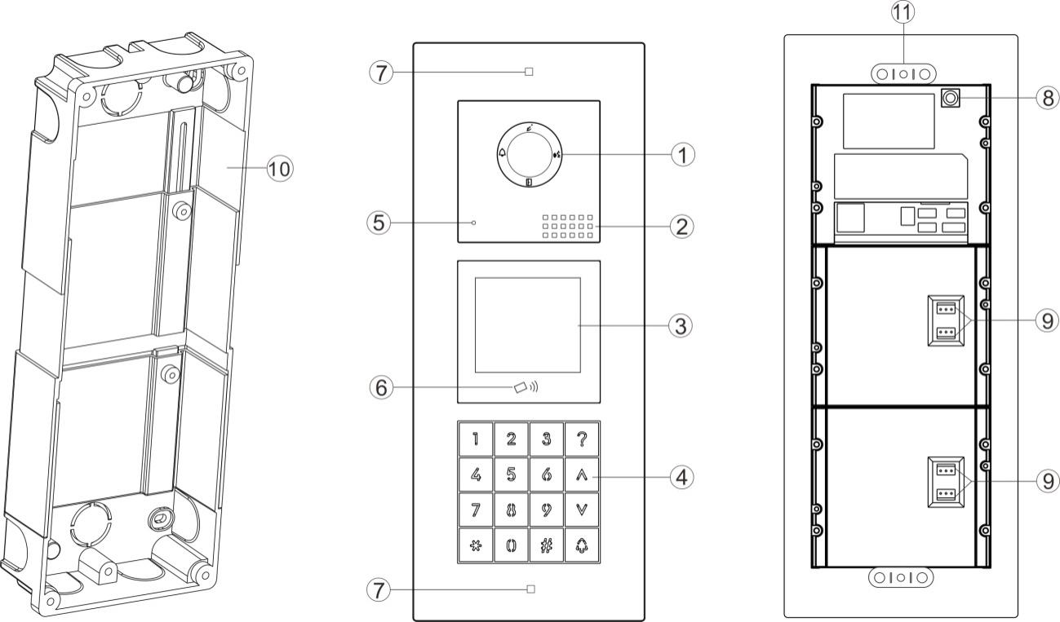

Surface mounted
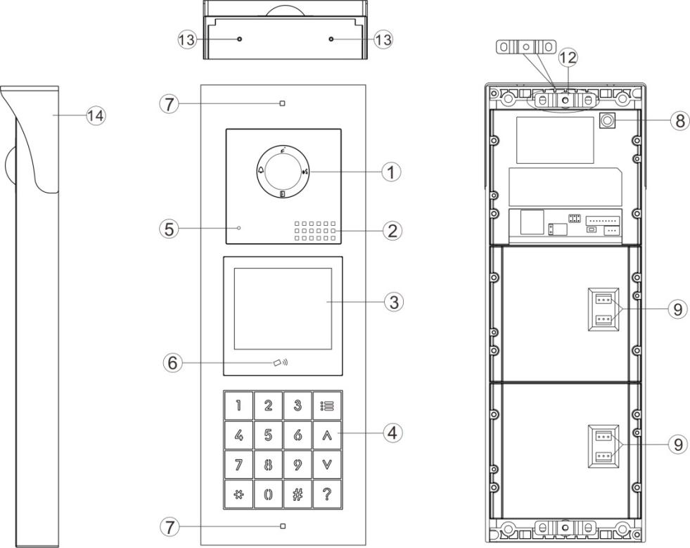
No. | Name of Parts | No. | Name of Parts
(1) | Camera | (2) | Speaker
(3) | Display | (4) | Keypad
(5) | Microphone | (6) | Card reader
(7) | Screw holes for installation | (8) | Tamper
(9) | Connection port for module | (10) | Mounting box
(11) | Screw holder | (12) | Screw holder
(13) | Screw holes for rain hood | (14) | Rain hood

Keypad Definition

Key | Definition | Key | Definition
(0-9) | Number button | () | Down button
() | Delete/Cancel/Return | (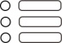) | Household list
(#) | Confirm/Enter | (？) | Help
() | Up button

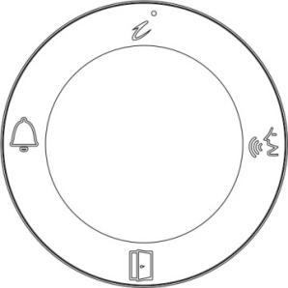
Indicator Definition
Call indicator
Unlock indicator
Talk indicator
Card register indicator

2.2 Terminal Description
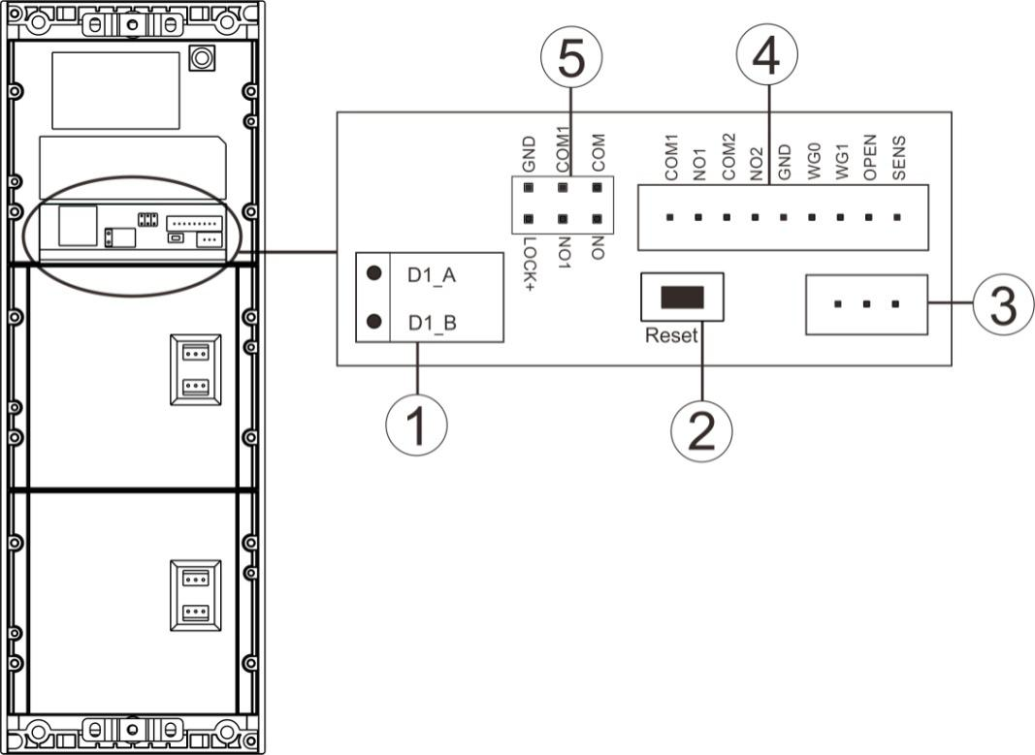

- 2-Wire BUS Port: Connect to the 2-wire BUS, non-polarized.

- Reset button
Reset door station password：
Reboot the door station, then press and hold on the reset button within 1 minute.The password resets successfully after two beeps.

Reset button number sequence:
Press and hold on the reset button, then reboot the door station to define the button sequence after 2 beeps. Release the reset button, the backlit on all the call buttons will be off. Press the 1st call button, its backlit will be on, and the button number is set as 1. Press the 2nd call button, its backlit will be on, and the button number is set as 2. The same operation for all the rest call buttons. After that, press reset button again, the door station will do self-checking, and the backlit of each button will turn on one by one, then off, new button sequence will be saved.

- Module connection port: For connecting other modules.

PIN | For connecting | PIN | For connecting
COM1 | Door lock | OPEN | Exit button
NO1 |  | GND
COM2 | Gate lock | SENS | Door status checking device
NO2 |  | GND
WG0 | Wiegand unlocking
WG1
GND
- Connection port

- Jumpers: For setting the power supply mode of door lock.
Picture 1: when door station supplies power for door lock.
Picture 2: Jumper setting when there’s an external power supply for door lock.
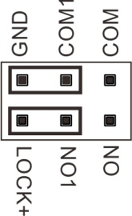
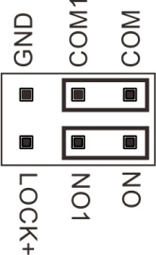

Picture 1 Picture 2

- Packing List
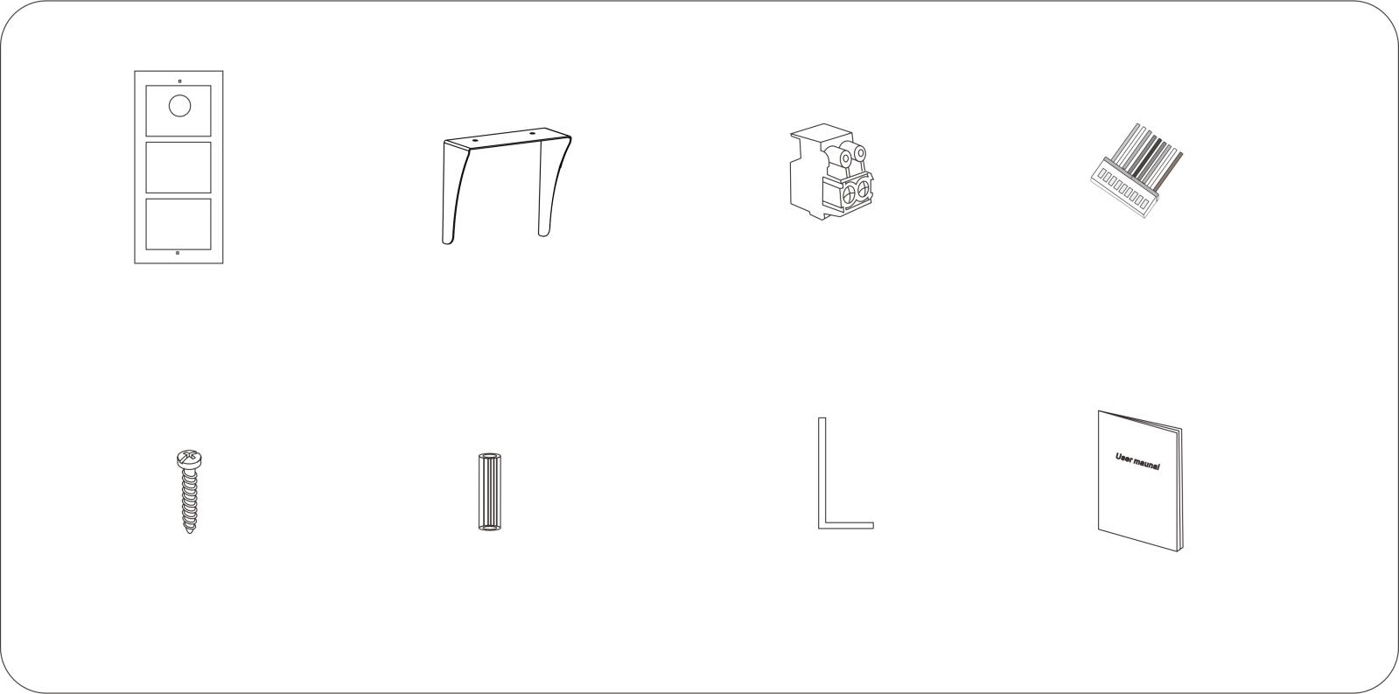
User manual
Allen wrench
4pcs 3.5*30mm
Screws

4pcs Expansion
columns

9P connection wire
Terminal block

Door station
Rain hood(Optional)

4. Wiring Diagram
4.1 Electrical Lock Wiring Diagram
4.11 Door Lock Powered by the Door Station
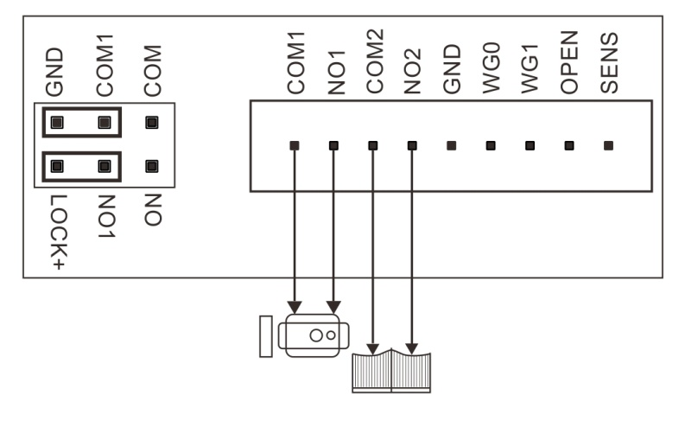
Door Lock

Gate lock

Jumper setting

(1) Support Door Lock "ype:
A: NC (normal close) lock, power off to unlock. Support lock of DC12V 0.35A (Max).
B: NO (normal open) lock, power on to unlock. Support lock of DC12V ≤2A (instantaneous),
DC12V ≤0.35A (Continuous current).
(2) Support Gate Lock Type (It gives a relay signal for unlocking.):
A: AC Lock: Support lock of AC125V, current≤1A
B: DC Lock: Support lock ≤DC30V, current ≤4A
(3) Jumper Setting: As the above picture.
(4) Lock Type and Unlock Time Setting:
It can be set in any indoor monitor which is installed in the system.
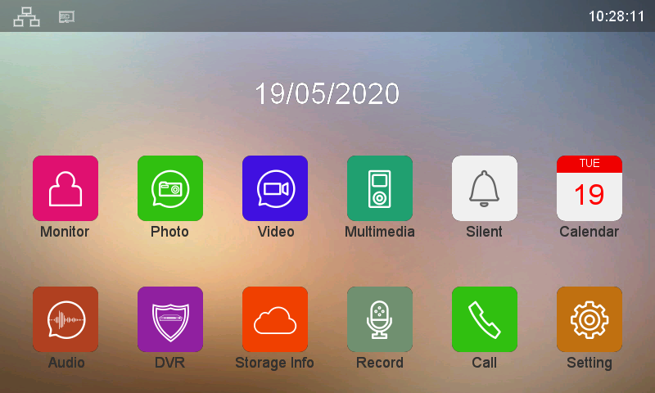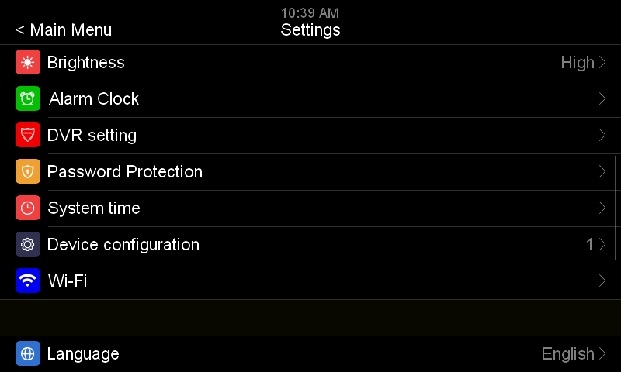
Touch SETTING icon on the Main Menu.

Touch DEVICE CONFIGUARATION.

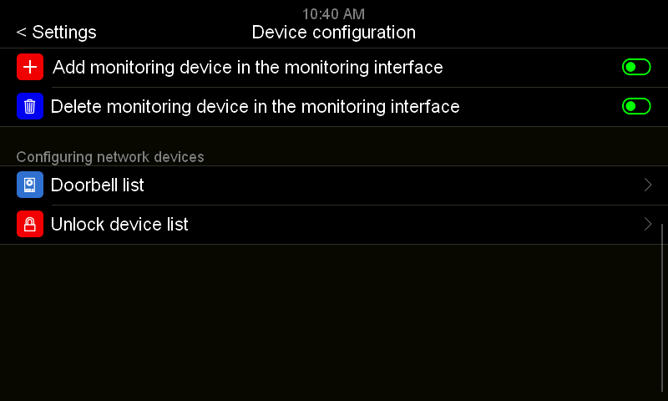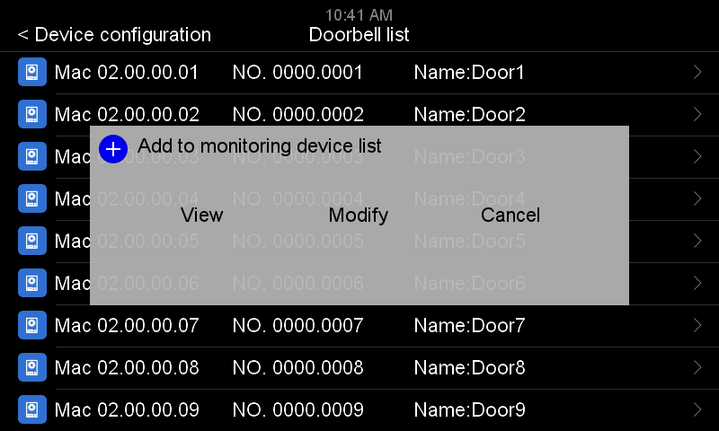
Touch the door station which you want to set, touch MODIFY..

Touch DOORBELL LIST.

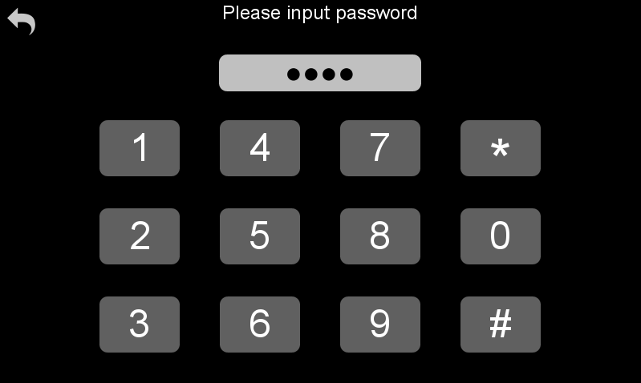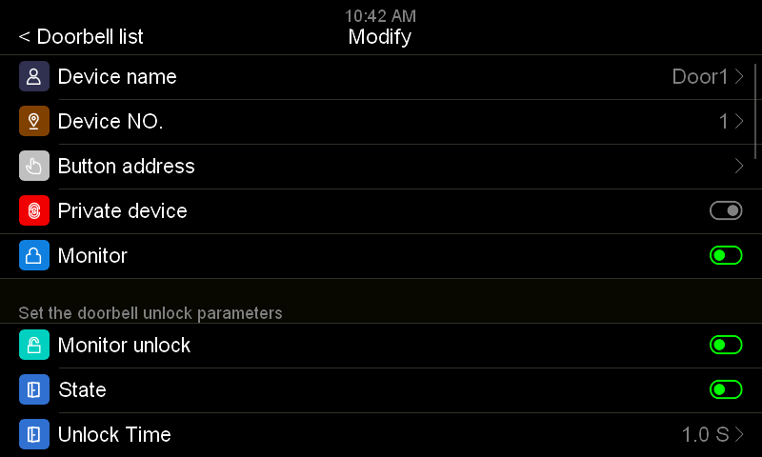
Input password, then touch ＃. The default password is 0000.
Enable DOOR LOCK STATE.

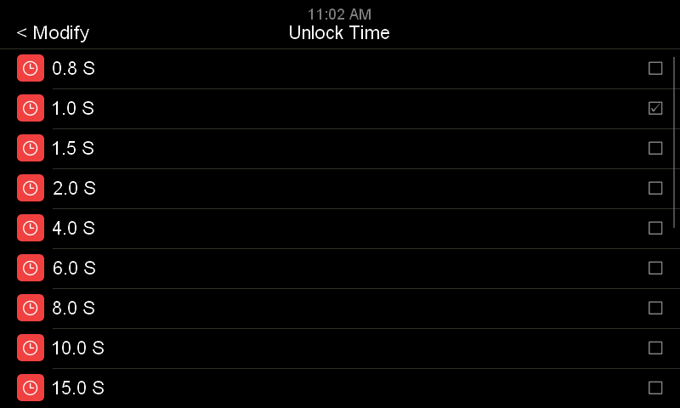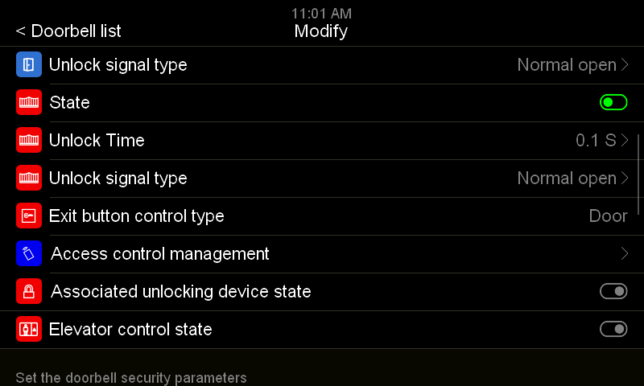
Touch UNLOCK SIGNAL TYPE to NORMAL OPEN or NORMAL CLOSE according to door lock type.

Touch UNLOCK TIME to set it according to the real needs. Touch MODIFY to exit UNLOCK TIME setting

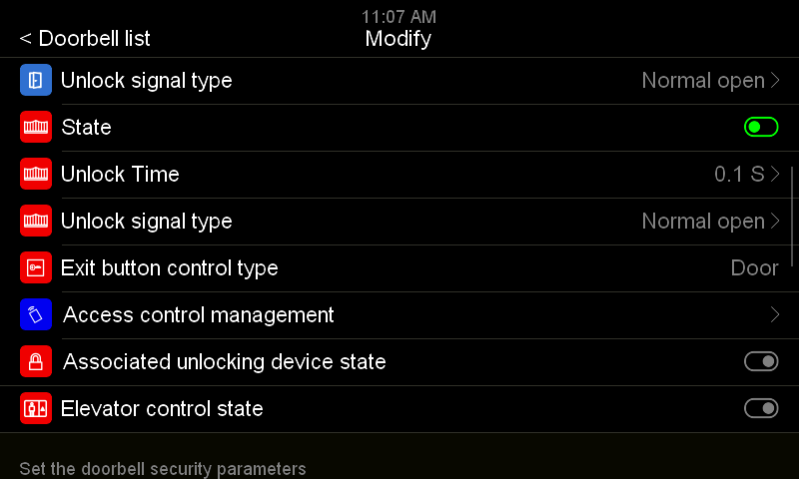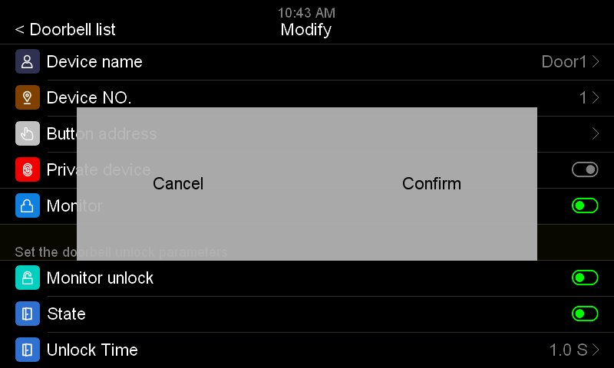
Touch CONFIRM to save the setting.
Touch DOORBELL LIST to exit setting.

4.12 Door Lock Powered by an External Power

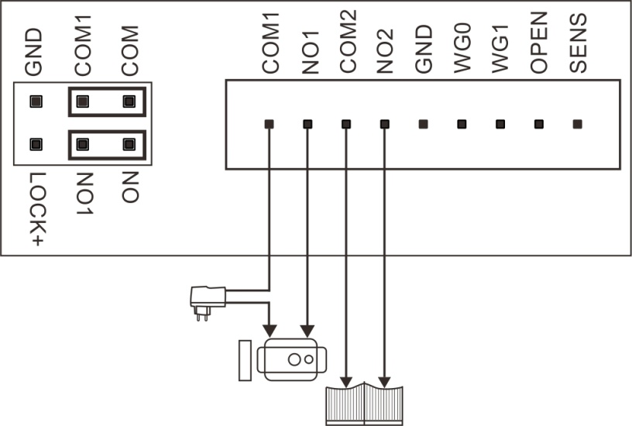
Jumper setting

Power supply

Gate lock

Door Lock

(1) Support Door Lock type: NO (normal open) lock, power on to unlock.
A: AC Lock: Support lock of AC125V current≤1A
B: DC Lock: Support lock ≤DC30V, current ≤4A
(2) Support Gate Lock Type (It gives a reply signal for unlocking.):
A: AC Lock: Support lock of AC125V current≤0.5A
B: DC Lock: Support lock ≤DC30V, current ≤4A
(3) Jumper Setting: As the above picture.
(4) Lock Type and Unlock Time Setting:
Same operation as DOOR LOCK setting in 4.11.
4.2 Wiring Diagram for BUS & Exit Button
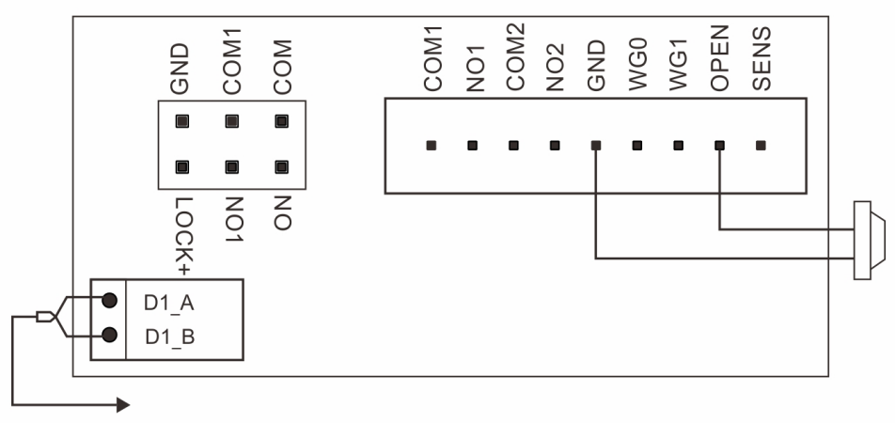
2-wire BUS

Exit Button

- Press the Exit Button to unlock the door or gate. For choosing the door or gate lock, please go to "Exit button control type" in the "Doorbell list” of 2-wire indoor monitor system setting.
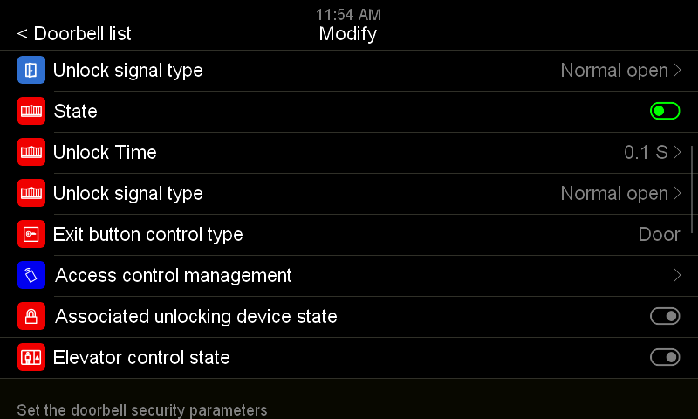
Touch DOORBELL LIST to exit setting, touch CONFIRM to save the setting.
Touch EXIT BUTTON CONTROL TYPE to choose DOOR or GATE.

- The 2-wire BUS has no polarity.

4.3 Wiring Diagram for Wiegand Unlock & Door Status Checking
Door status detection sensor

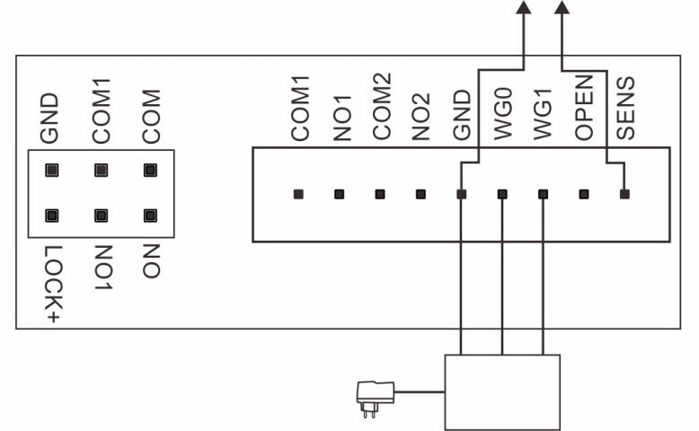
Wiegand reader

4.4 System Wiring Diagram
4.41 System Wiring Diagram without Distributor NV20
(1) Use PW03A as System Power (Maximum support 1 door station & 5 indoor monitors)
- PW03B + External Power Supply(Maximum Support 7 Monitors)

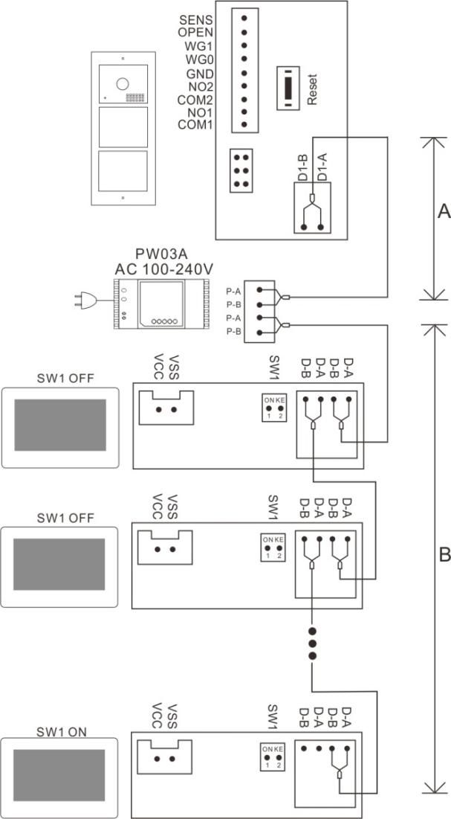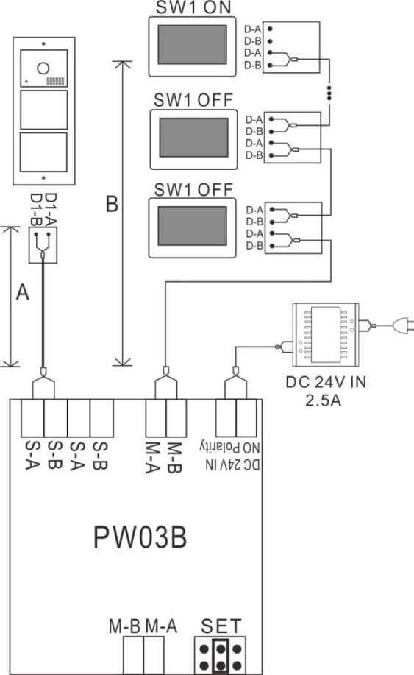

4.42 System Wiring Diagram with Distributor NV20 (Maximum support 24 monitors)

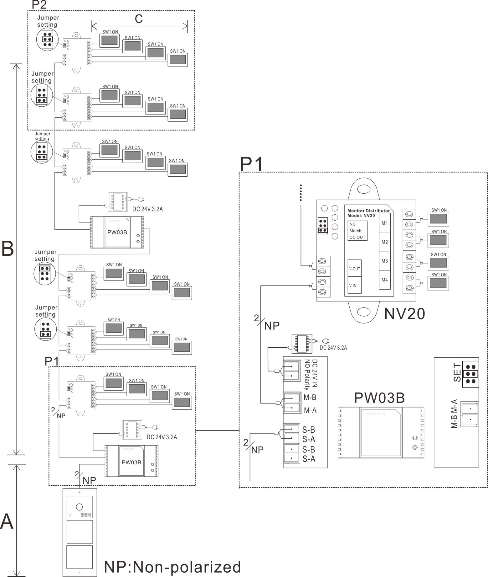

4.43 System Wiring Diagram with Distributor NV20 & BUS Extender PW03B (Maximum 72 monitors)

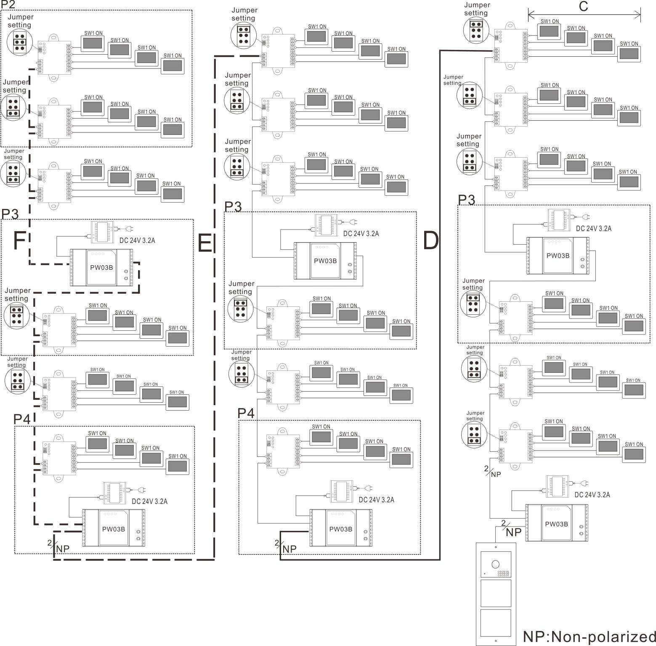

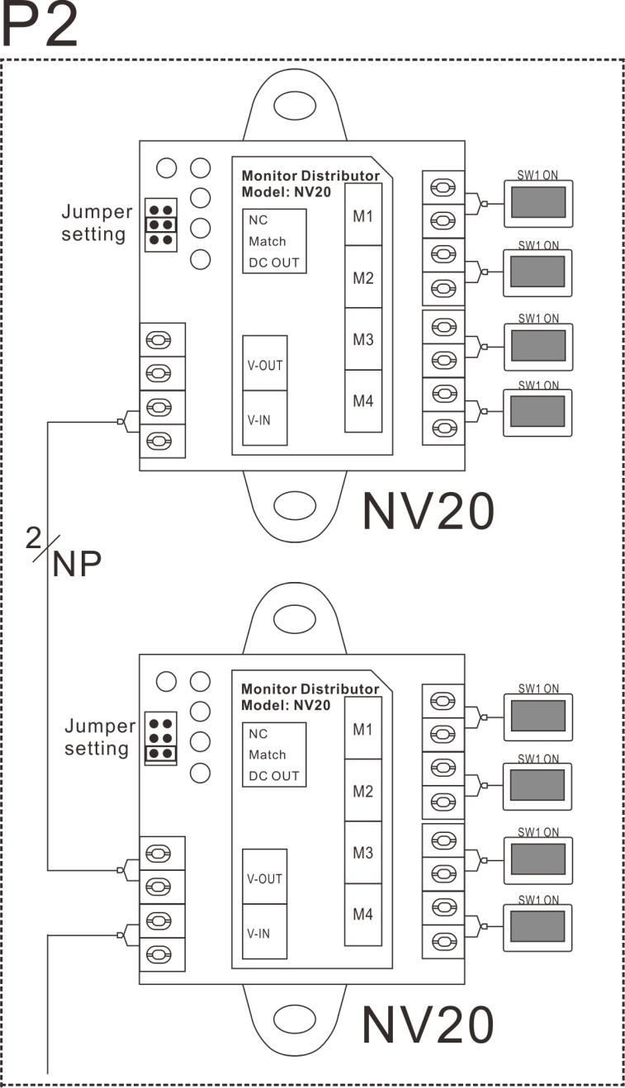

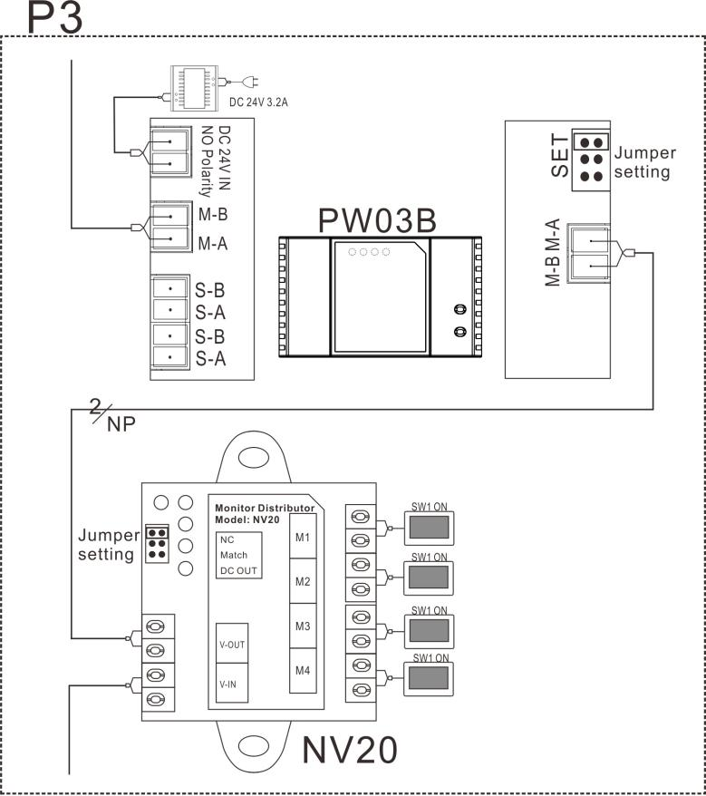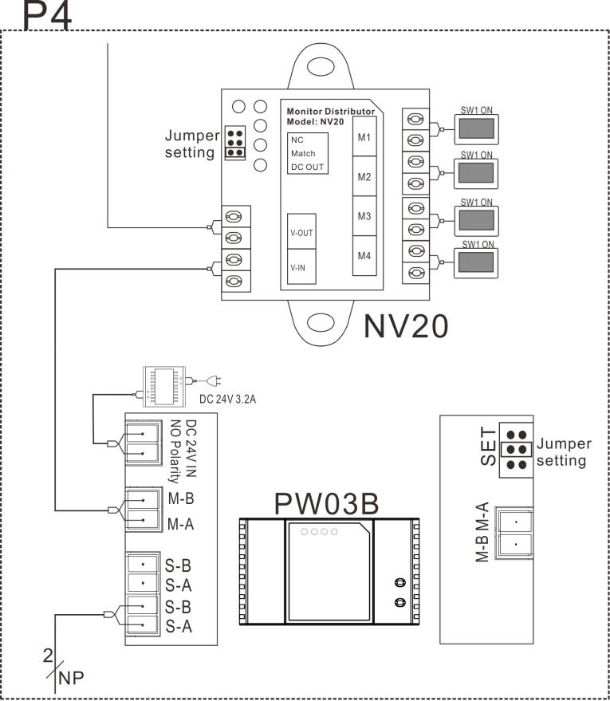

4.44 System Wiring Diagram with Villa Door Station for Each Flat (Maximum 36 monitors)
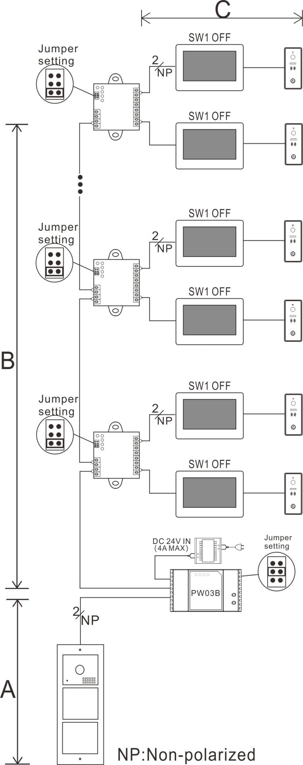

4.45 System Wiring Diagram with Slave Monitor in Each Flat (Maximum 72 monitors)
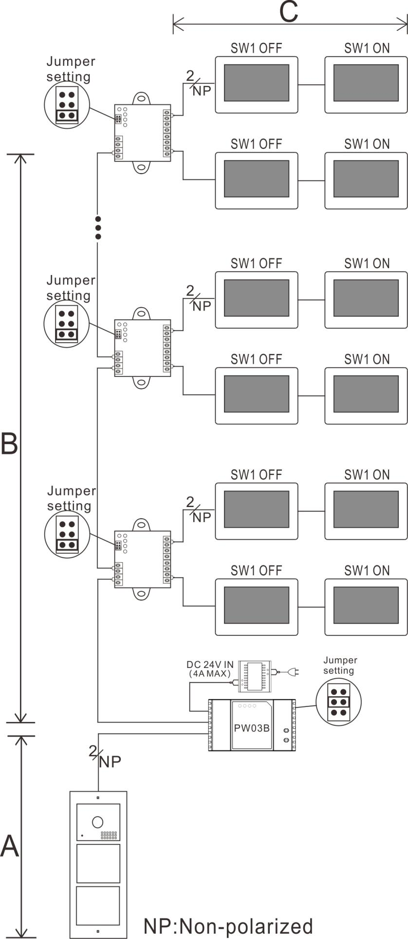
Remark:
- All cables must be unshielded.
- One BUS (A, B, D, E or F) should use the same cable with same specification.
- For each monitor distributor NV20, the wires to M1& M2 Port should be with same specification, the wires to M3 & M4 Port should be with same specification.
- All the last device on each BUS should make right terminal match setting as the diagram.
- Each monitor distributor NV20 can support maximum 4 devices.
- For Diagram 4.44 & 4.45, 2 devices should connect to Branch BUS 1(M1 or M2 Port), the other 2 devices should connect to Branch BUS 2(M3 or M4 Port).
- The address of monitors should be set same in the same flat.

4.5 Cable & Distance

Device Quantity on the Master  BUS Cable Type |  | 8  (2pcs PW03B + 6pcs NV20) | 7  (2pcs PW03B + 5pcs NV20) | 6  (2pcs PW03B + 4pcs NV20) | ≤5
Parallel pair cable  (BVVB)2*0.5mm² | A | 100 | 100 | 100 | 100
 | C | 50 | 50 | 50 | 50
 | B/D/E/F | 60 | 85 | 90 | 90
Parallel pair cable  (BVVB)2*0.75mm² | A | 100 | 100 | 100 | 100
 | C | 50 | 50 | 50 | 50
 | B/D/E/F | 75 | 90 | 100 | 115
Double pair cable (Standard CAT-5) | A | 100 | 100 | 100 | 100
 | C | 50 | 50 | 50 | 50
 | B/D/E/F | 120 | 150 | 180 | 180
Twisted pair cable  (ZC-RVS)2*0.5mm² | A | 100 | 100 | 100 | 100
 | C | 50 | 50 | 50 | 50
 | B/D/E/F | 55 | 100 | 110 | 110
Twisted pair cable  (ZC-RVS)2*0.75mm² | A | 100 | 100 | 100 | 100
 | C | 50 | 50 | 50 | 50
 | B/D/E/F | 55 | 95 | 95 | 95
Parallel pair cable 2*0.3 mm² | A | 100 | 100 | 100 | 100
 | C | 50 | 50 | 50 | 50
 | B/D/E/F | 60 | 85 | 100 | 110

Remark:
- All cables must be unshielded.
- The distance A will decrease to half if the PW03B connect 2 door stations.
- If the distance A is too long to open a high-power electric lock, please add an external power for the lock as 4.12.
- For the first diagram in 4.41, the total distance (A+B) shall be as same as B in the above form.

5. Installation Guide
5.1 Cautions
(5.11) Choosing a suitable position for installation to avoid direct sunlight and rain.
(5.12) Suggest installation height: 1.5~1.6Meters.
(5.13) Ensure no power supply before installation finished.
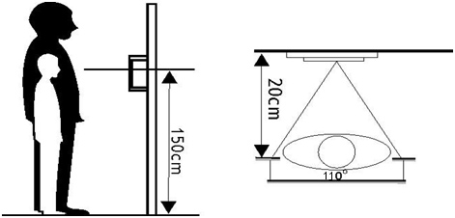

5.2 Module Connection Instruction
(1) Fix the module into the door station front housing, and lock it with screws.
(2) Connect all modules one by one with connection wires (J1 or J2 Port).
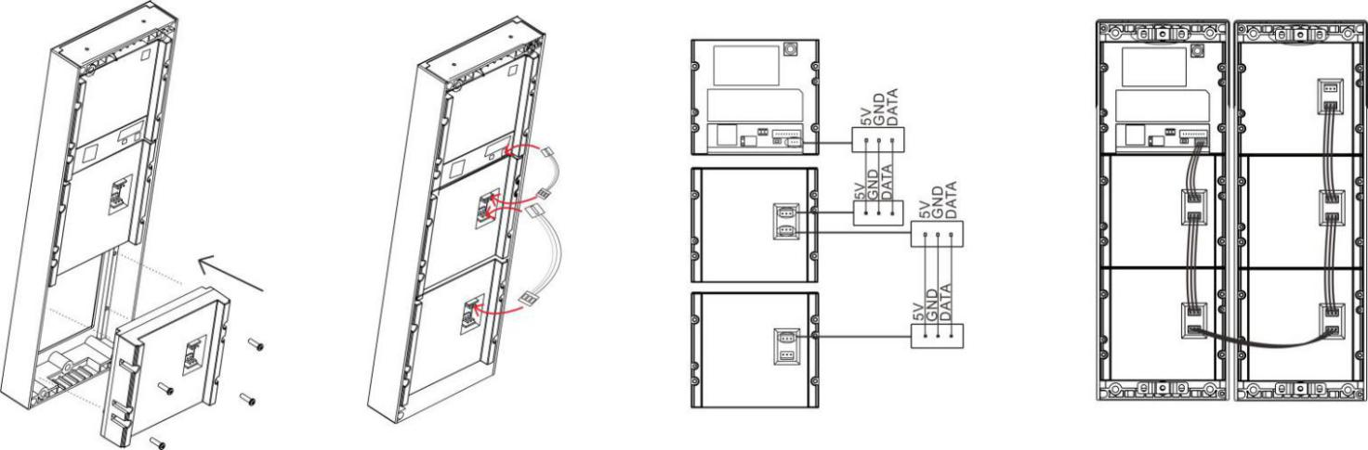
Remark:
The default button number sequence is from up to down. You need to redefine the button number after changing any button module. For detail operation method, please check Part (2) of 2.2 on Page 2.
5.3 Surface Mounted
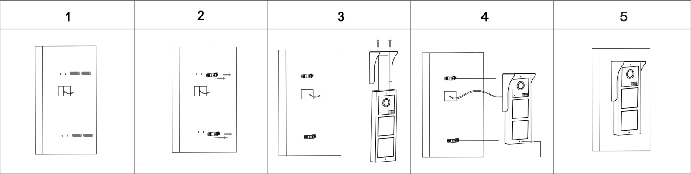

- Paste the mounting paper on the wall, and drill 4 holes according to the screw holes on the mounting paper.
(2) Fix the 2 screw holders on the wall.
(3) Fix the rain hood onto the door station with 2 screws (Ignore this step if no rain hood).
(4) Connect the cable according to the system wiring diagram.
(5) Fix the door station onto the screw holders with a Allen wrench (Remark: the 2 fixing screws are preinstalled in the 2 screw holes, see No. (7) on Page 1.).

5.4 Flush Mounted
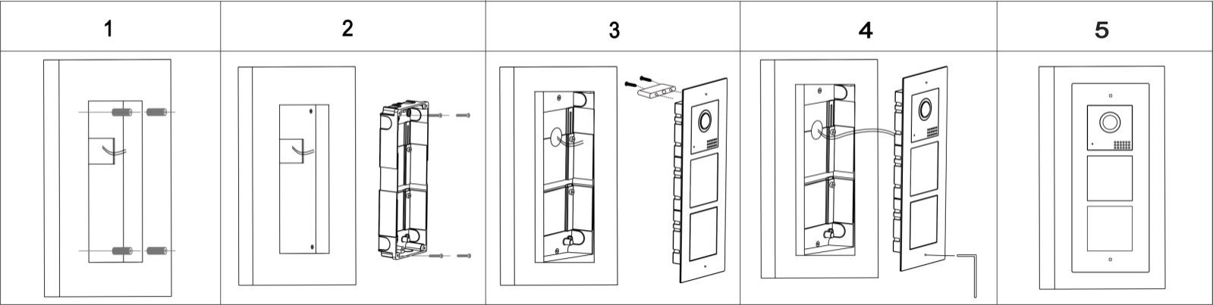
- Drill a hole in the wall according to the dimension of the mounting box. Then drill 4 small holes in the mounting box hole according to the screw holes position on the mounting box, and insert 4 expansion columns into the holes.
- Fix the mounting box into the wall with 4 screws.
- Connect the cable according to the system wiring diagram.
- Fix the door station onto the mounting box with an Allen wrench (Remark: the 2 fixing screws are preinstalled in the 2 screw holes, see No. (7) on Page 2.).

- Door Station Setting
All the setting can be done in any monitor in the same system.

Touch SETTING icon on the Main Menu.

Touch DEVICE CONFIGUARATION.

Touch the door station which you want to set, then touch MODIFY..

Touch DOORBELL LIST.

Input password, then touch ＃. The default password is 0000.
Enable DOOR LOCK STATE.

All the below settings can be done by an installer/user. After making all the necessary settings, please save the settings as below operation.
Touch CONFIRM to save the setting.
Touch DOORBELL LIST to exit setting.

6.1 Device Name(Door Station Name)
You can set a name for the door station.
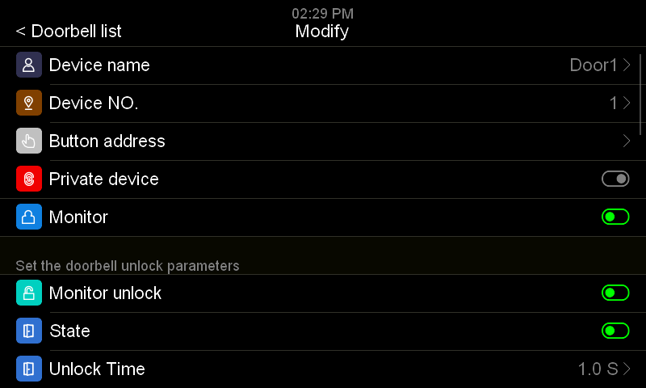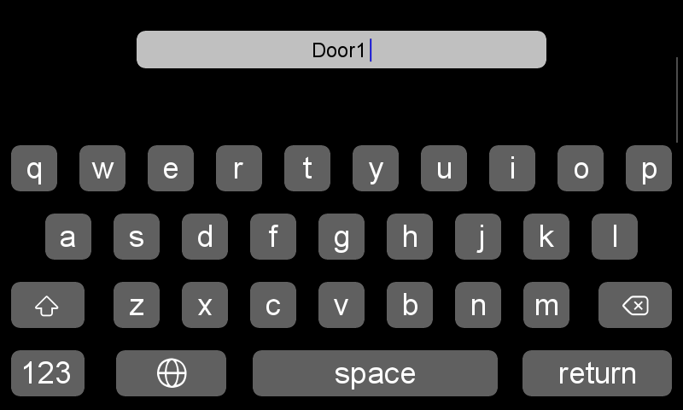
6.2 Device NO.
The full DEVICE NO. for door station is 8 digits, you can set as you want. But if there are more than 1 door station in the system, it’s not allowed to set 2 door station with same device no.

6.3 Private Device
For apartment door station, please disable this function. If enable this function, this door station can be set as a private device for one family. The private door station can only be monitored by this family, and it can only call to this family.

6.4 Monitor
If enable this function, the door station can be monitored by indoor monitors. If disable this function, the door station can not be monitored by indoor monitors.

6.5 Set the Doorbell Unlock Parameters
6.51 Monitor Unlock
If enable this function, you can unlock the door or gate at monitoring state by touching UNLOCK icon. If disable this function, you can only unlock the door or gate at talking state by touching UNLOCK icon.

6.52 Door Lock State
If you connect a door lock to the system, you need to enable this function, and set UNLOCK TIME for it. Also you need to set UNLOCK SIGNAL TYPE (NORMAL OPEN or NORMAL CLOSE) according to door lock type.

6.53 Gate Lock State
If you connect a gate lock to the system, you need to enable this function, and set UNLOCK TIME for it, also you need to set UNLOCK SIGNAL TYPE(NORMAL OPEN or NORMAL CLOSE) according to gate lock type.

6.54 Exit Button Control Type
Set exit button control target, it can be gate or door according to the actual installation. Press the exit button can open the door/gate.

6.55 Associated Unlocking Device
The associated unlocking device information will only display after the unlock devices are connected into the system.

6.6 RFID Access Control Management
It only supports this function when a RFID module is assembled in the door station.

At standby state, read a registered card at the door station, the door will be open after a beep, and below text will be showing on screen: PLEASE COME IN.
If read an unregistered card at the door station, there will be 2 beeps to remind you that it’s an invalid card.

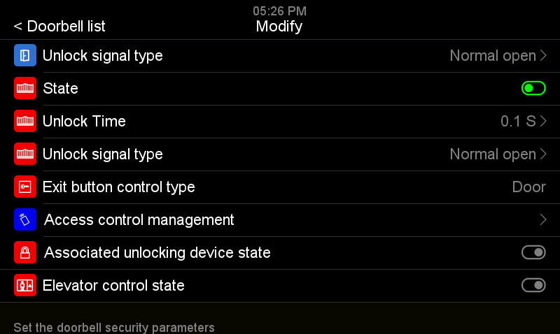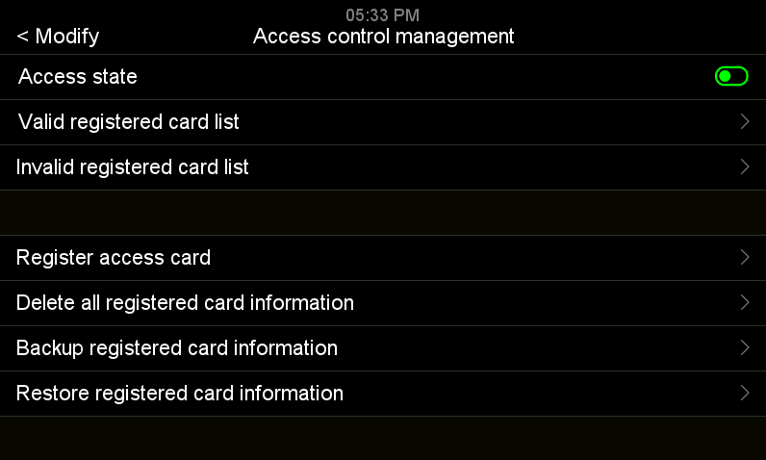
Touch ACCESS CONTROL MANAGEMENT.
Enable ACCESS STATE.

6.61 Access State
It’s on by default.

6.62 Register Access Card (125KHz ID card)
Touch REGISTER ACCESS CARD, the screen will display below message: Please show your card to the CARD READING AREA ON THE door panel...
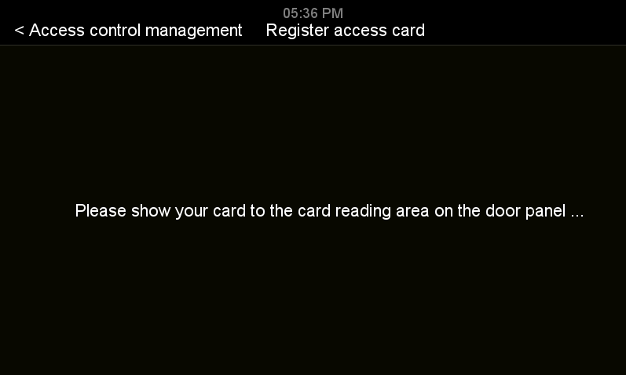
At such state, the user can register new cards at the door station. When the user shows a new ID card to the card reading area on the door panel, the card will be registered after a beep. Same operation to add more access cards. After registered all the cards, please exit REGISTER ACCESS CARD interface by touching ACCESS CONTROL MANAGEMENT.

Remark:
The registered card information is saved in the door station, so you can manage it at any indoor monitor which connects to the door station.

All the registered access card information could be found in VALID REGISTERED CARD LIST, and they are listed from up to down according to the registered sequence. So please remark on each card when you registered the cards if you need to manage the card information.

6.63 Check/Manage Registered Card Information
Go to VALID REGISTERED CARD LIST in ACCESS CONTROL MANAGEMENT. Touch any registered card to enter a sub menu, then you can edit the card information.

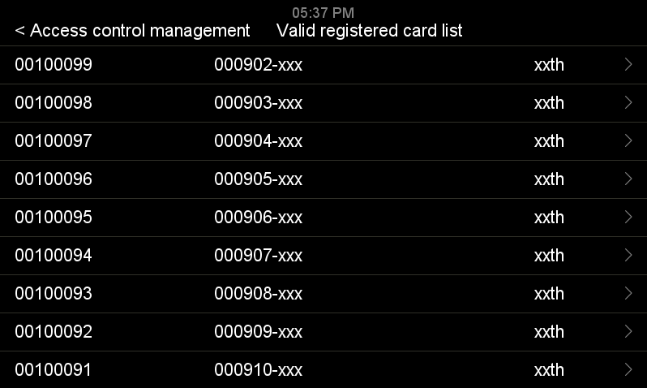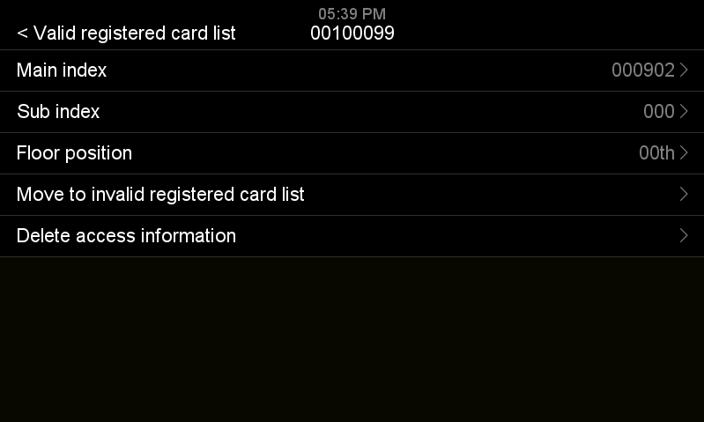
Touch any registered card.
Touch VALID REGISTERED CARD LIST.

MAIN INDEX can be a room number or any easily remember number for one family.
SUB INDEX can be a series number for the registered card of one family.
If you want to pause one access card, touch MOVE TO INVILID REGISTERED CARD LIST.
If you want to delete one access card, touch DELETE ACCESS CARD.
If you want to delete all registered card information, touch DELETE ALL REGISTERED CARD INFORMATION.

6.64 Backup Registered Card Information
Insert a micro SD card into the indoor monitor. Then go to ACCESS CONTROL MANAGEMENT, touch BACKUP REGISTERED CARD INFORMATION, a sub menu will appear, touch CONFIRM to start backup. When backup finished, it will go back to ACCESS CONTROL MANAGEMENT interface.
Remark:
This setting item only appears when a SD card is inserted in the monitor.

6.65 Restore Registered Card Information
Insert the micro SD card, which has registered card backup information, into the indoor monitor. Then go to ACCESS CONTROL MANAGEMENT, touch RESTORE REGISTERED CARD INDORMATION. Choose ACCESS DATE folder, a sub menu will appear, touch to restore registered card information.
Remark:
This setting item only appears when a SD card is inserted in the monitor.

6.7 Elevator control state
It can disable/enable elevator control function.
Remark:
This function only works when a lift control module is installed in the system.

6.8 Set Doorbell Security Parameters
6.81 Tamper State
The tamper in the door station will be active after enable this function, and it will alarm when someone tries to disassemble the door station. Also you need to set TARGET ROOM NUMBER FOR HANDLING ALARMS.

6.82 Check Door State
If enable this function, the system will check the door state after longest door open time. Set MAGNETIC CONTACT NODE TYPE to NORMAL OPEN or NORMAL CLOSE according to actual needs. Set LONGEST DOOR OPEN TIME. Once the door is open, the door station will detect the door state after it reaches longest door open time. If the door is not closed after the longest door open time, the door station will alarm with beeps sound.

6.9 Set the Doorbell Speaker Volume
You can set 10% to 100% volume according to actual needs.

7.0 Adjust the Viewing Angle
You can adjust the viewing angle for the door station. Touch ADJUST THE VIEWING ANGLE to start monitoring. Touch the place you want to focus on the screen. Then touch hang up icon to exit the monitoring. Finally, touch the return icon on the top left corner or slide left on the screen, touch CONFIRM to finish the setting. After that, the screen will be only showing the focused place when be called by the door station.

7.1 Set the Doorbell Configuration Password
The default password for door station is 0. The password can be set from 1 to 8 digits. You only need to input from the first digit which is not 0. If you input a wrong password, you can only enter VIEW model, and can not make any change to the door station settings.

7.2 Setup Mode
It’s on by default. At this state, the ROOM ADDRESS and FLOOR POSITION of the monitors in the network can be set freely. If disable it for all the door stations in the network, the addresses of the monitors in the network can not be changed.
So if you do not want users to change the monitors address by mistake, please disable this function for all door stations after installation.

8. Operation Instruction
8.1 Password unlock
At standby state, touch # button, below text will be showing on the screen: “Please input unlock password”, input correct password, below text will be showing on the screen: “Please come in”, and the door will be open.
Remark:
If you want to use password unlock function, the item “Password unlock enable status” in the 2 wire indoor monitor settings must be enabled.
Operation method:
Touch 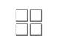button on the monitor to enter system main menu → Touch to enter SETTING menu → Touch Device configuration → Touch Doorbell list → Touch the target door station you want to set → Touch Modify → Input correct password, then touch # →Password unlock enable status → Enable it → Touch DOORBELL LIST on the left top corner → Touch CONFIRM to save the settings.

8.2 Unlock Password Change
The default unlock password is 000000.
If you want to change the unlock password, after enable Password unlock enable status → touch Unlock password setting → Change password → Touch DOORBELL LIST on the left top corner → Touch CONFIRM to save the settings.

8.3 Call Management Center
(1) Input the address of management center, then touch # key to make a call.
(2) If you don’t know the address of management center, touch ？Key to enter HELP menu, touch or to move the cursor to CALL MANAGEMENT CENTER, then touch # key to make a call.
(3) Management Center Address Setting
Touch button on the monitor to enter system main menu → Touch to enter SETTING menu → Touch Device configuration → Touch Doorbell list → Touch the target door station you want to set → Touch Modify → Input correct password, then touch # → Touch CALL MANAGEMENT CENTER → Edit the address → Touch DOORBELL LIST on the left top corner → Touch CONFIRM to save the settings.

8.4 Household List
(1) Touch button to enter HOUSEHOLD LIST interface.
(2) Touch ？button to enter HELP menu, touch or to move the cursor to HOUSEHOLD LIST, touch # key to enter HOUSEHOLD LIST interface.
(3) At HOUSEHOLD LIST interface, touch or to move the cursor to any household/room address, then touch # key to make a call.
Remark:
The HOUSEHOLD LIST list is empty by default. A household name will only be added into HOUSEHOLD LIST after being called at the door station. And the DEVICE NAME in the being called indoor monitor will be synchronized as the household name in the HOUSEHOLD LIST. If the user did not change the DEVICE NAME in his/her indoor monitor, the default DEVICE NAME is ROOM 1.

9. System Menu
Touch ？button at standby state, then press and hold on the # button, below text will be showing on the screen: “Please input system password”. Input password (default password: 000000), touch # button to enter system menu.

No. | Item | Content
1 | System time | For setting system time.
2 | Language | Default English.
3 | Password Setting | For setting password. The default password is 000000. In case you forget the password, reboot the door station, then input the default password within 1 minute to enter system menu.
4 | Reset | For clearing HOUSEHOLD list.
5 | About the device | Enter it to see program version.

10. Specification
No | Item | Content
1 | Communication | Digital 2 wire
2 | Subscribers quantity | Multi subscribers
3 | Audio | Digital audio (bidirectional)
4 | Video | 1 channel digital video (output)
5 | Camera | 1080P HD color CMOS camera
6 | Night vision | Infrared light(with automatic luminance compensation)
7 | Effective distance (0 Lux) | 0.5 meter
8 | Viewing angle | Horizontal 90 degree, Vertical 45 degree
9 | Buttons | Mechanical Buttons
10 | Working voltage | DC18-30V
11 | Support electrical lock | Please refer to 4.11 and 4.12 for detail information.
12 | Support gate lock | One unlock signal (dry contact), please refer to 4.11 and 4.12 for detail information.
13 | Unlock control | Signal instruction
14 | Power consumption | 6W MAX
15 | Support card type | ID card(125KHz)
16 | Card reading distance | ≤20mm
17 | Support card number | 1000pcs
18 | Working temperature | -25℃- +60℃
19 | Storage temperature | -30℃- +60℃
20 | IP Grade | IP54
21 | IK Grade | IK07
22 | Dimension | Surface mount with rain hood: 302*105*38MM  Flush mount: 325*130*60MM

SVS – Secure Video Systems
The Drive
Erith
DA*1ED

WWW.s-v-s.co.uk
info@s-v-s.co.uk
08001216097

Products are subject to change without prior notice. Svs Secure video systems is a trading name of Intercom repair LTD
Registered company number: 07648814 Vat No 140598900

