2-Wire Door Station
User Manual

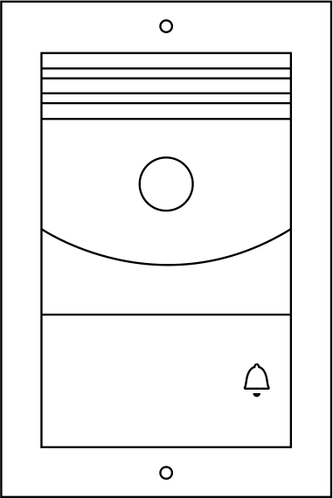
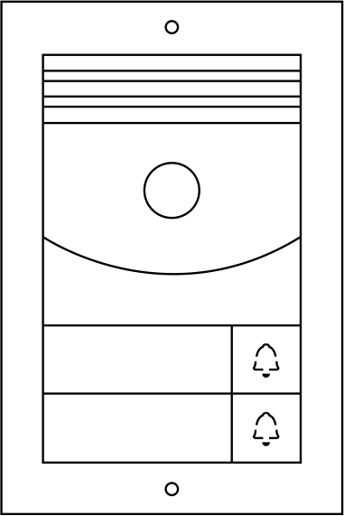
SVS-SOBP1 SVS-SOBP2 One/ Two button

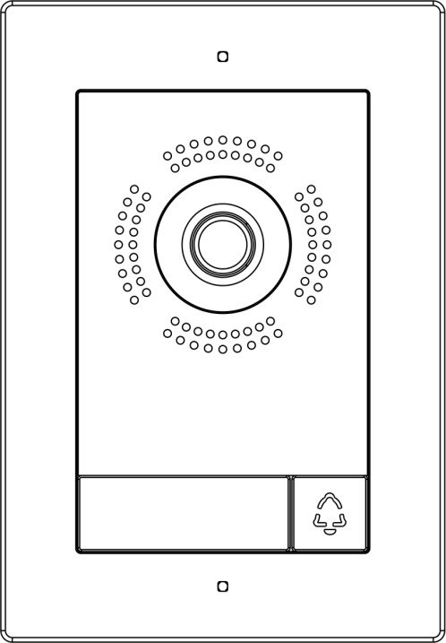
SVS-FOBP1 SVS-FOBP2 One/ Two button
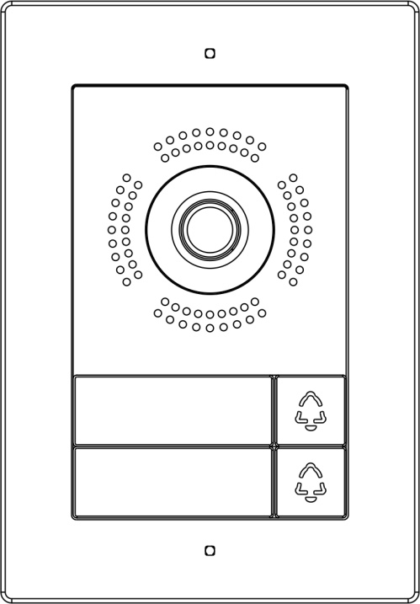

Thank you for purchasing our products.
Please read this User Manual carefully before using this product.

Index
1
1
1
2
3
3
3
3
4
4
5
5
8
9
11
11
11
13
13
14
- Product Features and Main Function .......................... ............................................................................
- The Function and Name of Each Part ....................................................................................................
  - Names of Each Part ...........................................................................................................................
  - Terminal Description .........................................................................................................................
3. Packing List ........................................................................................................................................
4. Wiring Diagram ..........................................................................................................................................
4.1 Electrical Lock Wiring Diagram ...............................................................................................................
4.11 Door Lock Controlled with Internal Power ........................................................................................
4.12 Door Lock Controlled with External Power .....................................................................................
4.2 2-Wire BUS and External Door Unlock Button(Exit Button) ...................................................................
4.3 Wiring Diagram ......................................................................................................................................
4.31 One Button Door Station Wiring Diagram .......................................................................................
4.32 Two Buttons Door Station Wiring Diagram ...............................................................................
4.33 Multi Door Stations Wiring Diagram ........................................................................................
5. Installation Guide .......................................................................................................................................
5.1 Cautions ..............................................................................................................................................
5.2 Wire Distance ...................................................................................................................................
5.3 Surface Mounted .................................................................................................................................
5.4 Flush Mounted ...................................................................................................................................
6. Specification .........................................................................................................................................
V1.2
1. Product Features and Main Function
◆ Nonpolar digital 2 wire, easy wiring
◆ Support 2 locks
◆1080P HD color CMOS camera
◆ Night vision with automatic lumens adjustment
◆ Support surface mounted & flush mounted
◆ Aluminum housing with IK07 & IP55 high protection level
◆ Support connecting an exit button
◆ Support door status checking
◆ Tamper alarm
2. Name and the Function of Each Part
2.1 Names of Each Part
Surface mounted
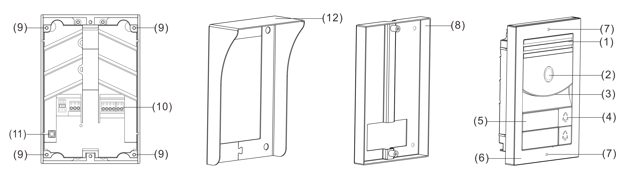
Flush mounted
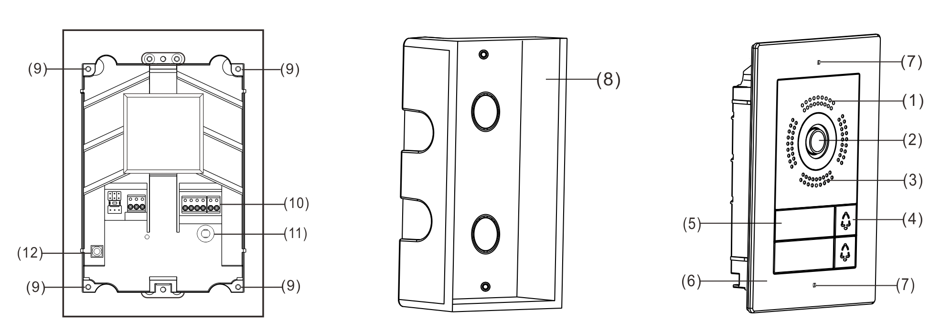
NO. | Name of Parts | NO. | Name of Parts
(1) | Speaker | (2) | Camera
(3) | Microphone | (4) | Call button
(5) | Nameplate | (6) | Front panel
(7) | Screw hole for locking to mounting box | (8) | Mounting box
(9) | Screw for locking front panel | (10) | Connection Ports
(11) | Tamper | (12) | Rain hood
Remark:
The infrared lights are under the name plate. And the name plate paper inside is special and can let the infrared light go through it. Please do not change it, or the night vision function will be affected.

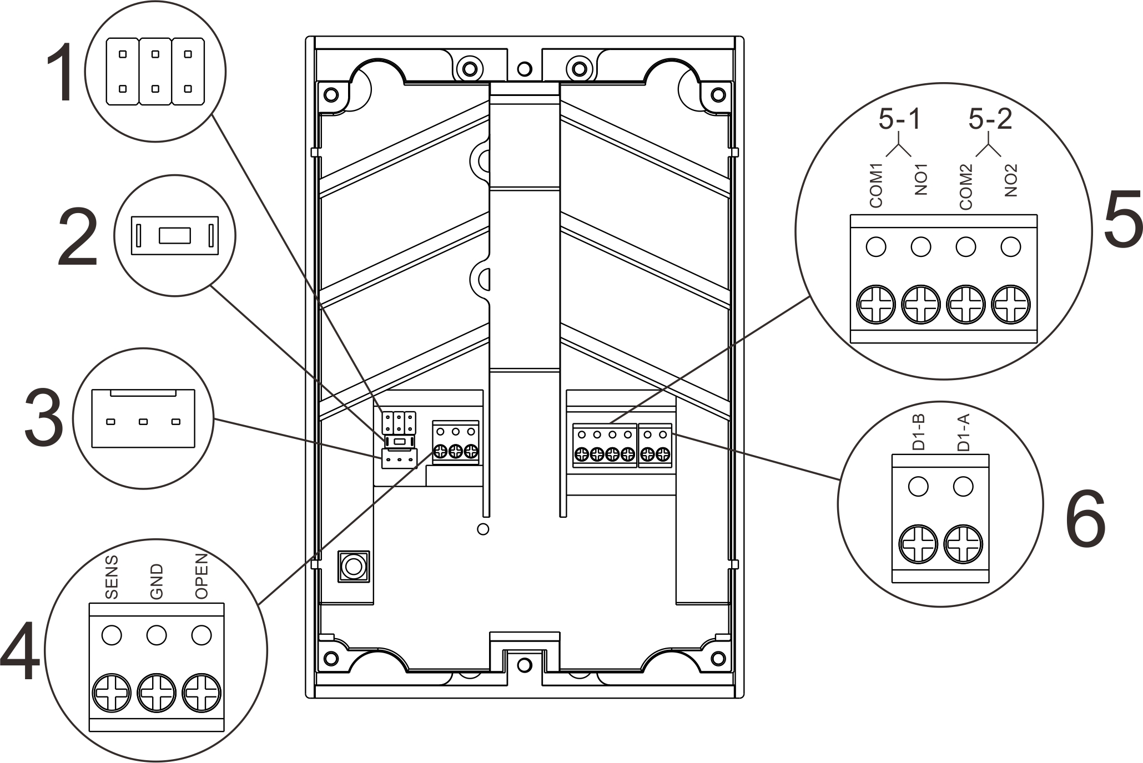
2.2 Terminal Description
① Lock Control Jumper:Set the power supply mode for Door Lock.
② Password Reset Button: Reboot the door station, then press and hold on the reset button within 1 minute.The password resets successfully after two beeps.

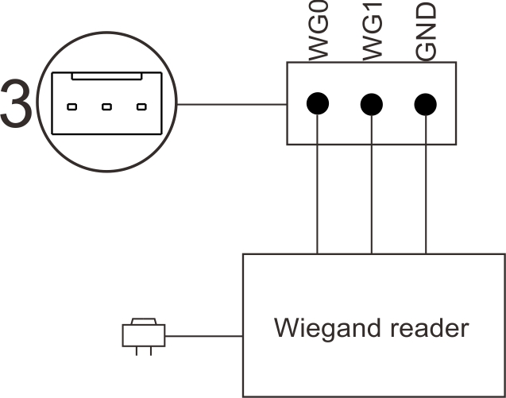
③ Wiegand Connection Port(optional)
Diagram for Wiegand Connection:

④ External Door Control Port:
OPEN: Connect the external door unlock button (Exit button).
SENS: Connect the door status detection switch.
Set up of door status detection function: In the System Setting menu of 2-wire indoor monitor, touch “Device configuration” to enter the “Doorbell list”, select the door station, enter the menu of “Add to monitoring devices list”, select the “Modify”to input the correct password, then enter the modification interface, enable “Check door state”. Set “magnetic contact node type” to “Normal open” or “Normal close” according to actual needs. Set “Longest door open time”. Once the door is open, the door station will detect the door state after it reaches longest door open time. If the door is not closed after the longest door open time, the door station will alarm with beep sound.
⑤Lock Connect Port: 5-1 is for Door Lock, 5-2 is for Gate Lock.
⑥2-Wire BUS Port: Connect the 2-wire BUS.
- Packing List

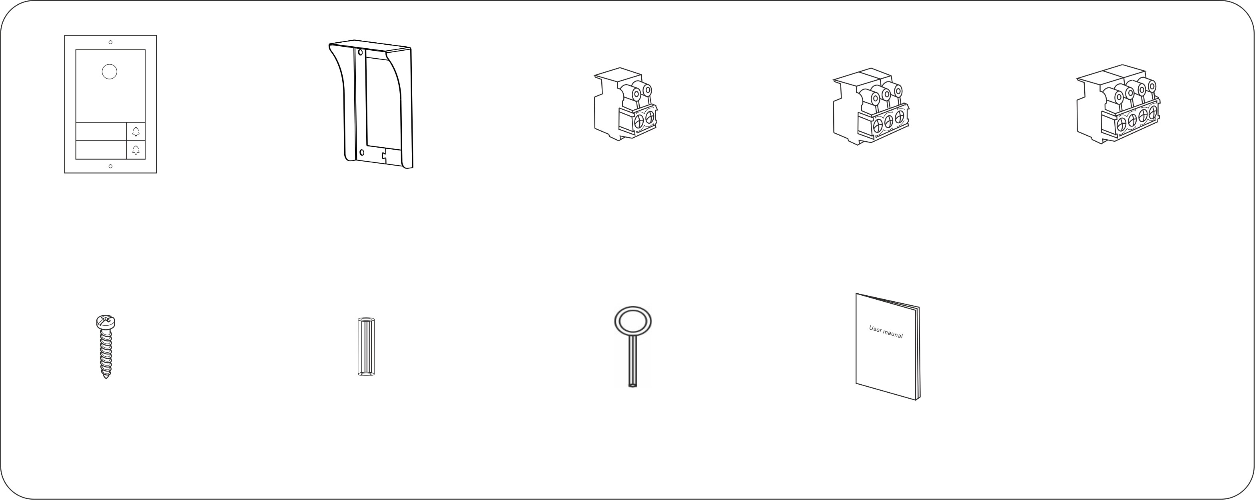
Door station

Rain hood (optional)
User manual
1pc Screw
driver
4pcs 3.5*30mm
Screws
4pcs Expansion
columns
Terminal block

Terminal block

Terminal block

Remark: The rain hood can only be used for surface mounted version door station.

Wiring Diagram
4.1 Electrical Lock Wiring Diagram

Jumper setting
Door Lock
Gate lock
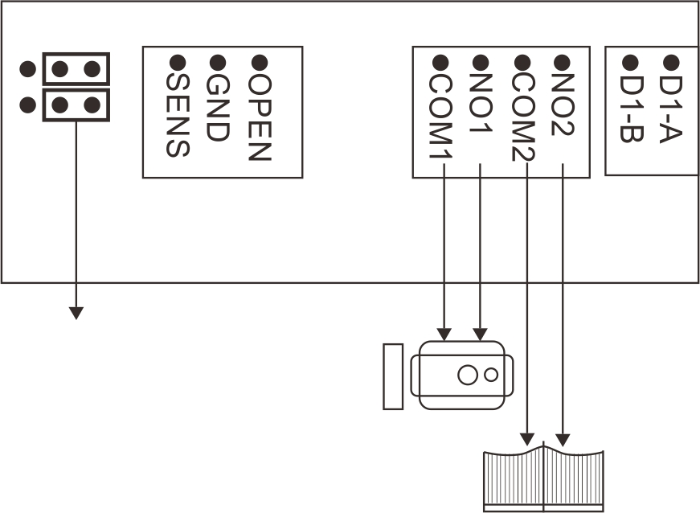
4.11 Door Lock Controlled with Internal Power
(1) Support Door Lock type:
A:NC (normal close) lock, power off to unlock.Support lock of DC12V 0.35A (Max).
B: NO (normal open) lock, power on to unlock. Support lock of DC12V ≤2A (instantaneous),
DC12V ≤0.35A(Continuous current).
(2) Jumper Setting:As the above picture.
(3) Lock Type and Unlock Time Setting:
Touch “Device configuration” in the System Setting menu of 2-wire indoor monitor to enter the “Doorbell list”, select the door station, then enter the “Add to monitoring devices list” menu, choose the “Modify” to input the correct password and enter the modification interface, select the lock type to set the State to be ON or OFF, and set “Unlock Time” according to the actual needs.
4.12 Door Lock Controlled with External Power
Jumper setting
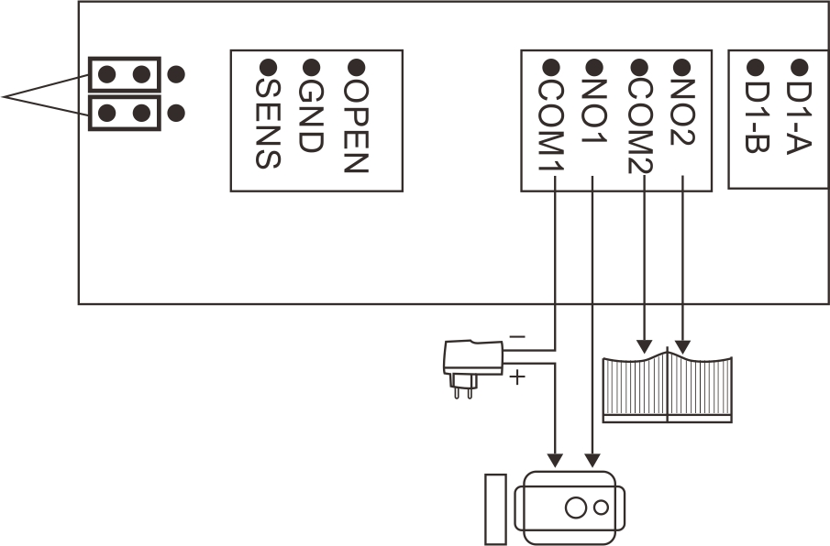
Door Lock
Gate lock
Power supply
(1) Support Door Lock type: NO (normal open) lock, power on to unlock. Support lock of AC/DC5V-24V, current≤3A.
(2) Jumper Setting: As the above picture
(3) Lock Type and Unlock Time Setting:
Touch “Device configuration” in the System Setting menu of 2-wire indoor monitor to enter the “Doorbell list”, select the door station, then enter the “Add to monitoring devices list” menu, choose the “Modify” item to input the correct password and enter the modification interface, selects the lock type to set the state to be ON or OFF, and set “Unlock Time” according to the actual needs.

4.2 2-Wire Bus and External Door Unlock Button(Exit Button)
2-wire BUS
Door status detection switch
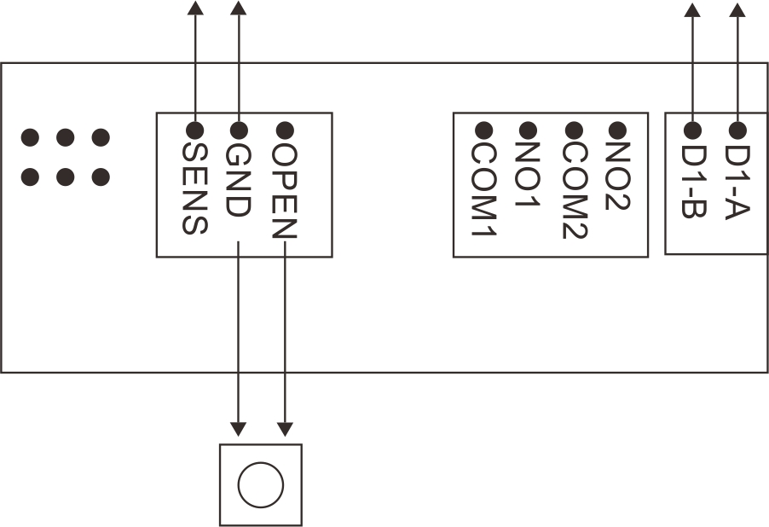
Exit Button
- The Exit Button is indoor. It will unlock the door or gate when pressing the Exit Button. For choosing the door or gate lock, please go to “Exit button control type” in the “Doorbell list” of 2-wire indoor monitor system setting.
- The 2-wire BUS has no polarity.
(3) You need to make right terminal match setting for 2-wire BUS.

4.3 Wiring Diagram
4.31 One Button Door Station Wiring Diagram
(A) One Monitor with One Door Station
(A-1) DC24V, 1A Adapter Power Supply
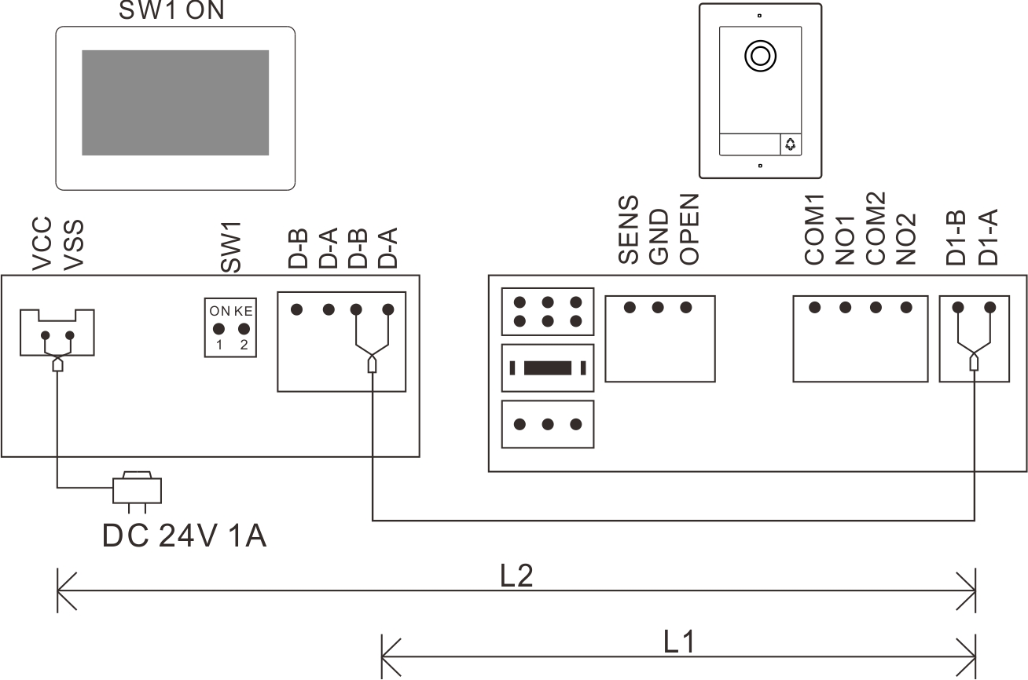

(A-2) DC24V 1A Din Rail Power Supply
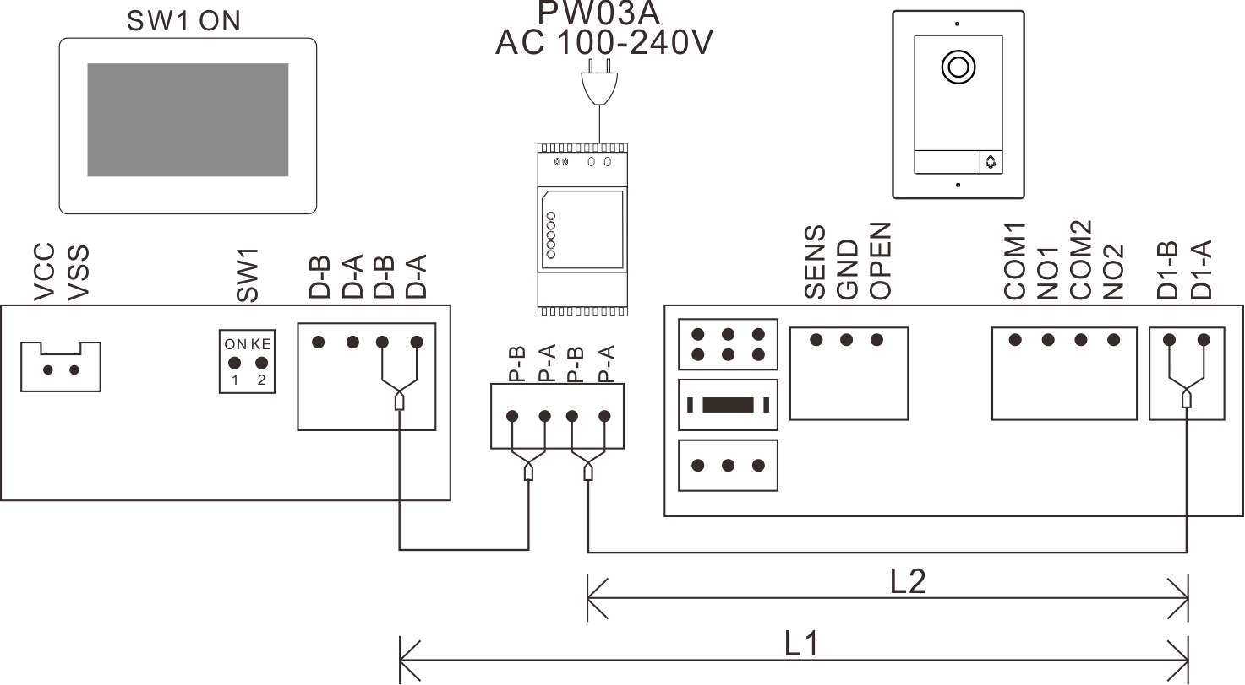

(B) Two Monitors with One Door Station
(B-1) DC24V, 1A Adapter Power Supply
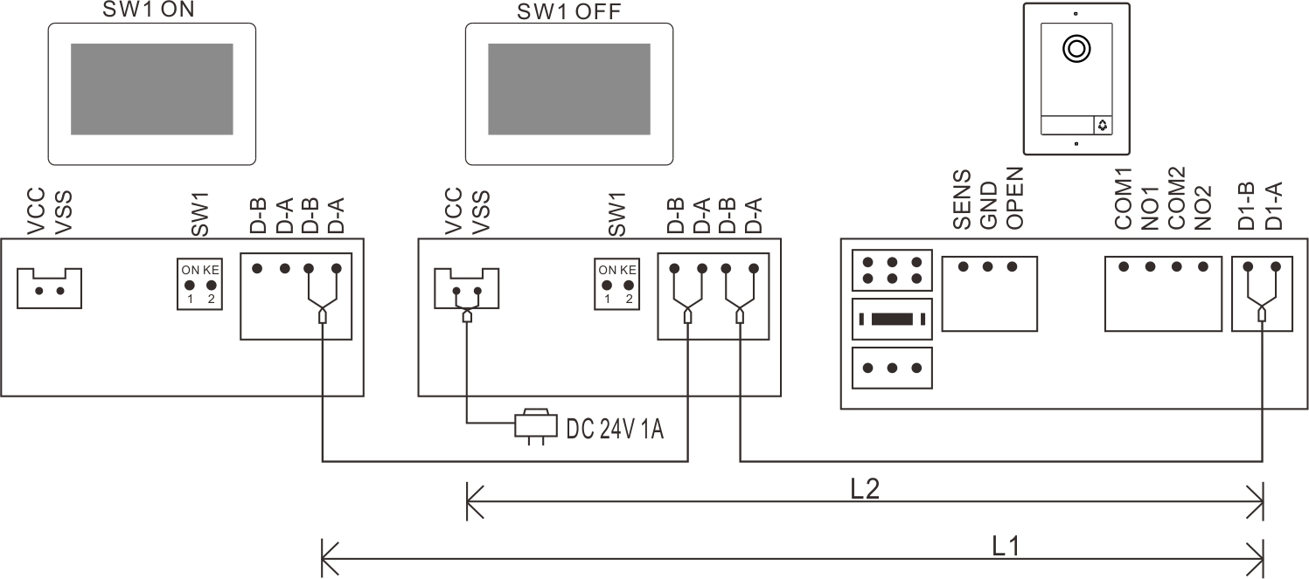
Remark:
As the system is nonpolarized, each system can only use 1 adapter. It will cause problem if you connect more than 1 adapter in one system.

(B-2) DC24V 1A Din Rail Power Supply
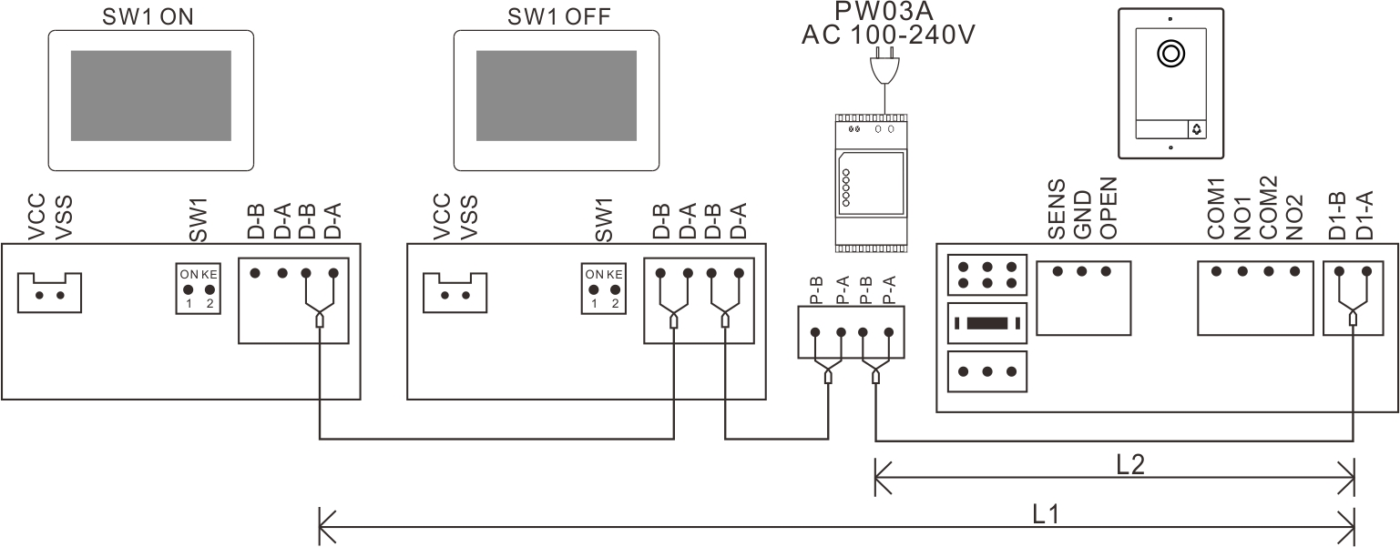

(C) Five Monitors with One Door Station (D) Four Monitors with Two Door Stations
(Maximum support five monitors with PW03A)
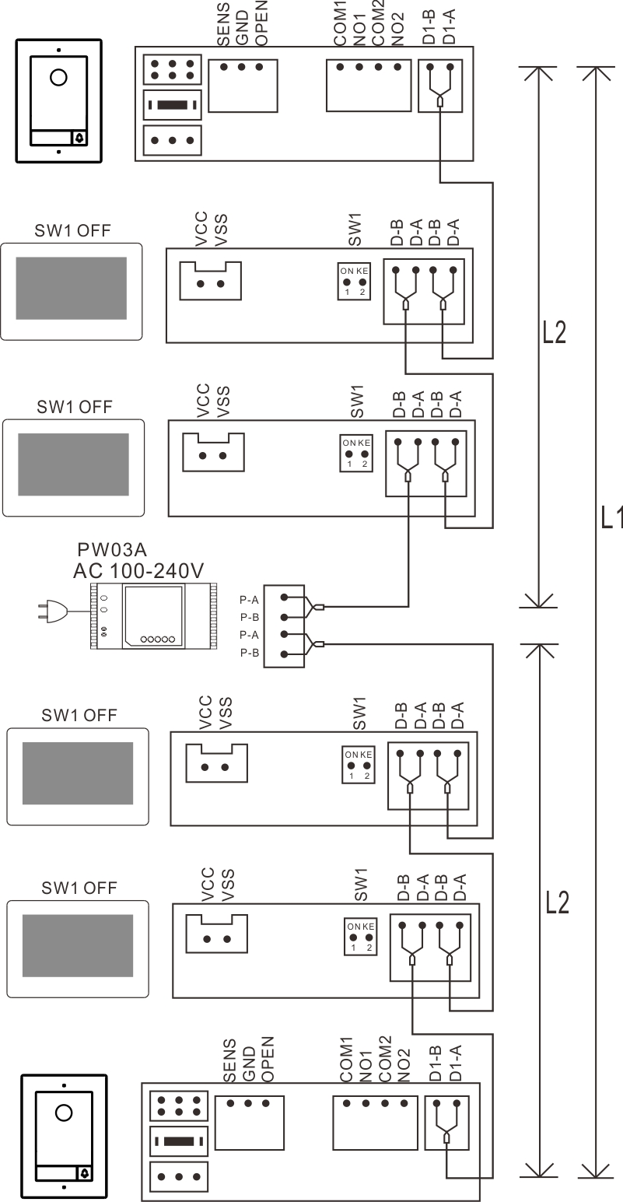
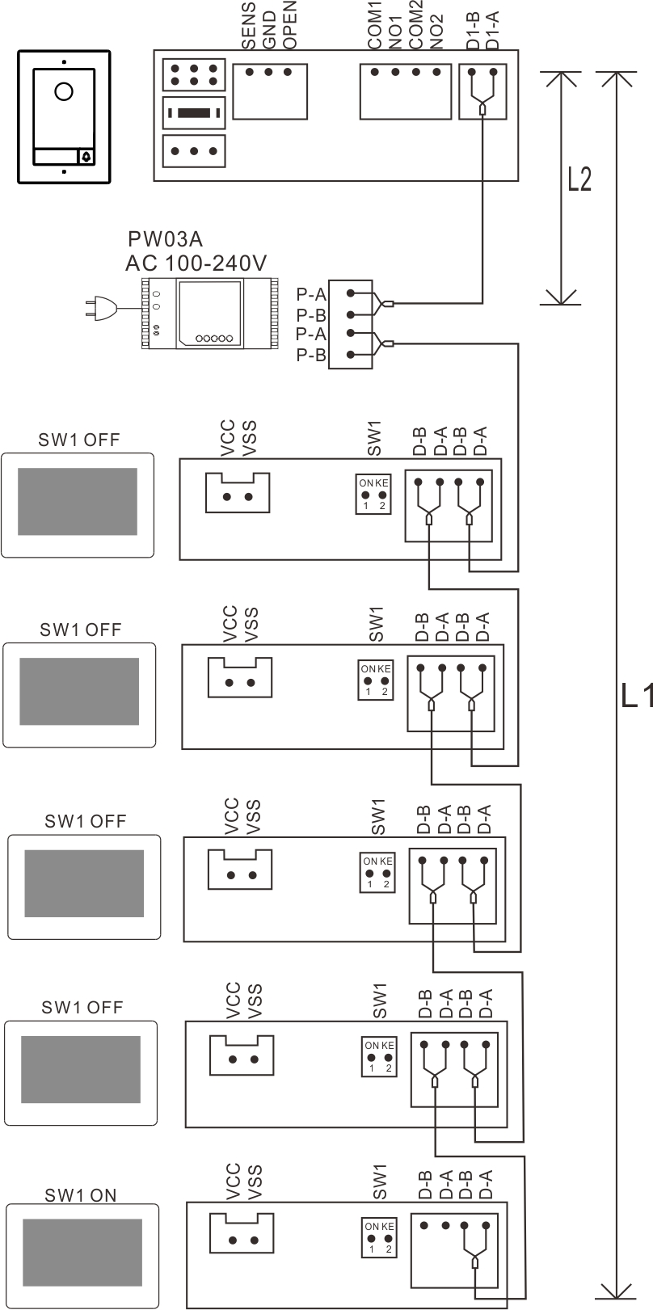

Remark:
- For above wiring B and C, the ROOM ADDRESS in all monitors must be set to the same. All monitors will chime together when pressing the call button on door station.
- If you want to connect more door stations or monitors(maximum 7 devices), please use PW03B instead of PW03A, but you need to add a DC24V 2A(maximum 4A) power for PW03B.
For all the above diagrams:
- All cables must be unshielded.
- The same BUS should use the same wire with same specification.
(5) You need to make right terminal match setting for 2-wire BUS: The last monitor on 2-wire BUS should set SW1 to be ON. Other monitors should set SW1 to be OFF .
(6) L1 represents the length of the BUS, and for detail L1 distance, please refer to the Wire Distance.
4.32 Two Buttons Door Station Wiring Diagram
(1) Same diagram as One Button Door station
Different indoor monitors are with different ROOM ADDRESS, and each call button on the door station should set right BUTTON ADDRESS. The BUTTON ADDRESS should be as same as the ROOM ADDRESS of the monitor which you want to call.
Operation method:
Touch “Device configuration” in the System Setting menu of 2-wire indoor monitor to enter the “Doorbell list”, select the door station needs to set , then enter the “Add to monitoring devices list” menu, choose the “Modify” to input the correct password and enter the modification interface. Go to “Button Index” to set BUTTON ADDRESS for each button.
- Use a distributor for connecting different families
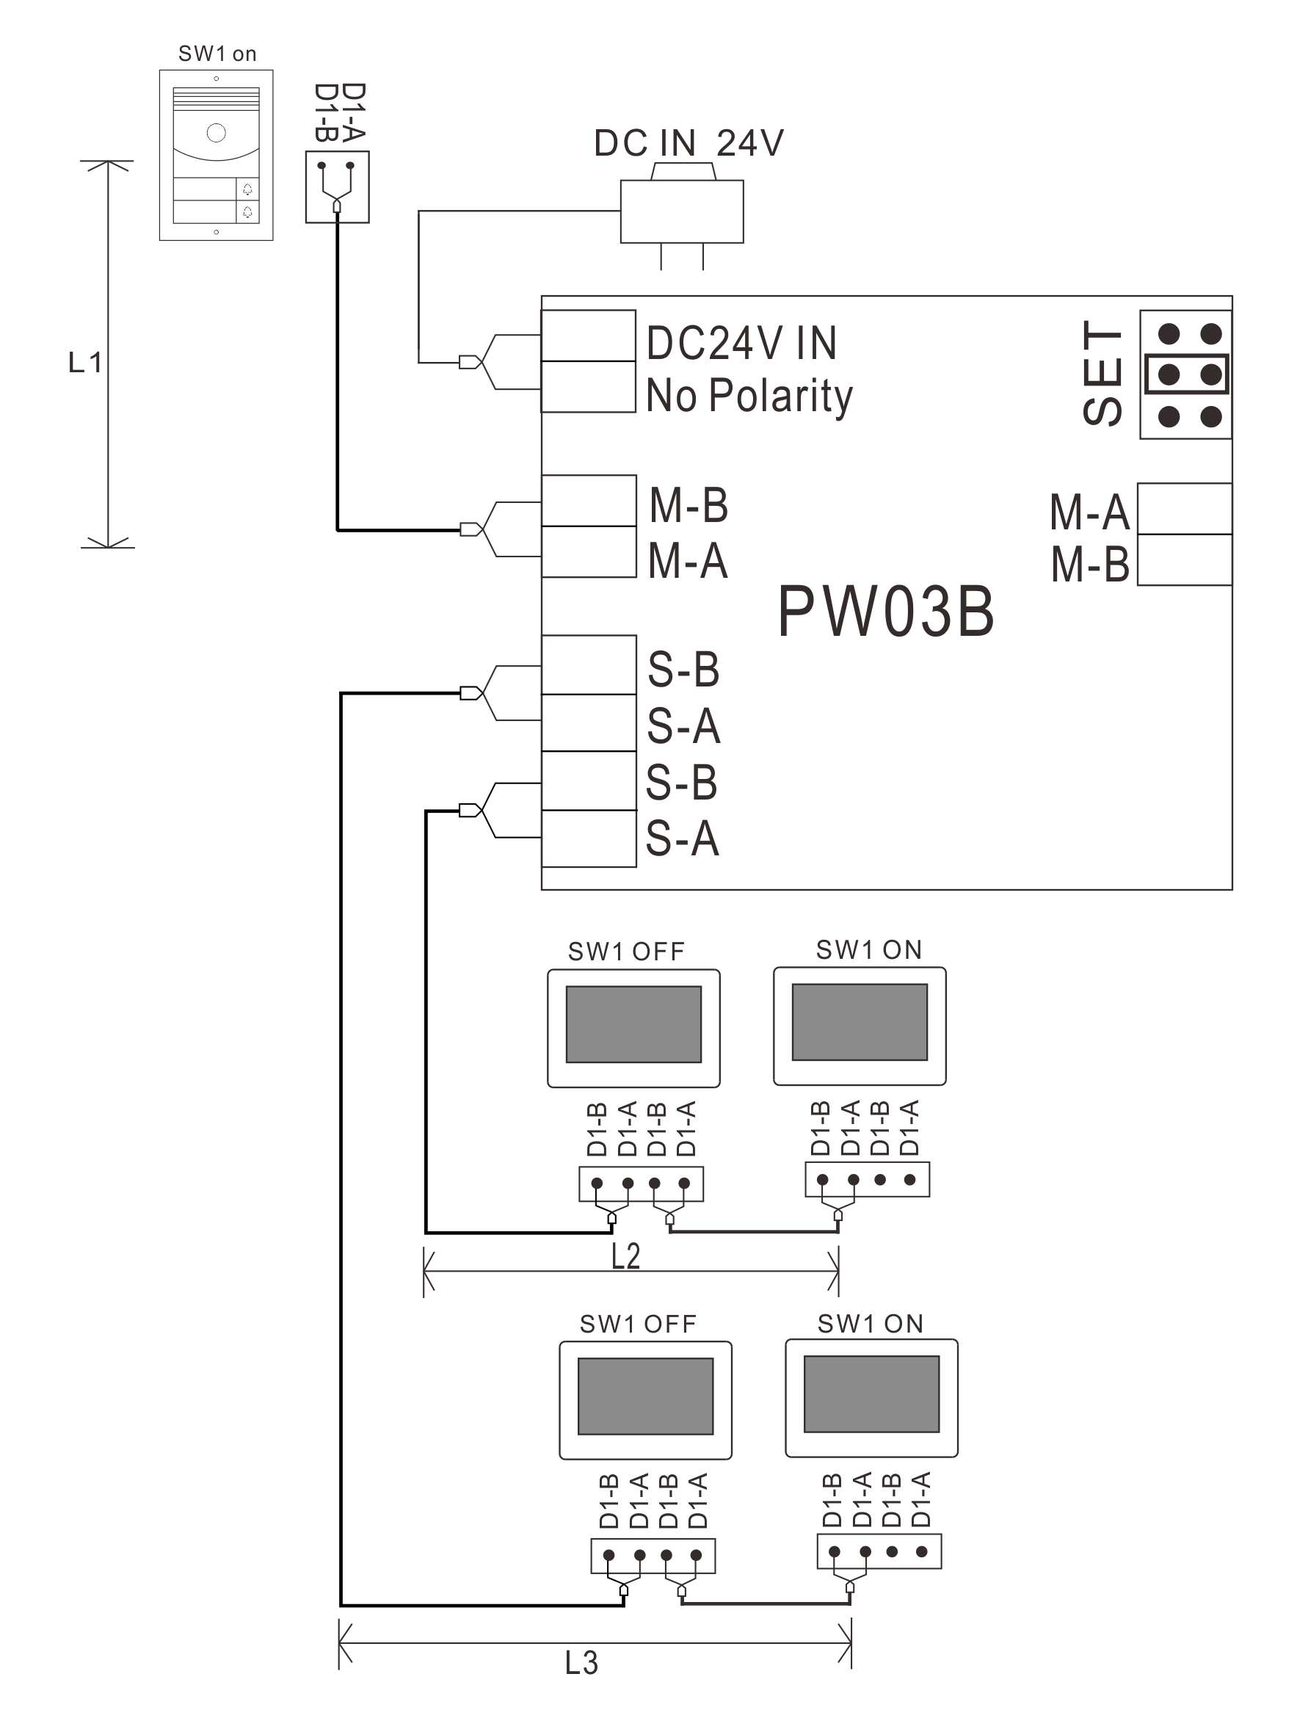
Remark:
- The same BUS should use the same wire with same specification.
- For the above diagram, the jumpers on PW03B must be set as same as in the diagram.
- L1 means the 2 wire BUS length.
- L2 & L3 means the distance from the last indoor monitor to PW03, and L3 + L4 ≦ L1(See Wire Distance on Page 16).
- 2-wire BUS terminal match setting:
(5-1) Master BUS(The 2 wire bus which connects M-A & M-B port): The last monitor on 2-wire BUS should set SW1 to be ON. The other monitors should set SW1 to be OFF.
(5-2) Slave BUS(The 2 wire bus which connects S-A & S-B port): All device connects to S-A and S-B must set SW1 to be ON.

4.33 Multi Door Stations Wiring Diagram
4.331 Three Door Stations Connect by a PW03C
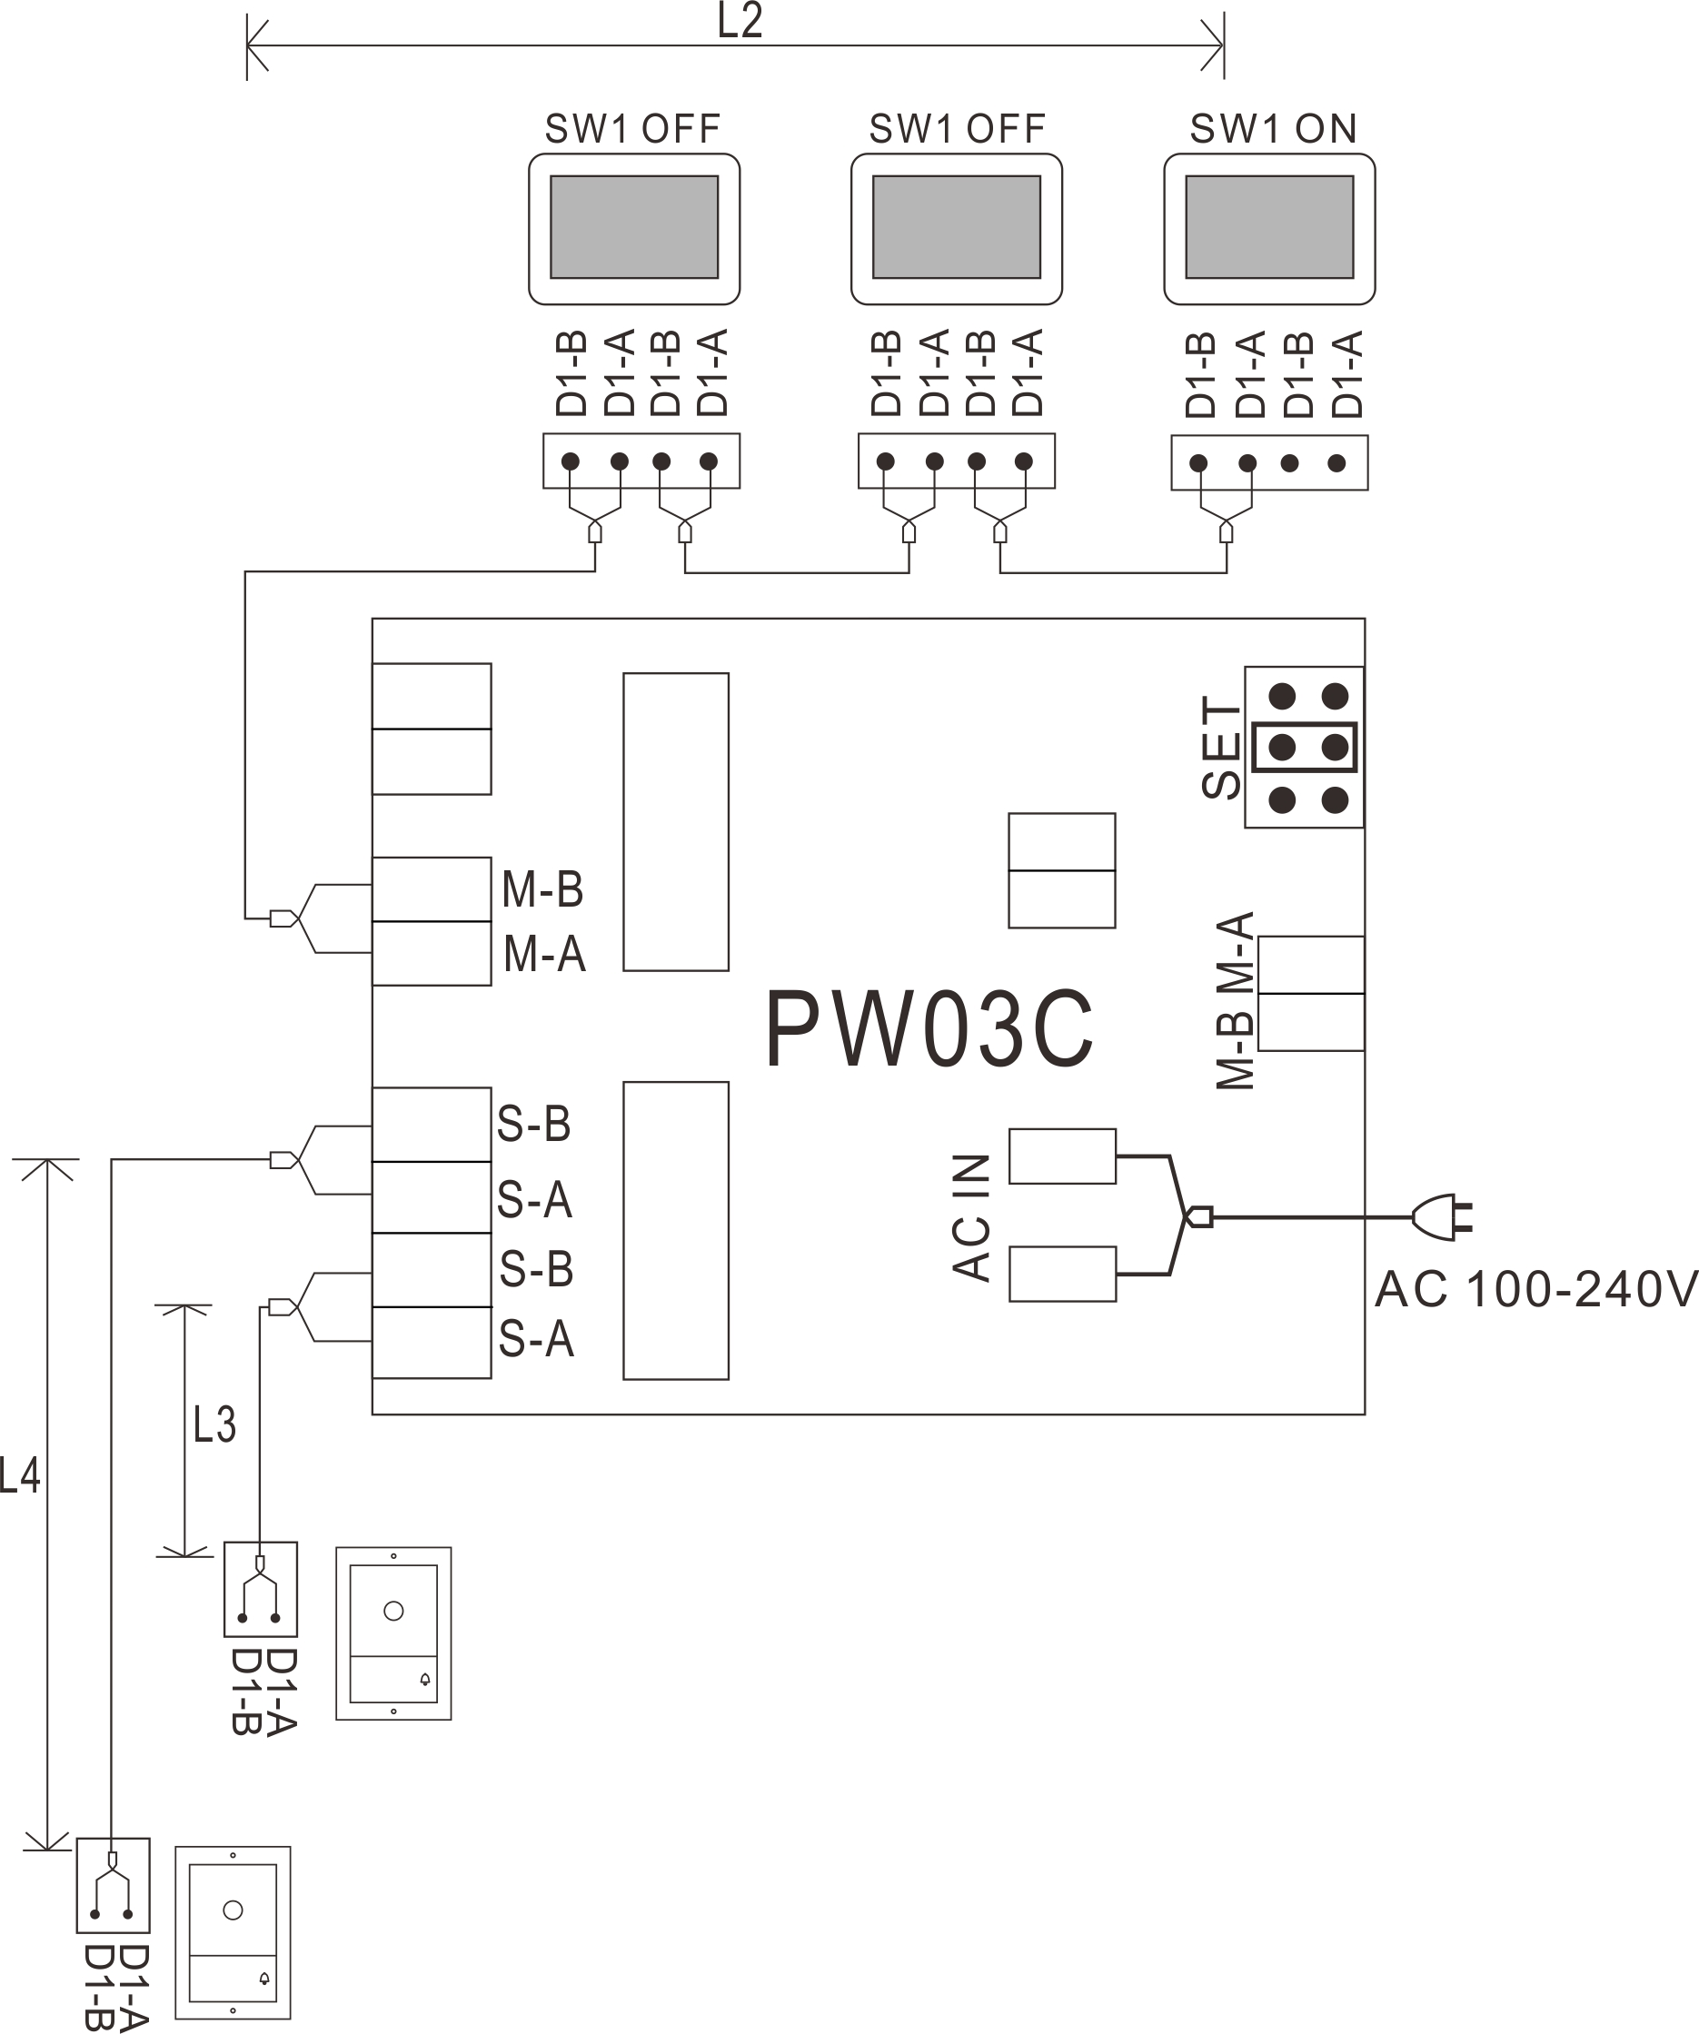

4.332 Three Door Stations Connect by a PW03B
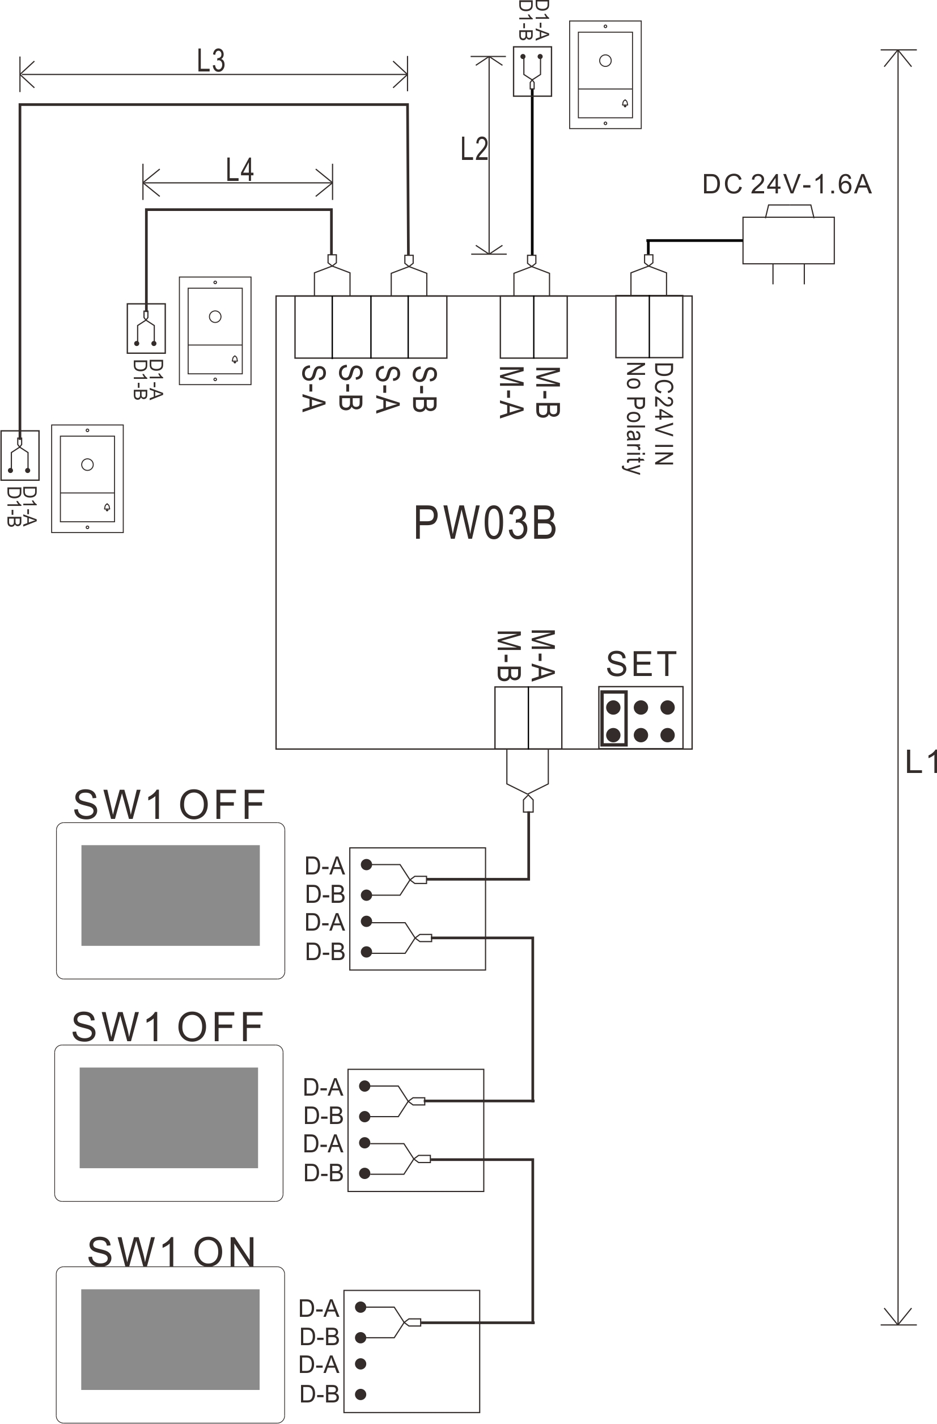

4.333 Five Door Stations Connect by Two PW03B
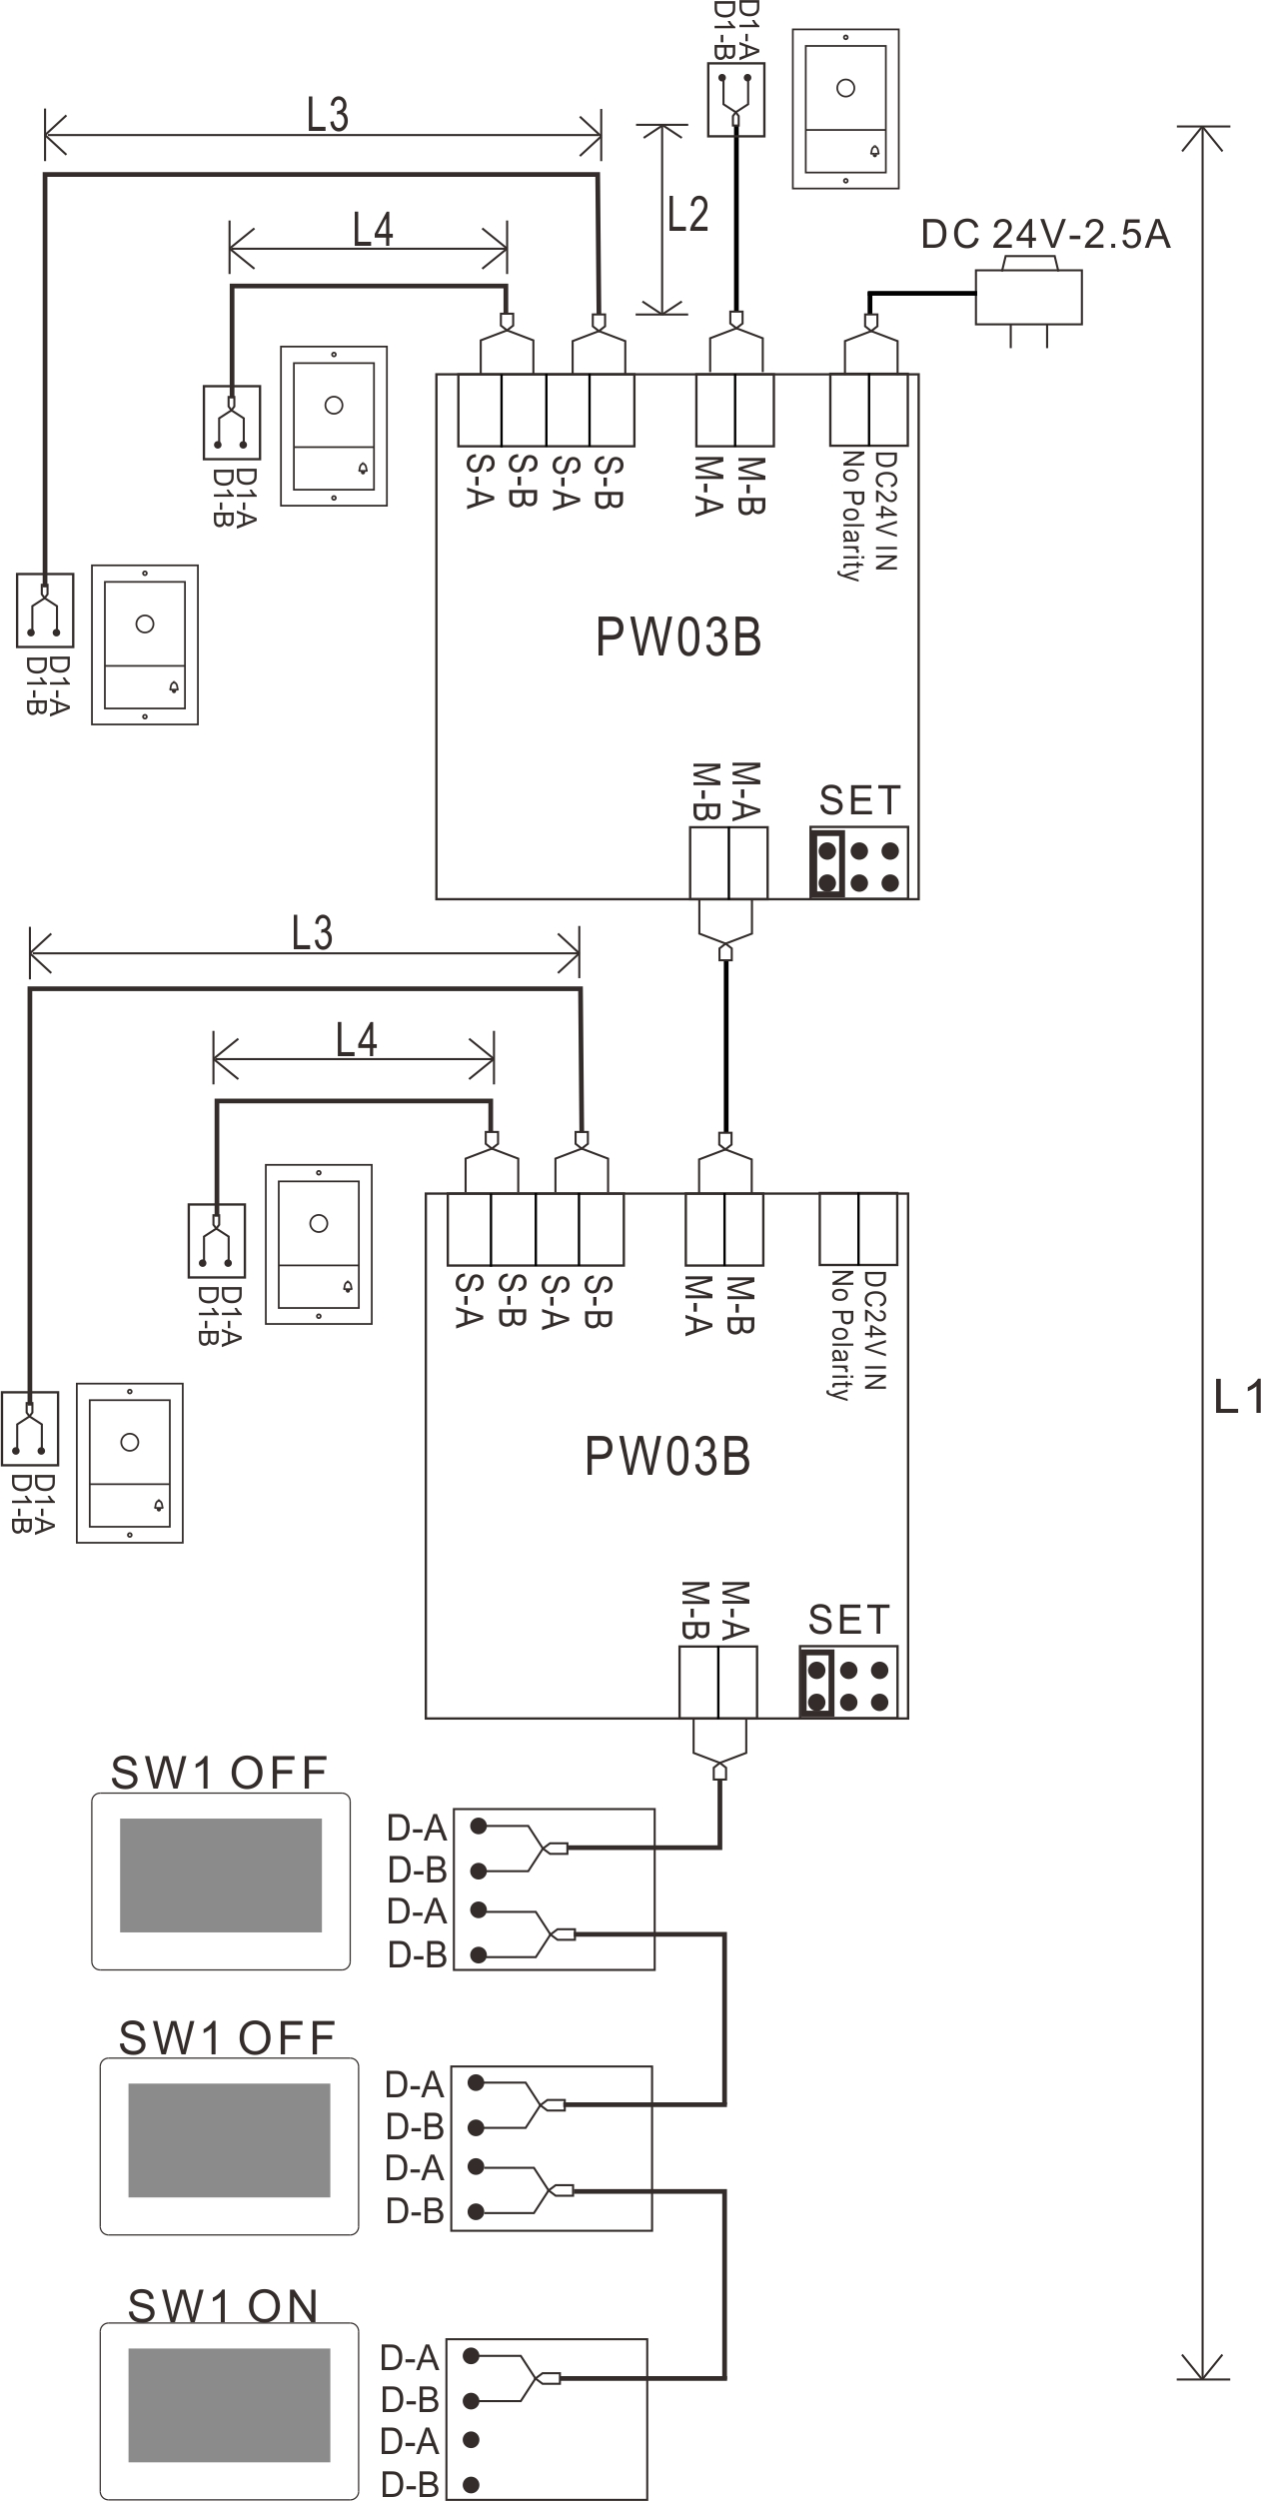
Remark:
- The same BUS should use the same wire with same specification.
- For the above diagram, the jumpers on PW03B must be set as same as in the diagram.
- If only connect 2 door stations, one of the door stations must connect to M-A and M-B.
- L1 means the 2 wire BUS length.
- L2 means the distance from the door station to the power supply.
- L3 & L4 means the distance from the door station to PW03, and L3 + L4 ≦ L1 maximum distance.
- 2-wire BUS terminal match setting:
Master BUS(The 2 wire bus which connects M-A & M-B port): The monitor on 2-wire BUS should set SW1 to be ON. The other monitors should set SW1 to be OFF.

- Installation Guide
5.1 Cautions
(5.11)Choosing a suitable position for installation to avoid direct sunlight and rain.
(5.12) Suggest installation height: 1.5~1.6Meters.
(5.13)Ensure no power supply before installation finished.
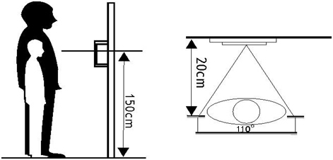

5.2 Wire Distance
Remark:
- Inner power unlock distance L2 means the distance from the 1st door station to the system power supply.
- If using system power to supply power to the door lock, the maximum wiring distance must not exceed L2.
- If using additional power supply for the door lock, the maximum wiring distance is L1.
- External power unlock distance means the distance from door lock to additional lock power supply.

No. | Cable Type | DC24V 1A Adapter |  |  | PW03A
No. | Cable Type | Intercom distance L1(m)  (MAX) | Inner power unlock distance L2 (m)  (MAX) | External power unlock distance  (m)  (MAX) | Intercom distance L1(m)  (MAX) | Inner power unlock distance L2 (m)  (MAX) | External power unlock distance  (m)  (MAX)
1 | Parallel pair cable  (BVVB) 2*0.5mm²   | 125 | 125 | 10 | 125 | 125 | 10
2 | Parallel pair cable (BVVB) 2*0.75mm² | 125 | 125 | 10 | 125 | 125 | 10
3 | Twisted cable (ZC-RVS)2*0.5mm²   | 150 | 150 | 10 | 150 | 150 | 10
4 | Twisted cable (ZC-RVS) 2*0.75mm² | 150 | 150 | 10 | 150 | 150 | 10
5 | Single pair cable (Standard CAT-5)   | 150 | 100 | 10 | 150 | 100 | 10
6 | Double pair cable (Standard CAT-5)   | 200 | 150 | 10 | 200 | 150 | 10
7 | Telephone line (HBV) 2*0.2mm²   | 50 | 50 | 10 | 50 | 50 | 10
8 | Parallel pair cable 2*0.3 mm²   | 100 | 100 | 10 | 100 | 100 | 10

5.3 Surface Mounted

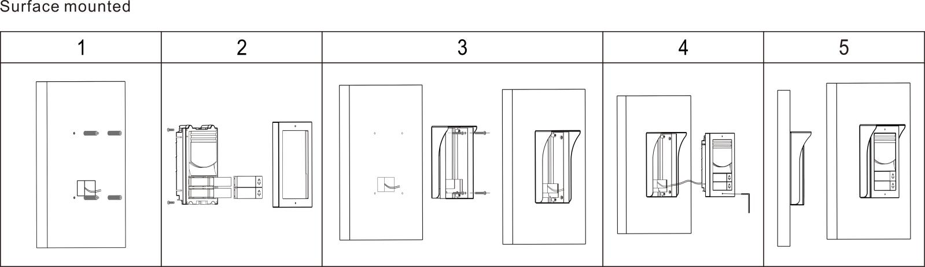
- Drill 4 holes according to the rain hood position, then insert the expansion columns into the holes.
- Disassemble the front panel to install the name plate, then lock the front panel again.
- Fix the mounting box and rain hood with 4 screws.
- Connect the cable according to the system wiring diagram.
- Fix the door station onto the mounting box with a special screw driver(Remark: 2 fixing screws are preinstalled in the 2 screw holes, see No. (7) on Page 1.).

5.4 Flush Mounted
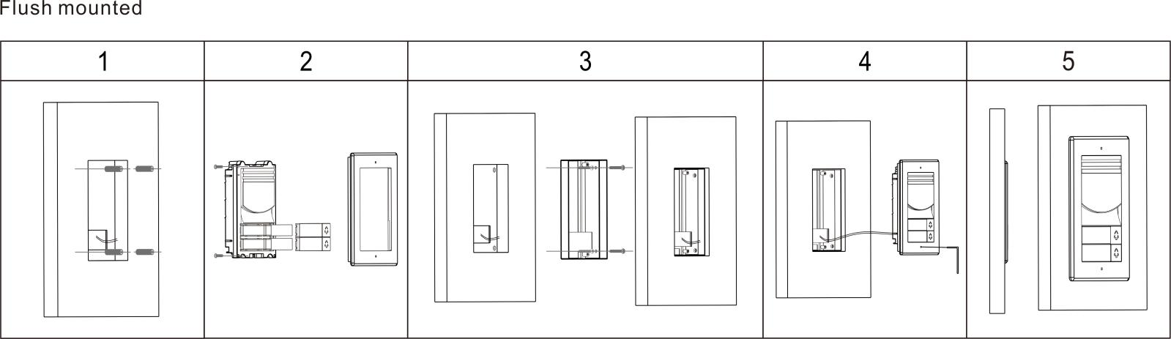
- Drill a hole in the wall according to the size of the mounting box. Then drill 4 small holes in the big hole according to the screw holes position on the mounting box, and insert 4 expansion columns into the holes.
- Disassemble the front panel to install the name plate, then lock the front panel again.
- Fix the mounting box and rain hood with 4 screws.
- Connect the cable according to the system wiring diagram.
- Fix the door station onto the mounting box with a special screw driver(Remark: 2 fixing screws are preinstalled in the 2 screw holes, see No. (7) on Page 1.).

- Specification
No | Item | Content
1 | Communication | Digital 2 wire
2 | Subscribers quantity | 1 subscriber / 2 subscribers
3 | Audio | Digital audio (bidirectional)
4 | Video | 1 channel digital video (output)
5 | Camera | 1080P HD color CMOS camera
6 | Night vision | Infrared light(with automatic lumens adjustment)
7 | Effective distance (0 Lux) | 0.5 meter
8 | Viewing angle | Horizontal 110 degree, Vertical 60 degree
9 | Buttons | 1/2 mechanical buttons
10 | Working voltage | DC 15V-24V
11 | Support electrical lock | - Door Lock Controlled with Internal Power: NC Lock of DC12V 0.35A (Max), or NO Lock of DC12V ≤2A(instantaneous), DC12V ≤0.35A(Continuous current).  (2) Door Lock Controlled with External Power: Support lock of AC/DC5V-24V, current≤3A.
12 | Support gate lock | One unlock signal (dry contact), current is less than 0.35A.
13 | Unlock control | Signal instruction
14 | Power consumption | 3W (Do not contain lock power supply)
15 | Working temperature | -25℃- +60℃
16 | Storage temperature | -30℃- +60℃
17 | IP Grade | IP55
18 | Dimension | 2D32 Surface mount: 153.5*103*44.5 MM  2D33 Flush mount: 191*140*48 MM

SVS – Secure Video Systems
The Drive
Erith
DA*1ED

WWW.s-v-s.co.uk
info@s-v-s.co.uk
08001216097

Products are subject to change without prior notice. Svs Secure video systems is a trading name of Intercom repair LTD
Registered company number: 07648814 Vat No 140598900

