SVS 2 Wire System Monitor Distributor
User Manual
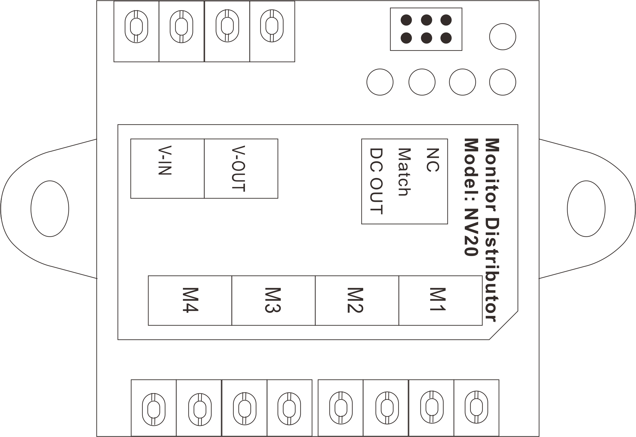
V1.0

1. Product Features and Main Function
● Support 4 devices.
● Signal transfer between master BUS and branch BUS.
● BUS signal isolation.
● Master BUS terminal match settings by a jumper.
● Branch BUS terminal match automatically.
● Supply power to the next monitor distributor NV20.
● LED indicators for showing communication state.
● Support maximum 2 video channels at the same time from 2 door stations.
● Video signal can only be transferred from master BUS to slave BUS.

- The Function and Name of Each Part
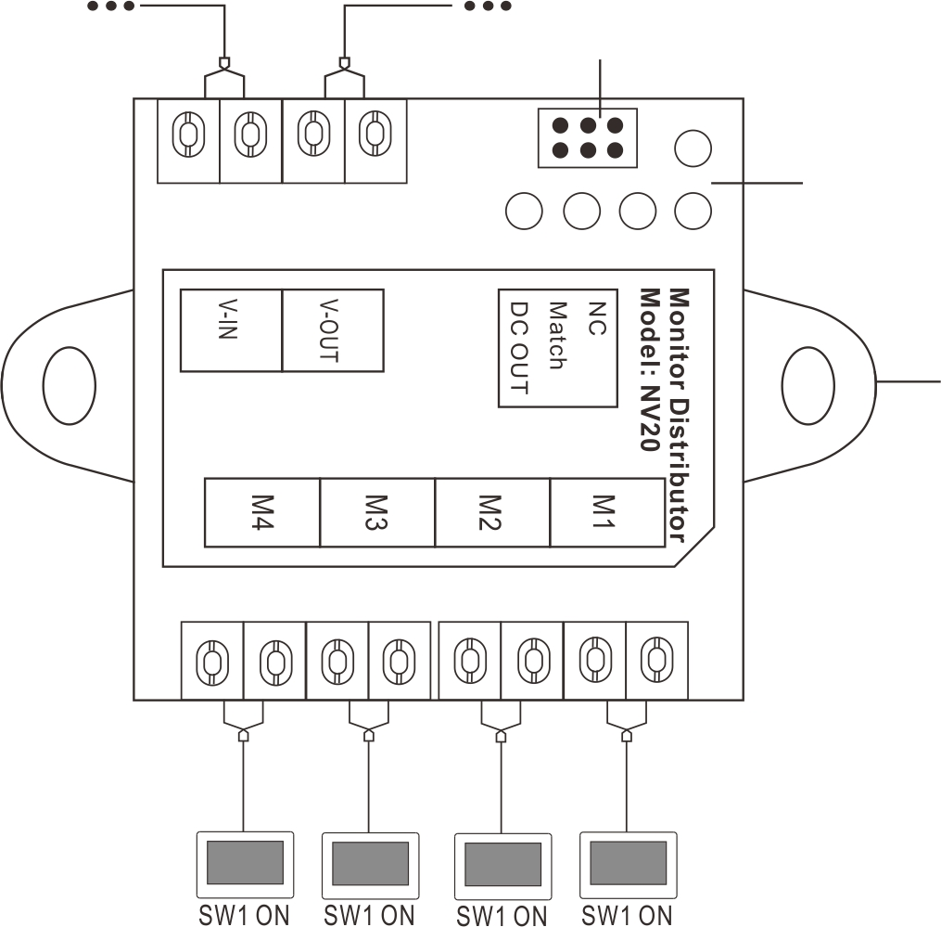
Master BUS in
Master BUS out
Indicator
Jumper setting

Screw hole for installation
- M1-M4: Ports for indoor monitors.
Remark:
There are 2 branch BUS on each NV20.
M1 & M2 Ports belong to the same branch, and the monitors connected to them could set different or same address.
M3 & M4 Ports belong to the same branch, and the monitors connected to them could set different or same address.
But never set the monitor address of M1 & M2 as same as M3 & M4, or it will cause communication problem.
- V-IN: Input port for maser 2 wire BUS
- V-OUT: Output port for mater 2 wire BUS
- Jumper setting

SET | Content
 | NC: No match setting and no supply power to the next NV20.
 | Match: It needs make match setting when the monitor distributor NV20 is the last device on the 2 wire BUS.
 | DC OUT: It needs to set as DC OUT when the monitor distributor NV20 needs to supply power to the next NV20.

- Indicator
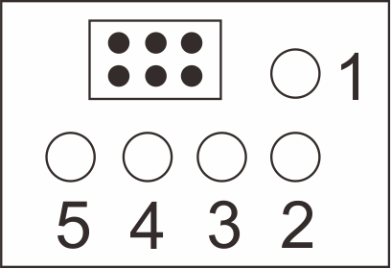

Indicator | Off | On | Flicker
1 | No power to NV20 | Standby state | There’s communication on the 2 wire BUS.
2 & 3 | No devices connected to M1 & M2 Ports. | Standby state | There’s communication in M1 or M2 Port.
4 & 5 | No devices connected to M3 & M4 Ports. | Standby state | There’s communication in M3 or M4 Port.

- Installation
- Drill 2 holes on the wall according to the monitor distributor screw holes position.
- Insert 2 expansion columns into the holes and fix the monitor distributor with 2 screws.
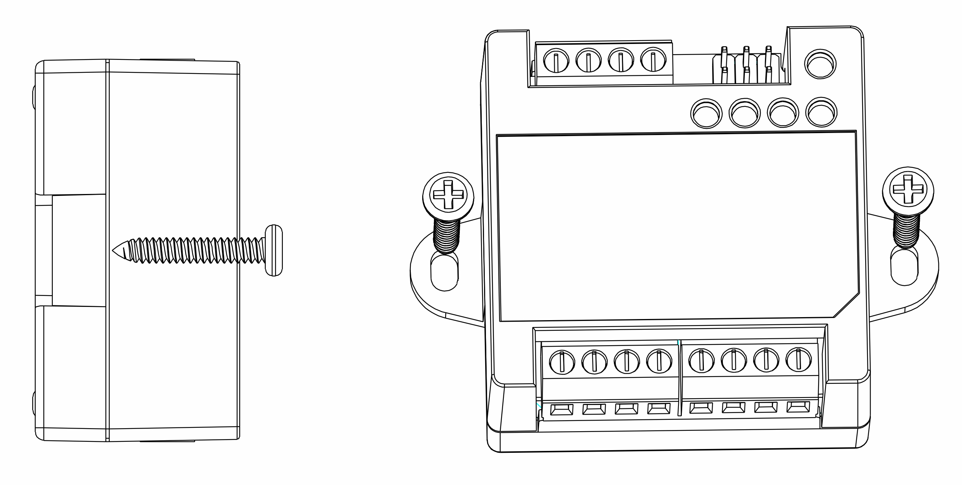
- Specification

NO. | Item | Content
1 | Working voltage | DC18-30V
2 | Power consumption | ≤2.5W Max(Output load current 1A), 0.5W(Standby)
3 | Branch port output | DC18-30V 0.35A Max (4 channels)
4 | Working temperature | -25℃ - +45℃
5 | Storage temperature | -30℃ - +60℃
6 | Dimension | 62*45*27mm（L*W*H）
5. System Wiring Diagram
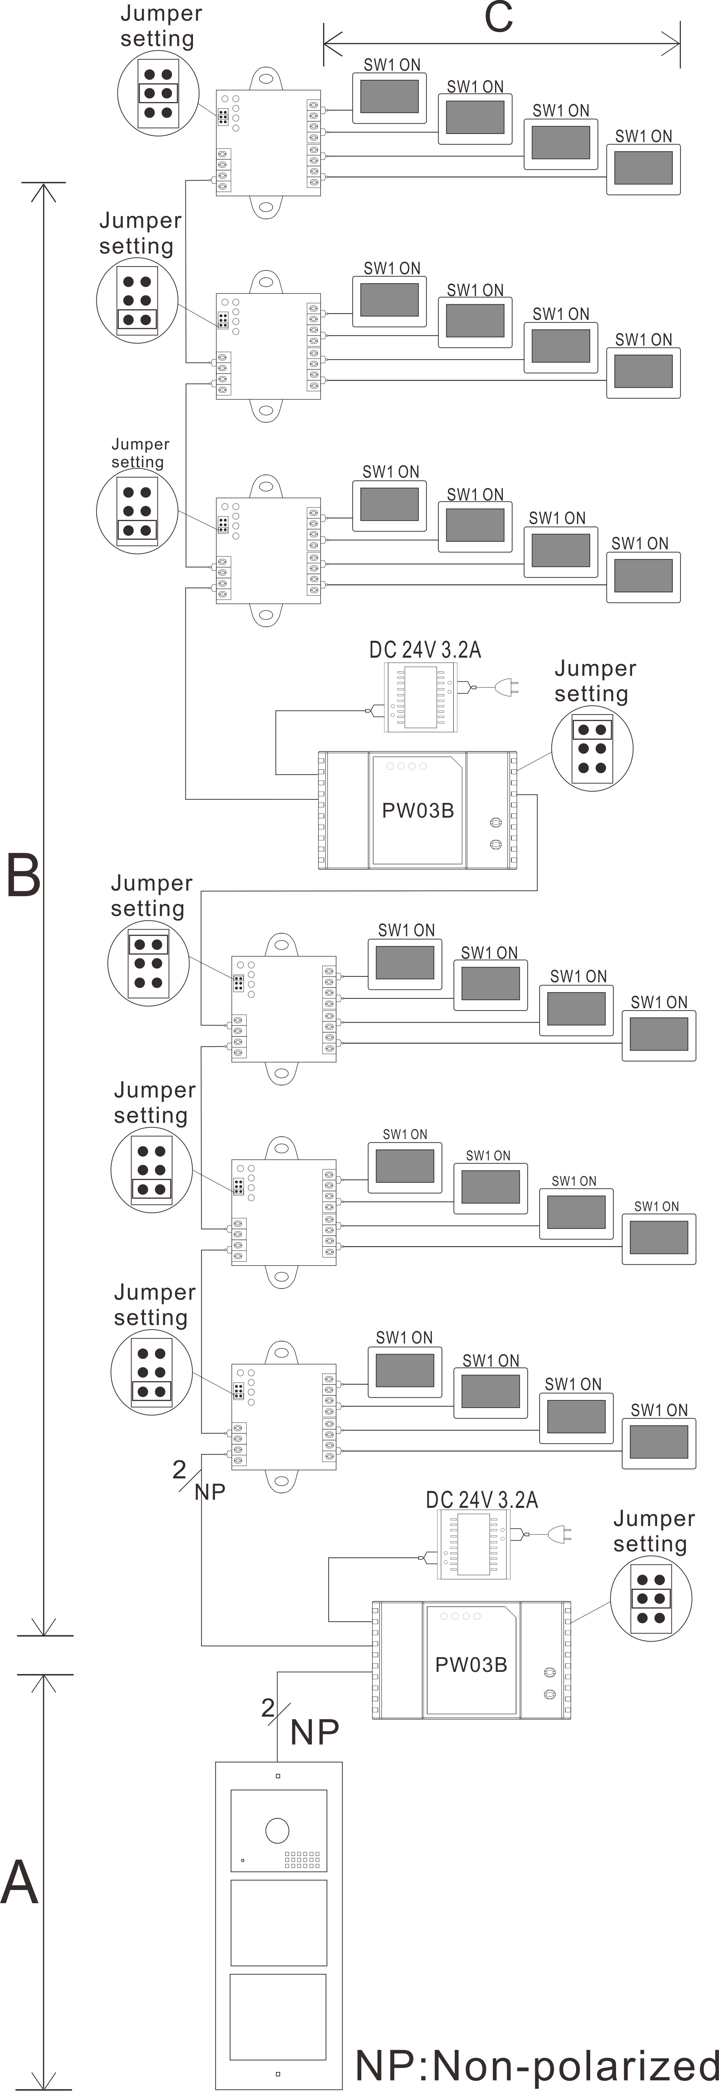
Remark:
- All cables must be unshielded.

- One BUS (A, B, D, E or F) should use the same cable with same specification.

- For each monitor distributor NV20, the wires to M1& M2 Port should be with same specification, the wires to M3 & M4 Port should be with same specification.

- All the last device on each BUS should make right terminal match setting as the diagram.

- Each monitor distributor NV20 can support maximum 4 devices.

SVS – Secure Video Systems
The Drive
Erith
DA*1ED

WWW.s-v-s.co.uk
info@s-v-s.co.uk
08001216097

Products are subject to change without prior notice. Svs Secure video systems is a trading name of Intercom repair LTD
Registered company number: 07648814 Vat No 140598900

